NorthWinds
End Time
Report to
the Church

My report of the status of the Church here in this End Time is designed to evaluate Her condition and prescribe Heavens Plans for the Church during the Tribulation. All Christian denominations have been infected, even down to their core, with the demonic spirit. God will choose from among us and place His mark on their forehead. After His selection is complete we will gather and protect His treasure. Our condition will be directly related to how we treat His Treasure.
First we cover the deconstruction of the book of Revelation to verify what we are told by God about this period of time. Next we see how a Conspiracy based on a Roman historian “Josephus” who was previously a ruler in Israel, distorted our understanding of Daniel. In Ezekiel we discover the last third of the book describes everything from the rapture with the dry bones to the battle of Armageddon and the Millennial reign. We discover in the next book how the Premillennial view allows for a thousand year rule of the Creator as Messiah. Next we examine what the Apostle Paul believed about the End Times.
Finally we discover the hidden things that allowed the world to sell us a strong delusion to believe the lies they use to set up the False Messiah. As the fallen angels gained control over humanity through the silencing of those who believed the Truth and promoting the darkness. This electronic control over the media enabled the fallen to force society to accept the unbiblical or loose their voice in the electronic realm.
In this analysis we discover that the same message Gabriel showed Daniel is mirrored in the Revelation of John the Apostle. All the passages of the Bible have taught the same thing and the religion of the world has distorted our view.

Page
Deconstructing Revelation 4
The Josephus Conspirency 32
Ezekiel 34 -48 60
Is Almillennialism Biblical? 72
What did Paul teach about the End Time? 82
Fallen Angels as Aliens 100

Deconstructing Revelation

April 2025

Defining

The Creators “Master Plan”

Forward
In the beginning God created a setting where He could commune with man personally and without any obstruction. He would visit Adam and Eve in the cool of the day and talk with them. God is perfect and sin impairs His ability to share such a perfect relationship.

The devil destroyed this relationship by enticing Eve to eat of the forbidden fruit. As mankind grew more distant from our Creators purpose through the meddling of the fallen angels, a reset was determined by the Creator to reestablish His Will on earth. The flood shortened the lifespan of man and changed the climate on earth. The removal of the blanket of moisture in the atmosphere and the formation of the polar icecaps, pushed the crust of earth together forming mountains. Mountains create friction as the earth rotates and the result is turbulent winds and storms of the destructive nature.

As God sought a more personal relationship with man, He chose a man named Abraham to bring forth this blessing and He chose a area of earth to focus His blessing upon. In Jacob, He chose a people to call His Own. In David, He chose a city and a Throne or Kingdom to call His Own.

Every time the Creator defines something as His Own, the devil attempts to ruin the Plan God has for His Creation. In this writing we will attempt to use the Testimony of the Creator to review what His Master Plan is for His Creation. An analysis of the Biblical record of time, places us at the 6000 year mark after the fall of man in the garden. God has placed emphasis on millennial markers throughout His Word. He has reserved the final millennium of this earths existence for His own control.

Abraham receives his blessing from the Creator at approximately 2000 years after the fall of man. The throne of David is selected by the Creator at approximately 3000 years after the fall of man. Jesus arrives as the sacrifice for sin at approximately 4000 years after the fall of man. The book of Revelation describes the process the Creator will use to regain psychical control over His Creation. Similarities between the millennial reign of Christ and the Eternal state define aspects of the Creators Master Plan. During the millennial reign a river of Life will emanate from the Throne of God in Jerusalem to heal the earth from the destruction of the wars between the fallen angel groups that control nations. This pattern will find its final design on the New Earth during the eternal state where mankind will once again commune with God in the absence of sin. Deconstructing Revelation

Revelation 22:7 Behold, I come quickly: blessed is he that keepeth the sayings of the prophecy of this book.
Revelation 22:16 I Jesus have sent mine angel to testify unto you these things in the churches. I am the root and the offspring of David, and the bright and morning star.

The Author has identified Himself as the Creator Jesus and He has associated a blessing with those who keep the writings of this Prophetical Book. Almost 2000 years ago the Creator prescribed the events preceding His return to posses His Creation. In this deconstruction we will examine His Master Plan. May God bless each who seek to understand and keep this Testimony of His Master Plan.

(The Eternal State)

Revelation 22:1 And he shewed me a pure river of water of life, clear as crystal, proceeding out of the throne of God and of the Lamb.
Revelation 22:3-4 And there shall be no more curse: but the throne of God and of the Lamb shall be in it; and his servants shall serve him: And they shall see his face; and his name shall be in their foreheads.

As we build a vision of what the “Eternal State” will be like, we recognize the river flowing from the Throne of God. This pattern is not new to the bible scholar, for we are told of a similar pattern described in the Millennial Kingdom of Christ. This river is on a “New Earth” where the curse of sin has never existed and no blood has stained the soil. This “New Earth” is what the Garden of Eden could have become absent of the rebellion of the fallen angels and the fall of man.

Zechariah 14:8-9 And it shall be in that day, that living waters shall go out from Jerusalem; half of them toward the former sea, and half of them toward the hinder sea: in summer and in winter shall it be. And the LORD shall be king over all the earth: in that day shall there be one LORD, and his name one. 4
Ezekiel 47:7-9 Now when I had returned, behold, at the bank of the river were very many trees on the one side and on the other. Then said he unto me, These waters issue out toward the east country, and go down into the desert, and go into the sea: which being brought forth into the sea, the waters shall be healed. And it shall come to pass, that every thing that liveth, which moveth, whithersoever the rivers shall come, shall live: and there shall be a very great multitude of fish, because these waters shall come thither: for they shall be healed; and every thing shall live whither the river cometh.

Ezekiel 47:12 And by the river upon the bank thereof, on this side and on that side, shall grow all trees for meat, whose leaf shall not fade, neither shall the fruit thereof be consumed: it shall bring forth new fruit according to his months, because their waters they issued out of the sanctuary: and the fruit thereof shall be for meat, and the leaf thereof for medicine.

We are told of the river that shall exist during the millennial reign of Christ in the Old Testament. The river flows out of the Throne of God in Jerusalem and heals the earth of the scars incurred from the wars and rebellion of man. The fruit of the trees on the banks are meant for food and the leaves of the trees for medicine. The difference between the eternal state and the millennial reign is the presence of sin. We are told that God will make a new heaven and a new earth after the old earth has run it's 7000 year course. Mankind was given authority over the earth for the first 6000 years and the Creator shall usurp this authority for the final millennium. After this 7000 year course, when sin has been extinguished from the remnant of humanity, then the Father in Heaven can commune with his creation without the abrasion of the imperfection of sin.

1 Corinthians 15:23-25 But every man in his own order: Christ the firstfruits; afterward they that are Christ's at his coming. Then cometh the end, when he shall have delivered up the kingdom to God, even the Father; when he shall have put down all rule and all authority and power. For he must reign, till he hath put all enemies under his feet.

5

Revelation 22:4-5 And they shall see his face; and his name shall be in their foreheads. And there shall be no night there; and they need no candle, neither light of the sun; for the Lord God giveth them light: and they shall reign for ever and ever.

Revelation 21:1-3 And I saw a new heaven and a new earth: for the first heaven and the first earth were passed away; and there was no more sea. And I John saw the holy city, new Jerusalem, coming down from God out of heaven, prepared as a bride adorned for her husband. And I heard a great voice out of heaven saying, Behold, the tabernacle of God is with men, and he will dwell with them, and they shall be his people, and God himself shall be with them, and be their God.

My goal is to analyze the biblical record, and build a reasonable expectation
for the Bible believer to rely on throughout the Tribulation period.

The Millennial Reign of Christ

Revelation 20:2-3 And he laid hold on the dragon, that old serpent, which is the Devil, and Satan, and bound him a thousand years, And cast him into the bottomless pit, and shut him up, and set a seal upon him, that he should deceive the nations no more, till the thousand years should be fulfilled: and after that he must be loosed a little season.

The reason for this thousand year incarceration is to deal with the natural born humans that evolved from surviving the Wrath of God and still maintaining a rebellious spirit. The Lord will rule with a rod of iron during the millennial reign and yet there is still a rebellious spirit in existence at the end of His reign. We will see this bottomless pit unlocked to release Satan in the beginning of the Tribulation and then he is locked up again.

Zechariah 14:1-2 Behold, the day of the LORD cometh, and thy spoil shall be divided in the midst of thee. For I will gather all nations against Jerusalem to battle; and the city shall be taken, and the houses rifled, and the women ravished; and half of the city shall go forth into captivity, and the residue of the people shall not be cut off from the city. 6
Zechariah 14:16-17 And it shall come to pass, that every one that is left of all the nations which came against Jerusalem shall even go up from year to year to worship the King, the LORD of hosts, and to keep the feast of tabernacles. And it shall be, that whoso will not come up of all the families of the earth unto Jerusalem to worship the King, the LORD of hosts, even upon them shall be no rain.

Here in Zechariah chapter 14 we find the Creator forecasting the conditions and expectations required for these survivors of the Wrath of God. They must worship the Creator Jesus or there will be no rain on their land. I believe that hundreds of millions from all the nations will survive to see Jesus rule.

Revelation 19:20 And the beast was taken, and with him the false prophet that wrought miracles before him, with which he deceived them that had received the mark of the beast, and them that worshipped his image. These both were cast alive into a lake of fire burning with brimstone.

At the beginning of the the Creators Millennial reign all the fallen angels are dealt with and the beast and the false prophet are also cast into the Lake of Fire. Imagine the world free from the influence of the Fallen Angels.

Revelation 20:4 And I saw thrones, and they sat upon them, and judgment was given unto them: and I saw the souls of them that were beheaded for the witness of Jesus, and for the word of God, and which had not worshipped the beast, neither his image, neither had received his mark upon their foreheads, or in their hands; and they lived and reigned with Christ a thousand years.

The Great White Throne Judgment

Revelation 20:10 And the devil that deceived them was cast into the lake of fire and brimstone, where the beast and the false prophet are, and shall be tormented day and night for ever and ever.

Revelation 20:11-12 And I saw a great white throne, and him that sat on it, from whose face the earth and the heaven fled away; and there was found no place for them. And I saw the dead, small and great, stand before God; and 7 the books were opened: and another book was opened, which is the book of life: and the dead were judged out of those things which were written in the books, according to their works.

Revelation 20:14-15 And death and hell were cast into the lake of fire. This is the second death. And whosoever was not found written in the book of life was cast into the lake of fire.

These verses assure the believer that there is an end to this madness as the deceiver Satan (the god of this world) is finally eliminated in the end. The Bible record informs us that this extermination occurs at the end of the Creators millennial reign. The great white throne judgment assigns everyone their place in an eternal judgment known as the second death. As we consider the time of the Millennial reign we see that the Creator installs a government of His Own choosing so that His children can rule with Him. Climatic conditions are restored to the preflood era where the mountains do not exist and there are no more destructive storms. The friction the mountains encountered caused great turbulence atmospherically producing storms of great destructive power. The extra water collected at the polar regions causing the ice caps to effectively squash the planet producing the mountains. The human life-cycle will be elongated because the vapor barrier in the atmosphere that protected the earths surface from the radiation of the sun that shortened the human lifespan will be restored.

The Battle of Armageddon
Immediately preceding the millennial reign of Jesus we find a confrontation between the powers of Light and darkness that we term “the Battle of Armageddon”.

Revelation 19:11-14 And I saw heaven opened, and behold a white horse; and he that sat upon him was called Faithful and True, and in righteousness he doth judge and make war. His eyes were as a flame of fire, and on his head were many crowns; and he had a name written, that no man knew, but he himself. And he was clothed with a vesture dipped in blood: and his name is called The Word of God. And the armies which were in heaven followed him upon white horses, clothed in fine linen, white and clean. 8
Revelation 19:19 And I saw the beast, and the kings of the earth, and their armies, gathered together to make war against him that sat on the horse, and against his army.

This battle of Armageddon is over the control of earth and is between the Creator and Lucifer just outside Jerusalem. Remember that Lucifer had previously been defeated in Heaven knowing he only had a short time left.

Zechariah 14:2-3 For I will gather all nations against Jerusalem to battle; and the city shall be taken, and the houses rifled, and the women ravished; and half of the city shall go forth into captivity, and the residue of the people shall not be cut off from the city. Then shall the LORD go forth, and fight against those nations, as when he fought in the day of battle.

Revelation 19:20-21 And the beast was taken, and with him the false prophet that wrought miracles before him, with which he deceived them that had received the mark of the beast, and them that worshipped his image. These both were cast alive into a lake of fire burning with brimstone. And the
remnant were slain with the sword of him that sat upon the horse, which sword proceeded out of his mouth: and all the fowls were filled with their flesh.

The specificity concerning how this final battle will take place is descriptive. The Creator will allow the Armies of darkness to capture half of the city Jerusalem before He stands up to defend His claim to His Created possession. We find the beast and the false prophet are permanently dealt with by casting them into the eternal lake of fire. At this point all of the fallen angels have been eliminated and the sole survivor of the fallen angels is Satan who is incarcerated within the bottomless pit. Immediately preceding the battle of Armageddon we find the Wrath of God Pored out on earth through the seven bowls of wrath.

The Wrath of God

Revelation 16:1 And I heard a great voice out of the temple saying to the seven angels, Go your ways, and pour out the vials of the wrath of God upon the earth. 9
Revelation 6:12-17 And I beheld when he had opened the sixth seal, and, lo, there was a great earthquake; and the sun became black as sackcloth of hair, and the moon became as blood; And the stars of heaven fell unto the earth, even as a fig tree casteth her untimely figs, when she is shaken of a mighty wind. And the heaven departed as a scroll when it is rolled together; and every mountain and island were moved out of their places. And the kings of the earth, and the great men, and the rich men, and the chief captains, and the mighty men, and every bondman, and every free man, hid themselves in the dens and in the rocks of the mountains; And said to the mountains and rocks, Fall on us, and hide us from the face of him that sitteth on the throne, and from the wrath of the Lamb: For the great day of his wrath is come; and who shall be able to stand?

Revelation 11:15 And the seventh angel sounded; and there were great voices in heaven, saying, The kingdoms of this world are become the kingdoms of our Lord, and of his Christ; and he shall reign for ever and ever.

Revelation 11:18 And the nations were angry, and thy wrath is come, and the time of the dead, that they should be judged, and that thou shouldest give reward unto thy servants the prophets, and to the saints, and them that fear thy name, small and great; and shouldest destroy them which destroy the earth.

Revelation 10:6-7 And sware by him that liveth for ever and ever, who created heaven, and the things that therein are, and the earth, and the things that therein are, and the sea, and the things which are therein, that there should be time no longer: But in the days of the voice of the seventh angel, when he shall begin to sound, the mystery of God should be finished, as he hath declared to his servants the prophets.

God declares that when the seventh Trump is sounded (The Last Trump) that time is no longer valid. The Sun goes out so we are unable to measure the length of a year. This is when the Wrath of God is pored out on earth. This pivotal point marking the “End of Time” is mentioned multiple times in the Revelation. First we find it mentioned in chapter 6 as the preview of the contents of the Book in the Fathers Right Hand is concluded through 10 the removal of the 6th seal and the Wrath of God. Again at the Last or final 7th Trumpet in chapter 11. The Wrath of God is an all consuming event for the earth as the mountains recede back into the earths crust and the islands are removed from the sea. The earthquake is so great that it ruins all the city's man has constructed on earth.

Revelation 16:19 And the great city was divided into three parts, and the cities of the nations fell: and great Babylon came in remembrance before God, to give unto her the cup of the wine of the fierceness of his wrath.

This next point when dealing with this time period has proven to be a problem area. We are taught things in our organized religious denominations that do not reflect biblical truth. The last or 7th Trump is clearly the moment when we find the Rapture of the Church. The Church is not on earth during the Wrath of God.
The Rapture of the Church

1 Corinthians 15:51-53 Behold, I shew you a mystery; We shall not all sleep, but we shall all be changed, In a moment, in the twinkling of an eye, at the last trump: for the trumpet shall sound, and the dead shall be raised incorruptible, and we shall be changed. For this corruptible must put on incorruption, and this mortal must put on immortality.

Matthew 24:29-30 Immediately after the tribulation of those days shall the sun be darkened, and the moon shall not give her light, and the stars shall fall from heaven, and the powers of the heavens shall be shaken: And then shall appear the sign of the Son of man in heaven: and then shall all the tribes of the earth mourn, and they shall see the Son of man coming in the clouds of heaven with power and great glory.

There is a critical marker of time that we cannot neglect. At the moment when the sun goes out the marking of time has stopped and as we see this condition reoccurring we are forced to conclude that these accounts are of the same moment in time. This enables us to build a more precise account of when this happens. All of the focus shall be on the only object brightening the sky. Jesus in the Clouds of Heaven, traveling to earth to take control. 11
Revelation 1:7 Behold, he cometh with clouds; and every eye shall see him, and they also which pierced him: and all kindreds of the earth shall wail because of him. Even so, Amen.

Revelation 14:12-14 Here is the patience of the saints: here are they that keep the commandments of God, and the faith of Jesus. And I heard a voice from heaven saying unto me, Write, Blessed are the dead which die in the Lord from henceforth: Yea, saith the Spirit, that they may rest from their labours; and their works do follow them. And I looked, and behold a white cloud, and upon the cloud one sat like unto the Son of man, having on his head a golden crown, and in his hand a sharp sickle.

Revelation 1:13 And in the midst of the seven candlesticks one like unto the Son of man, clothed with a garment down to the foot, and girt about the paps with a golden girdle.

Revelation is the emphasis of His arrival “One like unto the Son of Man”, coming in the clouds of heaven. This happens right after the sun goes out adding focus to His Arrival. We find in Revelation 1:13 that this One like unto the Son of Man is the Creator Jesus. Jesus uses agricultural examples to teach and here we find Him arriving in the Clouds with a Sickle to reap His harvest. All efforts to place this event “the Rapture” in any other timing than this location is an attempt to distort scripture.

Judgment of the Whore

Right before the sun goes out the judgment of the whore that rides the dragon takes place. Babylon is fallen tells us that the city that oversees the world religious system has entered judgment.

Revelation 18:2 And he cried mightily with a strong voice, saying, Babylon the great is fallen, is fallen, and is become the habitation of devils, and the hold of every foul spirit, and a cage of every unclean and hateful bird.

1 Peter 5:13 The church that is at Babylon, elected together with you, saluteth you; and so doth Marcus my son. 12
Revelation 17:3-5 So he carried me away in the spirit into the wilderness: and I saw a woman sit upon a scarlet coloured beast, full of names of blasphemy, having seven heads and ten horns. And the woman was arrayed in purple and scarlet colour, and decked with gold and precious stones and pearls, having a golden cup in her hand full of abominations and filthiness of her fornication: And upon her forehead was a name written, MYSTERY, BABYLON THE GREAT, THE MOTHER OF HARLOTS AND ABOMINATIONS OF THE EARTH.

Revelation 17:18 And the woman which thou sawest is that great city, which reigneth over the kings of the earth.

Revelation 18:8-11 Therefore shall her plagues come in one day, death, and mourning, and famine; and she shall be utterly burned with fire: for strong is the Lord God who judgeth her. And the kings of the earth, who have committed fornication and lived deliciously with her, shall bewail her, and lament for her, when they shall see the smoke of her burning, Standing afar off for the fear of her torment, saying, Alas, alas, that great city Babylon, that mighty city! for in one hour is thy judgment come. And the merchants of the earth shall weep and mourn over her; for no man buyeth their merchandise any more:

So we see the judgment of the great whore on one day , in one hour. Clearly it was Rome that ruled the world at the time of this writing and Rome has covertly ruled the world even in our time. Up to the creation of the printing
press, the Vatican usurped unparalleled control over religious activity of the Church. The Vatican has been busy consolidating religious control through it's unification efforts.

The Two Witnesses

Previous to the judgment of the Whore in Rome, there will be a world observed event where two witnesses of the Creator are killed and then brought back to life before being raised into Heaven. Daniel accounts for this interim time when the two witnesses are raised to life and the Antichrist turns on the Jews in his final chapter of his prophetic book.
13
Daniel 12:11-12 And from the time that the daily sacrifice shall be taken away, and the abomination that maketh desolate set up, there shall be a thousand two hundred and ninety days. Blessed is he that waiteth, and cometh to the thousand three hundred and five and thirty days.

To add understanding to this prophecy, we must realize that the Jews had signed a peace agreement with the Antichrist and when they determined that their False Messiah did not possess ultimate authority over death, for he could not keep the two witnesses dead; they lost faith in their false messiah and he turned against him.

Revelation 11:6-11 These have power to shut heaven, that it rain not in the days of their prophecy: and have power over waters to turn them to blood, and to smite the earth with all plagues, as often as they will. And when they shall have finished their testimony, the beast that ascendeth out of the bottomless pit shall make war against them, and shall overcome them, and kill them. And their dead bodies shall lie in the street of the great city, which spiritually is called Sodom and Egypt, where also our Lord was crucified. And they of the people and kindreds and tongues and nations shall see their dead bodies three days and an half, and shall not suffer their dead bodies to be put in graves. And they that dwell upon the earth shall rejoice over them, and make merry, and shall send gifts one to another; because these two prophets tormented them that dwelt on the earth. And after three days and an half the Spirit of life from God entered into them, and they stood upon their feet; and great fear fell upon them which saw them.

These two witnesses have 1260 days to conduct their activity's and their 42 month actions mirror the same time that the Antichrist rules for 42 months. We again will step into a problem area in prophetic reasoning when we discuss the 70 weeks of Daniel. Daniel is told by the Angel Gabriel that 70 weeks are determined on the city Jerusalem and that this period of time is a judgment to reconcile the Jews back into Communion with the Creator. He tells Daniel that these 70 weeks are divided into 2 segments. The first segment last for 62 weeks and is interrupted by the Antichrists 42 month reign.
14

Daniel 9:26 And after threescore and two weeks shall Messiah be cut off, but not for himself: and the people of the prince that shall come shall destroy the city and the sanctuary; and the end thereof shall be with a flood, and unto the end of the war desolations are determined.
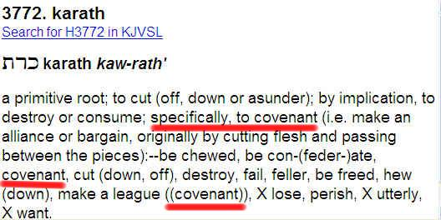

The previous verse has been the subject of incorrect translation for we find that the words “Cut Off” is the prime root's meaning while the actual meaning of the word used is “to Covenant”. The incorrect translation conceals the arrival of the Antichrist for his ordination or Covenant as the False Messiah. This confusion originated with the writings of Josephus where he invented the concept that this text was subject to the equivalent specified by another area of scripture applying weeks of years rather than weeks as the text clearly states. When God wants to apply a symbolic association He will clearly associate that symbology.

Daniel 9:23 At the beginning of thy supplications the commandment came forth, and I am come to shew thee; for thou art greatly beloved: therefore understand the matter, and consider the vision.

Daniel is instructed to consider the vision given in the previous chapter 8 where another span of time was specified.

Daniel 8:13-14 Then I heard one saint speaking, and another saint said unto that certain saint which spake, How long shall be the vision concerning the daily sacrifice, and the transgression of desolation, to give both the sanctuary and the host to be trodden under foot? And he said unto me, Unto two thousand and three hundred days; then shall the sanctuary be cleansed. 15
We are given the length of time the dream or vision consumes in the end time, (2300 Days).

Daniel 8:16-17 And I heard a man's voice between the banks of Ulai, which called, and said, Gabriel, make this man to understand the vision. So he came near where I stood: and when he came, I was afraid, and fell upon my face: but he said unto me, Understand, O son of man: for at the time of the end shall be the vision.

We will discover that these 2300 days are accounted for in the Revelation.
Trump 5 = 154 days + Trump 6 = 396 days + Antichrist reign = 1260 days and when we add the 70 weeks or 490 days we find the 2300 days mentioned here.

The Abomination of Desolation

The Abomination of Desolation also occurs at this time as the Antichrist turns on the Jews when they loose faith in their False Messiah. The Jews were in contract to conduct worship activities in their temple and when he turns on them he desecrates the temple.

Matthew 24:15-24 When ye therefore shall see the abomination of desolation, spoken of by Daniel the prophet, stand in the holy place, (whoso readeth, let him understand:) Then let them which be in Judaea flee into the mountains: Let him which is on the housetop not come down to take any thing out of his house: Neither let him which is in the field return back to take his clothes. And woe unto them that are with child, and to them that give suck in those days! But pray ye that your flight be not in the winter, neither on the sabbath day: For then shall be great tribulation, such as was not since the beginning of the world to this time, no, nor ever shall be. And except those days should be shortened, there should no flesh be saved: but for the elect's sake those days shall be shortened. Then if any man shall say unto you, Lo, here is Christ, or there; believe it not. For there shall arise false Christs, and false prophets, and shall shew great signs and wonders; insomuch that, if it were possible, they shall deceive the very elect. 16

Daniel 11:30-31 For the ships of Chittim shall come against him: therefore he shall be grieved, and return, and have indignation against the holy covenant: so shall he do; he shall even return, and have intelligence with them that forsake the holy covenant. And arms shall stand on his part, and they shall pollute the sanctuary of strength, and shall take away the daily sacrifice, and they shall place the abomination that maketh desolate.

It is obvious that the Antichrist is not in total control here at the end of his 42 month reign, for we find some of his angels use the countries they control to attack him. He forsakes the covenant and Desecrates the alter in Jerusalem. This failure of the covenant and his control over his allies is due to his inability to keep those two witnesses dead. His failure to control death exposes him as a poser and not the god like figure that the position of the Messiah should posses. As the Jews no longer hold him in high esteem, he commits the Abomination of Desolation and turns on the Jews. The Jews are instructed to flee to the Jordan mountains to wait out the final 8 weeks of the 70 weeks of Daniel.

Reign of the Antichrist

Prior to the failure of the covenant between the Jews and the Antichrist, we find the reign of the Antichrist for 42 months or 1260 days. He presents himself as god, the False Messiah. He signs a covenant with the Jews for a thousand year period posing as the beginning of the millennial reign.

Revelation 13:16-18 And he causeth all, both small and great, rich and poor, free and bond, to receive a mark in their right hand, or in their foreheads: And that no man might buy or sell, save he that had the mark, or the name of the beast, or the number of his name. Here is wisdom. Let him that hath understanding count the number of the beast: for it is the number of a man; and his number is Six hundred threescore and six.

Again we enter a problem area as we expose the Strong Delusion to believe a lie in the name of the Antichrist. Ask yourself what symbol most clearly represents the nation of Israel in our current day?
17

The “Hex Star” represents their False Messiah. To call on the Hex god is to call on Satan. The Hex god worshipers use an altar to summon the third star of Hex. It consists of a hex star on either side of the center of their altar with a candle in them. They use a mirror that reflects the 2 candles and the third star will enter in to the human by the eye gate which is a window into their soul. The Jesuit temple in the Vatican has a altar between 2 hex stars.

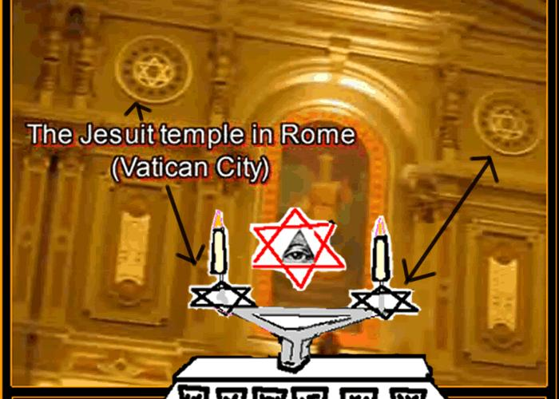
The seals afford us a preview of what is contained within the book in the Fathers Right Hand. We are told that the Antichrist's name is Death and Hell follows him.

Revelation 6:7-8 And when he had opened the fourth seal, I heard the voice of the fourth beast say, Come and see. And I looked, and behold a pale horse: and his name that sat on him was Death, and Hell followed with him. And power was given unto them over the fourth part of the earth, to kill with sword, and with hunger, and with death, and with the beasts of the earth.

Revelation 6:9-11 And when he had opened the fifth seal, I saw under the altar the souls of them that were slain for the word of God, and for the testimony which they held: And they cried with a loud voice, saying, How long, O Lord, holy and true, dost thou not judge and avenge our blood on them that dwell on the earth? And white robes were given unto every one of them; and it was said unto them, that they should rest yet for a little season, until their fellowservants also and their brethren, that should be killed as they were, should be fulfilled. 18

Revelation 12:11 And they overcame him by the blood of the Lamb, and by the word of their testimony; and they loved not their lives unto the death.

It is the Antichrist's desire to remove from the face of the earth everything that reminds him of the Creator and the impending doom awaiting him. He tries to sell himself as God to the Humans and as the Messiah to the Jews. The covenant he signs with the Jews is a thousand year covenant keeping up the appearance that he is fulfilling the thousand year millennial reign. His reign is only 42 months.

Daniel 11:21-22 And in his estate shall stand up a vile person, to whom they shall not give the honour of the kingdom: but he shall come in peaceably, and obtain the kingdom by flatteries. And with the arms of a flood shall they be overflown from before him, and shall be broken; yea, also the prince of the covenant.

Daniel 11:36 And the king shall do according to his will; and he shall exalt himself, and magnify himself above every god, and shall speak marvellous things against the God of gods, and shall prosper till the indignation be accomplished: for that that is determined shall be done.

The fallen angels under their leader Lucifer have each been assigned land on the earth that they have oversaw since the humans expanded their footprint. They inhabit and influence the humans controlling those they place in oversight. The wars you see on earth are a direct result of different fallen angel groups Waring with each other. Even as the spirit of God was placed within a human body and Lucifer will inhabit the Antichrist, the fallen angels will also inhabit humans and use their abilities to persuade the humans in their oversight that they are a god.
Matthew 24:24-27 For there shall arise false Christs, and false prophets, and shall shew great signs and wonders; insomuch that, if it were possible, they shall deceive the very elect. Behold, I have told you before. Wherefore if they shall say unto you, Behold, he is in the desert; go not forth: behold, he is in the secret chambers; believe it not. For as the lightning cometh out of the east, and shineth even unto the west; so shall also the coming of the Son of man be. 19
Refuge for the Church
There is a protected area for the Church on earth during the Tribulation. This refuge is located in Eastern America. America will be shutdown because of her christian influence over the past 400 years. While the world excommunicates America for the balance of the tribulation, the Creator holds other plans for Eastern America.

Revelation 12:6 And the woman fled into the wilderness, where she hath a place prepared of God, that they should feed her there a thousand two hundred and threescore days.

Revelation 12:14-17 And to the woman were given two wings of a great eagle, that she might fly into the wilderness, into her place, where she is nourished for a time, and times, and half a time, from the face of the serpent. And the serpent cast out of his mouth water as a flood after the woman, that he might cause her to be carried away of the flood. And the earth helped the woman, and the earth opened her mouth, and swallowed up the flood which the dragon cast out of his mouth. And the dragon was wroth with the woman, and went to make war with the remnant of her seed, which keep the commandments of God, and have the testimony of Jesus Christ.

What you were probably taught in Sunday school about the tribulation has no biblical foundation. Current teaching is rooted in fear, and projects objects for you to focus your fear on. To understand our time, you must first be aware that the 6000 year authority of man over creation has arrived at it's end. The fallen angels usurped mans authority and their ability to do this is coming to an end. God's judgment against the fallen angels takes place through the tribulation and is completed at the end of the tribulation. The Creator is protecting a small area on earth containing a remnant of His Church. This is what you see documented in the end of Revelation chapter 12. God will be conducting operations here on earth during this period of judgment against the fallen and those who affiliate themselves with them. The war between Satan and Michael has relocated from heaven to earth. At first the Devil and his angels loose in their attempt to conquer heaven and they are kicked out. Then the battle front is brought down to earth. This battle ends with the war of Armageddon in Jerusalem. The Creator has foreordained this 20
process and His documented Testimony provides us with a clear understanding of it.

Rebuilding the Temple

Before the Antichrist assumes his role as the False Messiah in that covenant with the Jews, the temple must be built. The Prophecy in Daniel indicates that the building process takes 434 days or 62 weeks. The Dome of the Rock must be destroyed for the temple to be rebuilt.

Daniel 9:24-25 Seventy weeks are determined upon thy people and upon thy holy city, to finish the transgression, and to make an end of sins, and to make reconciliation for iniquity, and to bring in everlasting righteousness, and to seal up the vision and prophecy, and to anoint the most Holy. Know therefore and understand, that from the going forth of the commandment to restore and to build Jerusalem unto the Messiah the Prince shall be seven weeks, and threescore and two weeks: the street shall be built again, and the wall, even in troublous times.

This building process is designed to construct a Temple where the Dome of the Rock currently exist for worship of the False Messiah. This temple will also be completely destroyed at the end of the Antichrist's reign. 62 weeks into the building process, the project is complete and the 70 Weeks of Daniel are interrupted by the Antichrist showing up to assume his role as false messiah. The balance of these 70 weeks occur after the Antichrist's reign, when he turns on the Jews to kill them.

Trump 6 World Unification Army
Prior to the temple building project the world must be unified into a One World Government system for the Antichrist to rule over. The Scripture affords the World Unification Army, 1 Day, 1 Month and 1 Year or (396 days) to accomplish this task.

Revelation 9:13-15 And the sixth angel sounded, and I heard a voice from the four horns of the golden altar which is before God, Saying to the sixth angel which had the trumpet, Loose the four angels which are bound in the great river Euphrates. And the four angels were loosed, 21
which were prepared for an hour, and a day, and a month, and a year, for to slay the third part of men.

Revelation 9:16-19 And the number of the army of the horsemen were two hundred thousand thousand: and I heard the number of them. And thus I saw the horses in the vision, and them that sat on them, having breastplates of fire, and of jacinth, and brimstone: and the heads of the horses were as the heads of lions; and out of their mouths issued fire and smoke and brimstone. By these three was the third part of men killed, by the fire, and by the smoke, and by the brimstone, which issued out of their mouths. For their power is in their mouth, and in their tails: for their tails were like unto serpents, and had heads, and with them they do hurt.

About 2 billion souls are killed by this army as they unify the world under one system of government. The earth is experiencing dramatic changes through seismic activity. This army had just been defeated in their conquest against Heaven and having their power greatly diminished, they make their final stand here on earth.

Trump 5 Bottomless Pit Opened
Before the world is unified by this army, Satan is released from within the earth. The key to the bottomless pit is sent down to earth to get the ball rolling and the Fifth Trumpet documents for us this activity.

Revelation 9:1-2 And the fifth angel sounded, and I saw a star fall from heaven unto the earth: and to him was given the key of the bottomless pit. And he opened the bottomless pit; and there arose a smoke out of the pit, as the smoke of a great furnace; and the sun and the air were darkened by reason of the smoke of the pit.

Revelation 17:8 The beast that thou sawest was, and is not; and shall ascend out of the bottomless pit, and go into perdition: ----

One might wonder just what Satan's plan might be upon his parole from the bottomless pit, but fortunately the Creator has told us what he is up to. Just before we find the devil making covenants and ruling for 42 months on 22 earth, we find the devil trying to expand his domain by attempting to conquer the Sides of the North in Heaven.

Revelation 12:7-9 And there was war in heaven: Michael and his angels fought against the dragon; and the dragon fought and his angels, And prevailed not; neither was their place found any more in heaven. And the great dragon was cast out, that old serpent, called the Devil, and Satan, which deceiveth the whole world: he was cast out into the earth, and his angels were cast out with him.

Revelation 12:12 Therefore rejoice, ye heavens, and ye that dwell in them. Woe to the inhabiters of the earth and of the sea! for the devil is come down unto you, having great wrath, because he knoweth that he hath but a short time.

So we find Satan loosing his attempt to rule over all of creation and he has now received a sentence limiting the time he has left to conduct his activities on earth. The earth-dwellers are warned that they would experience the wrath of the devil. We can now consider the occupation the devil leaves in place to occupy the earth while the devil is busy attempting his expansion plan. A supernatural plague of what the bible calls locusts but these flying demonic bodies are not permitted to attack the believers. They only can torture the unbelievers and since Mr. death is on vacation, men shall seek death and not be able to die. Yes those horror movies will come true for this time period.

Worldwide Nuclear War

This whole process we call the tribulation gets kicked off with a global nuclear war described in the first four trumps. As each of these first four trumpets sound, they mark the actions taking place on earth between the nations of the world and the fallen angels that control them. The humans will witness what has been traditionally called alien activity in the fallen angels.

Trump 1 (1/3 of Trees burnt up)

Revelation 8:7 The first angel sounded, and there followed hail and fire mingled with blood, and they were cast upon the earth: 23
and the third part of trees was burnt up, and all green grass was burnt up.

Trump 2 (1/3 of Ships, 1/3 of Fish, 1/3 sea water)

Revelation 8:8-9 And the second angel sounded, and as it were a great mountain burning with fire was cast into the sea: and the third part of the sea became blood; And the third part of the creatures which were in the sea, and had life, died; and the third part of the ships were destroyed.

Trump 3 (1/3 fresh water)

Revelation 8:10-11 And the third angel sounded, and there fell a great star from heaven, burning as it were a lamp, and it fell upon the third part of the rivers, and upon the fountains of waters; And the name of the star is called Wormwood: and the third part of the waters became wormwood; and many men died of the waters, because they were made bitter.

Trump 4 (Smoke from war hinders 1/3 of light)

Revelation 8:12 And the fourth angel sounded, and the third part of the sun was smitten, and the third part of the moon, and the third part of the stars; so as the third part of them was darkened, and the day shone not for a third part of it, and the night likewise.

Notice there is no element of time specified for the actions of these first four trumps. The wrath of men against each other through the world war may seem unimaginable, but the wrath of man has no comparison to the wrath of the devil on mankind.

The Sealing of the Saints

Revelation 7:1-3 And after these things I saw four angels standing on the four corners of the earth, holding the four winds of the earth, that the wind should not blow on the earth, nor on the sea, nor on any tree. And I saw another angel ascending from the east, having the seal of 24
the living God: and he cried with a loud voice to the four angels, to whom it was given to hurt the earth and the sea, Saying, Hurt not the earth, neither the sea, nor the trees, till we have sealed the servants of our God in their foreheads.

The love of God for His children is abundantly evident in this initial action taken before the Nuclear War ushers in the Tribulation. Every soul that the Holy Spirit dwells within at that moment will be sealed with the seal of God to protect them from the plague of the pit and to unify the home team.
I realize that there are also 144,000 Jews that are sealed in this action, but because the emphasis of the 144,000 has cloaked the majority of those that are sealed here; I thought it would be prudent to reverse the emphasis to unmask the millions of True believers that were also sealed in this event. John was a Jew and he naturally placed emphasis and delight on this number of Jews sealed, but all believers are sealed at this time.

Revelation 7:9 After this I beheld, and, lo, a great multitude, which no man could number, of all nations, and kindreds, and people, and tongues, stood before the throne, and before the Lamb, clothed with white robes, and palms in their hands;

Revelation 7:13-14 And one of the elders answered, saying unto me, What are these which are arrayed in white robes? and whence came they? And I said unto him, Sir, thou knowest. And he said to me, These are they which came out of great tribulation, and have washed their robes, and made them white in the blood of the Lamb.

The elders action was to correct John for neglecting the rest of those sealed while he only focused of those of his own nation. God will persevere for Himself a remnant of the natural stock of Israel while also sealing everyone else that has believed in Him.

Romans 8:11 But if the Spirit of him that raised up Jesus from the dead dwell in you, he that raised up Christ from the dead shall also quicken your mortal bodies by his Spirit that dwelleth in you.
25
The Seals

The Seals hold the Book in the Father's Right Hand closed concealing the secret contents describing how the story of creation shall come to completion. Remember this scenario takes place in-front of the Throne of God. As these seals are removed, John the Apostle is instructed to “come and see” or come and look down into the sea of glass before God's Throne, to witness what each seal represents within the closed book.

Seal 1
Revelation 6:1-2 And I saw when the Lamb opened one of the seals, and I heard, as it were the noise of thunder, one of the four beasts saying, Come and see. And I saw, and behold a white horse: and he that sat on him had a bow; and a crown was given unto him: and he went forth conquering, and to conquer.

Seal 2
Revelation 6:3-4 And when he had opened the second seal, I heard the second beast say, Come and see. And there went out another horse that was red: and power was given to him that sat thereon to take peace from the earth, and that they should kill one another: and there was given unto him a great sword.

As we consider these first two riders, we understand that they represent two world alliances that compete for world domination. We must conclude that these two alliances exist today and represent the Western and the Eastern ideologies. The fact that the rider on the red horse has the ability to remove peace from the earth confirms that these two riders fight each-other. The consequences of this world war in the end time, results in a unifying of the world order into a centralized government. The third seal reveals a preview of a unified world government employing a unified monetary system of control.

Seal 3
Revelation 6:5-6 And when he had opened the third seal, I heard the third beast say, Come and see. And I beheld, and lo a black horse; and he that sat on him had a pair of balances in his hand. 26
And I heard a voice in the midst of the four beasts say, A measure of wheat for a penny, and three measures of barley for a penny; and see thou hurt not the oil and the wine.

Seal 4
Revelation 6:7-8 And when he had opened the fourth seal, I heard the voice of the fourth beast say, Come and see. And I looked, and behold a pale horse: and his name that sat on him was Death, and Hell followed with him. And power was given unto them over the fourth part of the earth, to kill with sword, and with hunger, and with death, and with the beasts of the earth.

With a unified world government in place, the forth seal provides a preview of the Antichrist (Death) being followed by hell. We must be thankful to God that this evil tyrant only has 42 months to reign. The next seal reveals all of the dead Christians killed by the efforts of the Antichrist.

Seal 5
Revelation 6:9-11 And when he had opened the fifth seal, I saw under the altar the souls of them that were slain for the word of God, and for the testimony which they held: And they cried with a loud voice, saying, How long, O Lord, holy and true, dost thou not judge and avenge our blood on them that dwell on the earth? And white robes were given unto every one of them; and it was said unto them, that they should rest yet for a little season, until their fellowservants also and their brethren, that should be killed as they were, should be fulfilled.

Seal 6
Revelation 6:12-17 And I beheld when he had opened the sixth seal, and, lo, there was a great earthquake; and the sun became black as sackcloth of hair, and the moon became as blood; And the stars of heaven fell unto the earth, even as a fig tree casteth her untimely figs, when she is shaken of a mighty wind. And the heaven departed as a scroll when it is rolled together; and every mountain and island were moved out of their places. And the kings of the earth, and the great men, and the rich men, and the chief captains, and the mighty men, and every bondman, and every free man, hid themselves in the dens and in the rocks of the mountains; 27
And said to the mountains and rocks, Fall on us, and hide us from the face of him that sitteth on the throne, and from the wrath of the Lamb: For the great day of his wrath is come; and who shall be able to stand?

The sixth seal provides a preview of the very end of time when the wrath of God has arrived for the rebellious and the removal of the saints in preparation for the wrath of God that we will find contained in the bowls of God's wrath.

Seal 7
The seventh seal provides us with a preview of what happens just before the Tribulation gets under way. A span of ½ hour where the wind does not blow on earth and the believers are marked with the Seal of God in their foreheads. This seventh seal is a reminder to the Christians, that God has made preparations for his children.

Letters to 7 Churches

John was instructed to write letters to 7 churches in Asia informing them about the Creators critique of their performance and standing before their God. Almost like a carrot and stick approach, they are informed concerning their weaknesses and strengths and the reward or rebuke that awaits their outcome. It is understood that 7 identical letters were sent reflecting the document we now call the Revelation. Some have put forth that while these churches represented 7 actual churches of that era; that the churches might also represent 7 era's of time over the past 2000 years and that they might also represent 7 denominations of churches here with us today. A definitive or dogmatic position on the alternate points of view may be impossible to prove. It is possible that all three views may be valid.

Ephesus Revelation 2:1-6 ; …......I know thy works, and thy labour, and thy patience, and how thou canst not bear them which are evil: and thou hast tried them which say they are apostles, and are not, and hast found them liars: And hast borne, and hast patience, and for my name's sake hast laboured, and hast not fainted. Nevertheless I have somewhat against thee, because thou hast left thy first love. …... 28

Smyrna Revelation 2:8-11 .........I know thy works, and tribulation, and poverty, (but thou art rich) and I know the blasphemy of them which say they are Jews, and are not, but are the synagogue of Satan. ….... be thou faithful unto death, and I will give thee a crown of life. …..

Pergamos Revelation 2:12-16 ….... I know thy works, and where thou dwellest, even where Satan's seat is: …...But I have a few things against thee, because thou hast there them that hold the doctrine of Balaam, …..So hast thou also them that hold the doctrine of the Nicolaitans, which thing I hate. Repent; or else I will come unto thee quickly, and will fight against them with the sword of my mouth.

Thyatira Revelation 2:18-29 …..I know thy works, and charity, and service, and faith, and thy patience, and thy works; and the last to be more than the first. Notwithstanding I have a few things against thee, because thou sufferest that woman Jezebel, which calleth herself a prophetess, to teach and to seduce my servants to commit fornication, and to eat things sacrificed unto idols. …........ I will put upon you none other burden. But that which ye have already hold fast till I come. …....

Sardis Revelation 3:1-5 …..I know thy works, that thou hast a name that thou livest, and art dead. …..for I have not found thy works perfect before God........ If therefore thou shalt not watch, I will come on thee as a thief, and thou shalt not know what hour I will come upon thee. …....

Philadelphia Revelation 3:7-11 ….... I know thy works: ….. and hast kept my word, and hast not denied my name. …....Because thou hast kept the word of my patience, I also will keep thee from the hour of temptation, which shall come upon all the world, to try them that dwell upon the earth. ….......

Laodiceans Revelation 3:14-19 ….... I know thy works, that thou art neither cold nor hot: I would thou wert cold or hot. So then because thou art lukewarm, and neither cold nor hot, I will spue thee out of my mouth. …..

29
God's Master Plan

The “Master Plan” is documented in the Testimony of the Creator that we call the Holy Bible. Acceptance of the Word is essential in understanding His Plan. Careful analysis of the study of Biblical time reveals where we stand in His predefined process. We are currently at the end of the 6000 year rule of man over creation, and at the beginning of the Creators Millennial reign.
An overview of the Master Plan is as follows:

1) The Sealing of the Saints--All True Christians sealed and marked for Rapture.
2) Worldwide Nuclear War-1/3 trees burnt-1/3 fish killed -1/3 ships sunk-1/3 light
3) Bottomless Pit Opened- Ascension of beast from pit, 5 month plague (154 days)
4) World Unification Army-Army unifies world governments (396 days)
5) Rebuilding the Temple- 62 weeks of 70 weeks of Daniel (434 days)
6) Refuge for the Church- 1260 days remnant of Church protected from face of beast
7) Reign of the Antichrist- 1260 day (42 month) reign of Antichrist
8) The Two Witnesses- 1260 days coinciding with Antichrist reign
9) The Abomination of Desolation- End of Antichrist reign, turns on Jews (evacuate)
10) Judgment of the Whore- Rome (Babylon) destroyed
11) The Rapture of the Church- Last Trump - before Wrath - Sun goes out
12) The Wrath of God- End of accounting of Time
13) The Battle of Armageddon- Just outside Jerusalem between fallen angels and God
14) The Millennial Reign of Christ- Jesus rules with a rod for 1000 years
15) The Great White Throne Judgment- Second Death for all not in Book of Life 16) The Eternal State- New Heaven, New Earth, No Sin, New Jerusalem from Heaven

As we consider this Master Plan of God, we fail to acknowledged the details that enable all of this to take place. Embedded within the fallen angels abilities are God like qualities allowing them to defy elements of the physical realm. What the humans term aliens turn out to be the offspring of the fallen angels. They are unified in their opposition to Gods Master Plan, because they are condemned to eternal judgment that begins before the Millennial reign of Christ. They have shared their abilities with those who control this world. They inhabit their human hosts allowing to appear human. When the church is sealed by God, the True Believer will be more sensitive to detect these false operatives. When the pit is opened, the fallen will attack heaven and fail in their attempt to rule creation. Their supernatural abilities will then be attenuated, so that when they return to earth, they will experience limitations to their previous abilities.

30
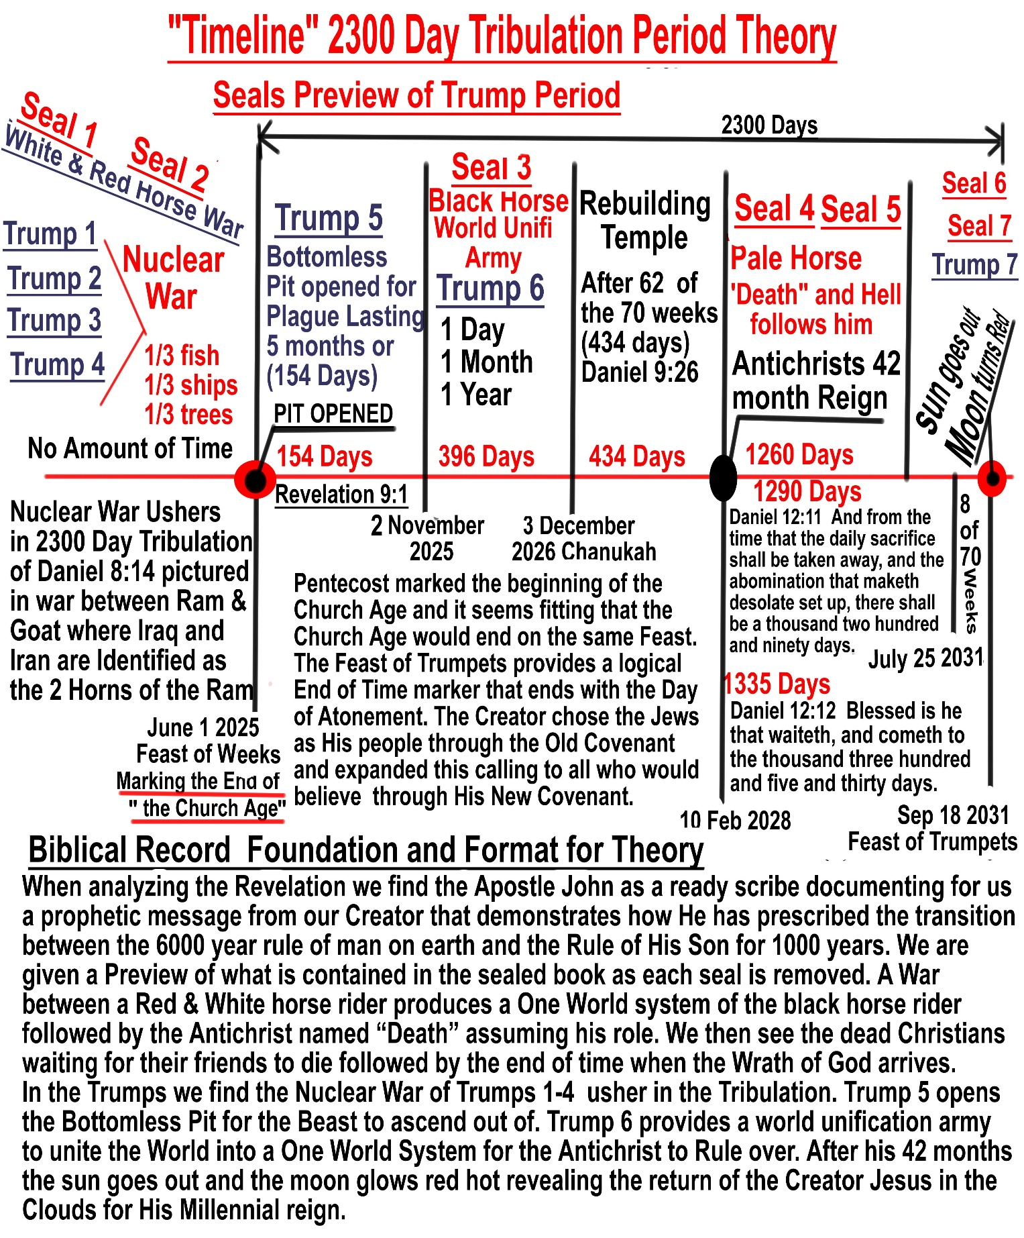


Defending Gabriel's Message to Daniel

In this work I will attempt to establish in the readers mind a view of Gods message to Daniel void of current teachings that distort your understanding as to how Daniels visions relate to the displacement of Time. I will also attempt to demonstrate through this writing, God's message to Daniel concerning His people Israel and how their heritage should perceive their future.

A simplistic overview of the last half of the book of Daniel is as follows: Daniel was used by God to explain for Nebuchadnezzar how he fit within the plans of God. You will remember he was the head of gold and other kingdoms would follow his kingdom of an inferior nature culminating with a final kingdom involving ten toes. God, having laid a foundation in Daniels mind of this master plan, sends the Angel Gabriel to Daniel to expound upon this final kingdom and how God would restore Israel to communion with Himself.

In Daniel chapters 7 and 8, God is giving visions directly to Daniel rather than using him to interpret for others God's message. The reason for this is because God had already determined to revoke the Old Covenant because of the constant rebellion of the nation Israel and implement the New Covenant with new requirements required for fellowship with Himself. At the moment of the writing of Daniel, God had taken away the Ark of the Covenant, taken away the Temple of the Covenant and removed Israel the Covenanted People from their Promised Land. In effect God had removed access from the Nation Israel too all of the implements required to conduct service under the Old Covenant. Israel had lost its ability to be forgiven for sin and to maintain covenant and communion with a Holy God.

In Daniel chapters 7 and 8 God sends Daniel 2 visions supplying him with two points of View of the Same time. These 2 visions start with a great war , identify a world government with an evil world Dictator and end with a world Judgment with the arrival of the Creator to rule earth.

35
Daniel was very upset and fasted and prayed and studied. While studying the writings of Jeremiah, he is scouring Jeremiah for answers and we see his discovery of the amount of time assigned for this punishment of Israel's captivity to be 70 years. (Jeremiah 29:10) Through deductive reasoning we understand
that Daniel had also discovered the change from the Old Covenant to the New Covenant. (Jeremiah 31:31) Daniels prayer in chapter 9 was fueled by Israel's forsaking of the Covenant of Moses and Jeremiah clearly condemns Israel for this in (Jeremiah 32:30-32).

As Daniel is praying the Angel Gabriel arrives to clarify Daniels understanding about these 2 visions and Gabriel while referring to these 2 visions comforts Daniel by telling Him about a subset of time contained in the second vision identified as 2300 days. This subset is of 490 days that we refer to as 70 weeks. As we review the purpose of the assigned actions for these 70 weeks , we discover that each item is a final act in an effort to reestablish communion between the Natural Stock of Israel and their Creator.

This is where we discover the foundation of a conspiracy in Daniel. A Jewish historian Flavius Josephus is the originator of this conspiracy. While trying to apply this prophetic book to his time of the first century, he attempted to propose a distortion of the biblical text that ascribed weeks of years to the term weeks. This would redefine 490 days to 490 years and ensnare theologians into a unbiblical quest to locate the beginning and ending of these weeks of years.

One distortion will eventually lead to another and so the Translators are ensnared it the Josephus conspiracy. To accommodate this theory a word in the text of the 70 weeks needed to be changed. The conspiracy attempted to apply 69 of the 70 weeks of years to identify the time from the return of Israel from Babylon and the rebuilding of the temple, to the coming of the Messiah leaving only one week of years to apply to the end time tribulation.

The problem is that where the Scripture Identifies the Covenant of the false messiah or Antichrist with the Jewish Nation, the Josephus 36 conspiracy identifies Jesus as the person identified. Language has developed as time goes on and words have been used to further identify changes in the development of society. In example: Electricity: comes from the Greek word electron. The definition of the word electron is Amber which is a yellow reddish-brown stone used in jewelry. When Amber was rubbed it developed an electrical charge allowing a feather to float above it through static electricity.

It would not be proper to call the electric company and say the amber is off and it is not proper to substitute the prime root of the word Covenant with its prime root “Cut Off”
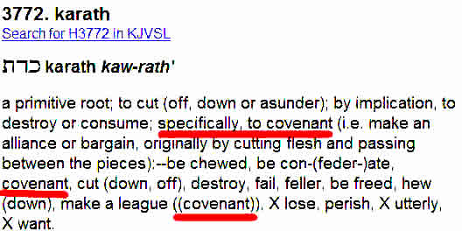
In Daniel 10:14 Gabriel again informs Daniel that the vision (singular) is for the latter days.

Daniel 10:14 Now I am come to make thee understand what shall befall thy people in the latter days: for yet the vision is for many days.

So Daniel is again fasting and praying to understand this disturbing vision of the end of time and the removal of the Jewish foundation of the Old Covenant and its replacement with this New Covenant. Daniel is then told that the Vision is many days in the future and applies to the Last Time. The Conspiracy applies itself again by ending the chapter here and starting a new chapter. Gabriel continues his meeting with Daniel without any pause of time and you can include chapter 12 to this final discussion. Daniel chapter 10,11 and 12 are to be reviewed as one conversation between the angel Gabriel and Daniel. In chapter 11 Gabriel adds more definition to Daniels understanding of these final 2300 days. Chapter 12 begins with the final event of the Rapture and then Daniel discovers some more issues of timing. 37
Keeping in mind that this discourse is a simple overview of the last half of Daniel, I wanted to address why Satan uses Josephus to distort the true meaning of the intended message of the last half of Daniel. If one is able to identify the arrival of the Antichrist in this text one might be able to discover the ultimate conspiracy in the presentation of a False Messiah as God. The Vatican wants to sell you their False religion and False Messiah and the Jews want you to accept their False Messiah as God. Remember the Jews rejected the True Messiah some 2000 years ago.

We will now take a closer look at each chapter of the last half of Daniel to substantiate the claim that the prophecy has been shrouded in Conspiracy. To faithfully accomplish this task we will need to drift back and forth from the book of Daniel to the book of Revelation proving these two passages are describing the same time period. Both of these passages describe the time just before the Creator Jesus returns to establish His millennial reign on earth.

Why a Millennial reign? 2 Peter 3:8 But, beloved, be not ignorant of this one thing, that one day is with the Lord as a thousand years, and a thousand years as one day. When God created man, and man fell through the temptation of sin; a countdown clock started metering out the balance of mans time to rule the earth. Genesis 1:26 And God said, Let us make man in our image, after our likeness: and let them have dominion !!!

To prove this heavenly edict, we must analyze the history of time to define how much time has passed between the fall of man and now. If you add up the Biblical account of time using the fathers age when he begat a son and then adding the age of that son when he begat a son we are able to account for the first 2500 years after the fall of man. We are then able to account for time using the rulers of Israel to arrive at a certain figure of 4000 years after the fall of man at the time of Jesus. When adding the 2000 years that have expired between then and now, we can understand that the 6000 years of mans dominion are quickly drawing to a close.

Chapter 7
To set up your understanding of when Daniel penned chapter 7, you will recall Daniel was removed from Israel as a youth during the reign 38
of king Nebuchadnezzar. Daniel obtained favor through the reign of Nebuchadnezzar and this continued for many years; however Daniel had lost favor with the reign of king Belshazzar. Daniel is no longer advising the rulers of the kingdom and God starts to give Daniel his own visions. There is a 2 year passage of time between Daniels night vision in the first year of Belshazzar (chapter 7) and the day vision in the third year of Belshazzar (chapter 8).

God loves Daniel and wants to share with him secrets leading up to the glorious rule of God over His Creation. Many of the Prophets speak of this time when God rules His Creation as “In That Day” looking forward to the Day when Christ Jesus sits on His Throne to Rule. We also find that God Loved the Apostle John and shared with him this very same secret description of that very same time. Because these two Biblical passages cover the same material, we will draw from both sources in our analysis.

Daniel 7:2-3 Daniel spake and said, I saw in my vision by night, and, behold, the Four Winds of the heaven strove upon the great sea. And four great beasts came up from the sea, diverse one from another.

Revelation 7:1 And after these things I saw four angels standing on the four corners of the earth, holding the Four Winds of the earth, that the wind should not blow on the earth, nor on the sea, nor on any tree.

As we enter our study of this chapter, we are made aware of an impending World War that will unite the world into one governmental system or a “One World Government”. All Angels are on deck as this final conquest between darkness and light prepares to enter the transition between the Dominion of Man and the Dominion of God. The term “The Four Winds” tells us that all the Angelic forces are poised for battle in this global and universal climax of Heavenly Authority over Creation.

Daniel 7:4-5 The first was like A Lion, and had Eagle's Wings: I beheld till the wings thereof were plucked, and it was lifted up from the earth, and made stand upon the feet as a man, and a man's heart was given to it. And behold another beast, a second, like to a Bear, and it raised up itself on one side, and it had three ribs in the mouth of it between the teeth of it: and they said thus unto it, Arise, Devour Much Flesh. 39
Revelation 6:2-4 And I saw, and behold a White Horse: and he that sat on him had a bow; and a crown was given unto him: and he went forth conquering, and to conquer. And when he had opened the second seal, I heard the second beast say, Come and see. And there went out another Horse that was Red: and power was given to him that sat thereon To Take Peace From the Earth, and that they should kill one another: and there was given unto him a great sword.

Both these passages reveal the same war between the Western forces and the Eastern forces that will culminate with one force for world dominion. This first beast of both these passages describe the Western NATO allied forces with a Lion of England and the Eagles Wings of America as the White Horse of Revelation. The second beast represents the communist Bear of Russia as the Red Horse in Revelation. Both of these passages identify the Communist Russian Bear or Red Horse as the instigator of this World War in the command to devour much flesh and take peace from the earth.

At this point we must understand the organizational method of prophetic works. God will send one vision and then complement that vision with a second representation of the same material from another view. Pharaoh received two dreams of the same bountiful harvest followed by a lack of harvest. In this same method, Daniel is given 2 visions of the same time, one vision incorporates the Eastern communist forces against the west, while the second vision incorporates the eastern allied Muslim forces of Persia or Iran with the Western Realm of Grecca.

We see the same method used by God when informing the Apostle John through the Preview of all that is contained within the sealed book represented in the removal of each seal. Remember John is told to come and see as he peered down into the sea of glass before the Throne of God to witness the effect of the removal of each seal. Remember the Sixth Seal previews for us what shall happen at the Last Trump in Revelation chapter 11:15 where the Wrath of God is administered upon the rebellious world.

Revelation 8:7-12 The First Angel --- and the third part of trees was burnt up, and all green grass was burnt up. And the Second Angel sounded, --- and the third part of the sea became blood; And the third part of the 40
creatures which were in the sea, and had life, died; and the third part of the ships were destroyed.

And the Third Angel sounded, --- and the third part of the waters became wormwood; and many men died of the waters, because they were made bitter. And the Fourth Angel sounded, and the third part of the sun was smitten, and the third part of the moon, and the third part of the stars; so as the third part of them was darkened, and the day shone not for a third part of it, and the night likewise.

The Preview of the World War in the first two seals is demonstrated within the first four Trumps where we find the killing of 1/3 of the marine life, the sinking of 1/3 of the ships, poisoning of 1/3 of the water and the burning of war darkens the atmosphere. In the 60s America developed Nuclear torpedoes for navel warfare and you can see how this can produce the sinking of 1/3 of the ships while killing 1/3 of the fish and poisoning 1/3 of the water.

Daniel 7:6 After this I beheld, and lo another, like a leopard, which had upon the back of it four wings of a fowl; the beast had also four heads; and Dominion was given to it.

Revelation 6:5-6 And when he had opened the third seal, I heard the third beast say, Come and see. And I beheld, and lo a Black Horse; and he that sat on him had

a Pair of Balances in his hand. And I heard a voice in the midst of the four beasts say, A measure of wheat for a penny, and three measures of barley for a penny; and see thou hurt not the oil and the wine.

Remember the first two beasts or horse riders conducted a World War and the aftermath of this war provides a single Authority with Dominion and power to levy world financial control.

Daniel 7:7-8 After this I saw in the night visions, and behold a Fourth Beast, dreadful and terrible, and strong exceedingly; and it had great iron teeth: it devoured and brake in pieces, and stamped the residue with the feet of it: and it was diverse from all the beasts that were before it; and it had ten horns. 41

I considered the horns, and, behold, there came up among them another Little Horn, before whom there were three of the first horns plucked up by the roots: and, behold, in this Horn were Eyes like the Eyes of Man, and a mouth speaking great things.

Revelation 6:7-8 And when he had opened the Fourth Seal, I heard the voice of the fourth beast say, Come and see. And I looked, and behold a Pale Horse: and His Name that sat on him was Death, and Hell followed with him. And power was given unto them over the fourth part of the earth, to kill with sword, and with hunger, and with death, and with the beasts of the earth.

The introduction of this personality called Death who Daniel is told to be a Little Horn with the eyes of man is the Antichrist and Hell follows Him. This world dictator will kill ¼ of the remaining humans on earth that survived the World Wide Nuclear War that ushered in this transitional tribulation period in this war between Darkness and Light. Revelation 13:5 informs us that this personality will rule for 42 months before being neutralized by the Creator.

Revelation 9:1 And the fifth angel sounded, and I saw a star fall from heaven unto the earth: and to him was given the key of the bottomless pit.

Revelation 11:7 And when they shall have finished their testimony, the Beast that Ascendeth Out of the Bottomless Pit shall make war against them, and shall overcome them, and kill them.

In Revelation chapter 6 we have the preview of this nefarious character named death and as the fifth Angel sounds the Fifth Trumpet, we find the Bottomless Pit being opened and we discover in Revelation 11:7 just what has been locked up in the Pit. Remember the Devil was kicked out of Heaven after causing the Woman to eat of the forbidden fruit and thus altering the relationship the Creator had with His Created. Over the past two thousand years and most notably the past two hundred years, the fallen angels have enabled and harnessed humanity to develop a vast assortment of technology designed for the satanic assault on the Sides of the North and the Heavenly Throne of God. The release of their Champion from the Bottomless Pit is the only obstacle delaying their attack.
42
Revelation 12:7-9 And there was war in heaven: Michael and his angels fought against the dragon; and the dragon fought and his angels, And prevailed not; neither was their place found any more in heaven. And the great dragon was cast out, that old serpent, called the Devil, and Satan, which deceiveth the whole world: he was cast out into the earth, and his angels were cast out with him.

Revelation 12:12 Therefore rejoice, ye heavens, and ye that dwell in them. Woe to the inhabiters of the earth and of the sea! for the devil is come down unto you, Having Great Wrath, because he knoweth that He Hath But A Short Time.

After the failed coup for the Heavenly Throne of God the defeated fallen angel forces return to earth knowing that they have a very limited time to conduct their World Government over-site. It would be prudent to identify three sources of end time wrath at this point. Remember the World Wide Nuclear War that ushered in this Tribulation Period? That was the Wrath of the dominion of Man. Now we are told that the Devil has a short time to display to the world his Great Wrath. We will discover that at the Last Trump, God will begin to display His Great Wrath through the Vials of Revelation 15.

Daniel 7:21 I beheld, and the same horn made war with the saints, and prevailed against them;

Daniel 7:25 And he shall speak great words against the most High, and shall Wear Out the Saints of the Most High, and think to change times and laws: and they shall be given into his hand until a time and times and the dividing of time. (3 ½ Years)

Revelation 6:9-10 And when he had opened the fifth seal, I saw under the altar the souls of them that were slain for the word of God, and for the testimony which they held: And they cried with a loud voice, saying, How long, O Lord, holy and true, dost thou not judge and avenge our blood on them that dwell on the earth?

The same story told in the same order to two men greatly favored by God who lived hundreds of years apart and thousands of years in our History, and yet we see the manifestation of God's hand bringing to pass 43
all that He has ordained by His Own Word.

Daniel 7:18 But the saints of the most High shall take the kingdom, and possess the kingdom for ever, even for ever and ever.

Daniel 7:22 Until the Ancient of days came, and judgment was given to the saints of the most High; and the time came that the saints possessed the kingdom.

Zechariah 2:11 And many nations shall be joined to the LORD in that day, and shall be my people: and I will dwell in the midst of thee, and thou shalt know that the LORD of hosts hath sent me unto thee.

Chapter 8
Here we find Daniel receives a Day Vision to compliment his first Night Vision about 2 years following the first vision. Daniel was a man of prayer and having received secret information about the leading up to the end of time, he was greatly troubled and concerned for his people Israel and their position with God.

Daniel 8:3-4 Then I lifted up mine eyes, and saw, and, behold, there stood before the river a Ram which had Two Horns: and the two horns were high; but one was higher than the other, and the higher came up last. I saw the ram pushing westward, and northward, and southward; so that no beasts might stand before him, neither was there any that could deliver out of his hand; but he did according to his will, and became great.

Here we find a description of a Ram with 2 horns and one is larger and came up last. We are told later in the text that the rams 2 horns represent Iraq for the smaller horn and Iran for the larger horn which signifies the War with Iran will be larger and follow the first war with Iraq. Daniel is told that the horns represent Media and Persia, I only represented them as our modern country's for effect. Notice this ram represents Kingdoms of the east because that is the only direction they do not push in for they resides there in the east.

Daniel 8:5-7 And as I was considering, behold, an He Goat came from the West on the Face of the Whole Earth, and Touched Not the Ground: 44
and the goat had a notable horn between his eyes. And he came to the ram that had two horns, which I had seen standing before the river, and ran unto him in the fury of his power. And I saw him come close unto the ram, and he was moved with choler against him, and Smote the Ram, and brake his two horns: and there was no power in the ram to stand before him, but he cast him down to the ground, and stamped upon him: and there was none that could deliver the ram out of his hand.

We are told later in the text that this He Goat is the Western realm of Grecca or the descendants of Greece. During the western expansion, Grecco Roman migration after reaching the western shores of Europe, discovered the new land we now call America. It would be hard to identify the land of America some twenty five hundred years ago except by their heritage and that's what we see here. Notice that this He Goat comes on the face of the whole earth and does not touch the ground. Here we find this vision starting with a world wide war between principle players that we see currently manifested before us in modern times. We can logically deduct from this text that the American / NATO air campaign is successful and if it were possible to declare a victor of a war in advance, this might be that occasion; how can anyone be a victor in a war of such magnitude?

Daniel 8:8-12 Therefore the He Goat waxed very great: and when he was strong, the great horn was broken; and for it came up four notable ones toward the four winds of heaven. And out of one of them came forth a Little Horn, which waxed exceeding great, toward the South, and toward the East, and toward the pleasant land. And it waxed great, even to the host of heaven; and it cast down some of the host and of the stars to the ground, and stamped upon them. Yea, he magnified himself even to the prince of the host, and by him the daily sacrifice was taken away, and the place of his sanctuary was cast down. And an host was given him against the daily sacrifice by reason of transgression, and it cast down the truth to the ground; and it practised, and prospered.

As we saw in the previous vision, this World War culminates with the One World Dictator we know as the Antichrist. What is not obvious is that the Nuclear War conducted by the He Goat ends with EMP warfare and the removal of the electronic society. So when it states the Great Horn was broken, this is the implementation of that world superpower poised for 45 complete world domination being sidelined. This is that Lion of England with American Eagles Wings being plucked off the Lion and no longer able to influence world affairs. It was necessary to shut down the global electric grid while the fallen angels depart for their heavenly conquest attempt. When they return the Lion of England with the eyes of man will assume authoritative position for the Northern Kingdom.

How perplexing to receive assurance that your nation would be restored to the promised land, that the temple would be rebuilt and that offerings would be given, and then to receive knowledge that the sacrifices would be stopped and the sanctuary would be cast down. I am sure Daniel was beside himself as he discovered this from the angelic source.

Daniel 8:13-14 Then I heard one saint speaking, and another saint said unto that certain saint which spake, How long shall be the vision concerning the daily sacrifice, and the transgression of desolation, to give both the sanctuary and the host to be trodden under foot? And he said unto me, Unto Two Thousand and Three Hundred Days; then shall the sanctuary be cleansed.

The Meat of the prophecy starts with figures and numbers that can account for time displacement and validate our understanding of how all this must transpire. The question has been asked as to the “length of the Vision” that involves the Abomination of Desolation or transgression of desolation. The total length of this vision shall be the amount of time of 2300 days. We must at this point associate these 2 visions together as one general vision with 2 viewpoints and we must emphasize the definitive time allotted for this Prophetic event.

Daniel 8:16-17 And I heard a man's voice between the banks of Ulai, which called, and said, Gabriel, make this man to understand the vision. So he came near where I stood: and when he came, I was afraid, and fell upon my face: but he said unto me, Understand, O son of man: for at the Time of the End shall be the vision.

God tells Gabriel to assist Daniel in understanding the Vision using the singular sense meaning that these two visions are one account of the same event. We are also informed by the angel that the event would take place at the “Time of the End”. 46
Daniel 8:26 And the Vision of the Evening and the Morning which was told is true: wherefore shut thou up the vision; for it shall be for many days.

Again both visions are associated together and the assertion that the events are far in the future as we see in the description of “it shall be for many days”. The same source, the Angel Gabriel and the same message, that a singular vision, given in two parts, separated by 2 years of Daniels life that would take place at the End of Time, solidifies our understanding of this material.

Daniel 9:23 At the beginning of thy supplications the commandment came forth, and I am come to shew thee; for thou art greatly beloved: therefore understand the matter, and Consider the Vision.

Gabriel returns during the first year of the rule of Darius to expand Daniels knowledge of this End of Time Sanctuary desecration or the Abomination of Desolation and he tells Daniel to understand the matter by considering this two part vision of the Time of the End.

At this point Gabriel adds more texture to the vision by identifying a subset of the previous figure of 2300 days that we were told would be the total length of time required to fulfill the events associated. This subset of time is denoted as 70 weeks or 490 days of the 2300 days.

Daniel 10:14 Now I am come to make thee understand what shall befall thy people in the latter days: for yet the vision is for many days.

Gabriel again returns during the first year of the reign of Cyrus to complete Daniels training on this End of Time Vision and again Gabriel identifies this two part vision as one singular vision that would happen in the latter days.

Chapter 9
Through the last half of Daniel we find an account of the Four times the Angel Gabriel was sent by God to embed within Daniel the knowledge of what shall happen to his people concerning the replacement of the Jewish Law of Moses through the termination of the Old Covenant and the restoration of the Jewish people to their God through these 70 weeks. 47
We find Daniel in this chapter studding the writings of Jeremiah. Daniel mentions the rebellion of his people and pleads to God for mercy and forgiveness. We understand that Daniel understood that God had decided to revoke the Old Covenant and redefine the method required for the Jewish people to commune with their Creator through this New Covenant.

Daniel 9:23-25 At the beginning of thy supplications the commandment came forth, and I am come to shew thee; for thou art greatly beloved: therefore understand the matter, and consider the vision. Seventy weeks are determined upon thy people and upon thy holy city, to finish the transgression, and to make an end of sins, and to make reconciliation for iniquity, and to bring in everlasting righteousness, and to seal up the vision and prophecy, and to anoint the most Holy. Know therefore and understand, that from the going forth of the commandment to restore and to build Jerusalem unto the Messiah the Prince shall be seven weeks, and threescore and two weeks: the street shall be built again, and the wall, even in troublous times.

Again Daniel is instructed to consider the vision when accounting for these 70 weeks. This is what shall befall thy people in the last days or the Time of the End. Notice the actions of these 70 weeks complete the forgiveness process and unify the Jewish people back to their Creator. Through the deceptive conspiracy introduced by Josephus, many biblical scholars have been found wasting their life chasing their tail to assign a starting and ending point to these 70 weeks.

To identify all the subsets of the 2300 days we must incorporate the parallel passages in the Revelation. You will recall that all the prophetic texts show that a world war ushers in the starting point of this 2300 day End Time prophecy. We also showed that the seals on the book in Revelation demonstrate a Preview of the contents of the Book. As we see the actual events transpire within the book after the final seal is removed; we discover that the first four trumps depict the carnage associated with this world wide war. There is no time given or associated with these first four Trumpet soundings and therefor we can conclude that they happen together and quickly. When a King would attend an event or arrive at a city, a succession of trumpets would announce their arrival. How fitting that the Creator uses 7 Trumpets to announce His Return. 48
Revelation 9:1 And The fifth angel sounded, and I saw a star fall from heaven unto the earth: and to him was given the Key of the Bottomless Pit.

Revelation 9:3 And there came out of the smoke locusts upon the earth: and unto them was given power, as the scorpions of the earth have power.

Revelation 9:10 And they had tails like unto scorpions, and there were stings in their tails: and their power was to hurt men Five Months.

Here we find the first mention of time in Revelations 5th Trump account and it is associated with this plague of the Bottomless Pit. We are told that this plague lasts for 5 months and we will apply 154 days to this event.

Revelation 9:13-15 And The Sixth Angel Sounded, and I heard a voice from the four horns of the golden altar which is before God, Saying to the sixth angel which
had the trumpet, Loose the four angels which are bound in the great river Euphrates. And the four angels were loosed, which were prepared for an Hour, and a Day, and a Month, and a Year, for to slay the third part of men.

The second amount of time is associated with the 6th Trumpet Sounding with an army that is allotted 1 day 1 month and 1 year to accomplish their task of world unification. A day a month and a year total 396 days as another subset of time contained within the 2300 days.

Revelation 13:4-5 And they worshipped the dragon which gave power unto the beast: and they worshipped the beast, saying, Who is like unto the beast? who is able to make war with him? And there was given unto him a mouth speaking great things and blasphemies; and power was given unto him to continue Forty and Two Months.

So here we find the final subset of the 2300 days in the 42 month reign of the Antichrist. As we tabulate our figures , seventy weeks = 490 days + 154 Days + 396 days +1260 days we discover the exact figure we are trying to populate. For those who are full of pride and don't care what this cross referenced validation of the true intent of the 70 weeks mean; there is no remedy for their ignorance because their financial and scholarly position requires they maintain the traditions of their elders, the tradition of 49
their religion, the tradition of this conspiracy.

Daniel 9:26 And after Threescore and Two Weeks shall Messiah be Cut Off, but not for himself: and the people of the prince that shall come shall destroy the city and the sanctuary; and the end thereof shall be with a flood, and unto the end of the war desolations are determined.

Notice it says after three score and two weeks and not three score and nine weeks proving that the conspiratorial deception of a final 70th week of Daniel is a delusion required to adapt this text to their erroneous concept set forth by Josephus's incorrect application of Gabriel's instructions to Daniel. It seems that this teaching of a seventieth week of Daniel is like a holy grail that must be protected at all costs, no matter what the scripture says. There are dark forces opposing any who would attempt to discredit such a distortion as we find here in Daniel. This verse declares a Covenant between the Jews who have just finished the end time temple and are waiting for the arrival of their False Messiah.

As we stated previously, this error in the translator is another deceptive distortion that allows the reader and the scholar to incorrectly ascribe this prophetic value of 70 weeks to the distortion that applies weeks of years to
the assigned figure of weeks. The correct interpretation of this area of scripture indicated that after the completion of the temple which used 62 of the 70 weeks; the Antichrist steps into his position through a Covenant made with the nation Israel. So the Antichrist has 42 months to reign and we would expect to find the balance of these 70 weeks at the end of his 1260 days. We know that the Antichrist turns on the Jews at the end of his reign and that is when he commits the Abomination of Desolation to desecrate the newly built temple that the Jews have been using for worship of their false messiah.

Revelation 11:7-8 And when they shall have finished their testimony, the beast that ascendeth out of the bottomless pit shall make war against them, and shall overcome them, and kill them. And their dead bodies shall lie in the street of the great city, which spiritually is called Sodom and Egypt, where also our Lord was crucified.
50
Revelation 11:11 And after three days and an half the Spirit of life from God entered into them, and they stood upon their feet; and great fear fell upon them which saw them.

This event takes place at the end of the Antichrist's 42 month reign and this also ends the 42 months given to these 2 witnesses to oppose the reign of the Antichrist. Their 42 month ministry coincides with the 42 month reign of the Antichrist. So the Antichrist finally kills these 2 supernatural witnesses of God and they come back to life causing the Jews to realize that their new false messiah is an impostor because he could not keep these two dead. The Jews loose faith in the Antichrist and he turns on them causing them to flee to the Jordan mountains. That is why the Antichrist commits the Abomination of Desolation.

Daniel 12:11-12 And from the time that the daily sacrifice shall be taken away, and the abomination that maketh desolate set up, there shall be a thousand two hundred and ninety days. Blessed is he that waiteth, and cometh to the thousand three hundred and five and thirty days.

We find evidence of the balance of the 70 weeks here at the end of Daniel chapter 12. Daniel was a diligent investigator and Prophet as he pried out of Gabriel this final figure allowing us to see the complete picture of the 70 weeks.

Chapter 10, 11 & 12

Chapters 10, 11 and 12 record the final visit of Gabriel to Daniel with an expansion on the details surrounding what shall befall thy people in the end of time. This expansion of knowledge incorporates political or world governmental authority within the 2300 day period defined in the vision Daniel received in chapters 7 and 8. To constrict all the activity contained within chapter 11 into a period of 2300 days is a feet similar to pulling a camel through the eye of a needle; we will allow the Creator to lead us through the task.
51
Daniel 10:1 In the third year of Cyrus king of Persia a thing was revealed unto Daniel, whose name was called Belteshazzar; and the thing was true, but the time appointed was long: and he understood the thing, and had understanding of the vision.

Daniel is an old man at this time when Gabriel brings this final installment of secret knowledge. The description that the time appointed was long indicates that the actions would not occur for a very long time.

Daniel 10:14 Now I am come to make thee understand what shall befall thy people in the latter days: for yet the vision is for many days.

Again we are to understand that this material is also connected to the previous vision with a purpose to add more details concerning the final world government before the Creator would take control over His Creation.

Daniel 10:20-21 Then said he, Knowest thou wherefore I come unto thee? and now will I return to fight with the prince of Persia: and when I am gone forth, lo, the prince of Grecia shall come. But I will shew thee that which is noted in the scripture of truth: and there is none that holdeth with me in these things, but Michael your prince.

The last verse in Daniel chapter 10 informs us that Daniel is about to receive information contained within the Scripture of Truth indicating a foreordained plan or secret plan that only Michael and this instructor are aware of. Notice that these Angels are at war with the fallen angels to constrain their progress. God often uses competing worldly forces to fight and constrain the world into Gods predefined plan, and here we see that the Angel is aware that Greek forces would soon enter the battle with Persia giving Alexander the great a pathway east.
The definition “prince” of Persia or prince of the Greek nation are not necessarily identifying a person, but rather the Fallen Angel in control of that country.

Daniel 11:1-2 Also I in the first year of Darius the Mede, even I, stood to confirm and to strengthen him. And now will I shew thee the truth. Behold, there shall stand up yet three kings in Persia; and the fourth shall be far richer than they all: and by his strength through his riches he shall stir up all against the realm of Grecia. 52
Gabriel tells Daniel that it was he who God used to setup Darius over Babylon and remember king Darius and Daniel were good friends. King Darius had reinstalled Daniel to a place of Honor as the principal overseer to kingdom affairs. You will recall this made his adversary's trick the king into a law that would place Daniel in the lions den.

Daniel 11:2 And now will I shew thee the truth. Behold, there shall stand up yet three kings in Persia; and the fourth shall be far richer than they all: and by his strength through his riches he shall stir up all against the realm of Grecia.

We are told of a fourth Persian king who shall stir up all against the realm of Grecia. This Iranian leader is uniting the Muslim and Communist world against the Western Kingdom. Even Turkey, a NATO power is about to join the Iranian assault on Israel. Notice that the Nation Israel is the center of this end time prophecy.

Daniel 11:3-4 And a mighty king shall stand up, that shall rule with great dominion, and do according to his will. And when he shall stand up, his kingdom shall be broken, and shall be divided toward the four winds of heaven; and not to his posterity, nor according to his dominion which he ruled: for his kingdom shall be plucked up, even for others beside those.

Who is like unto America in power as the last superpower before the great WW3, we can see why Iran must stir up all against us for it is the only chance they have at a fair fight. So America Stands up with NATO or that part of NATO that still sides with the west.(Remembering Chapter 8)

A He Goat came from the West on the Face of the Whole Earth, and Touched Not the Ground: Smote the Ram, and brake his two horns: The He Goat waxed very great: and when he was strong, the great horn was broken; and for it came up four notable ones toward the Four Winds of Heaven.

Daniel 7:4-5 The first was like A Lion, and had Eagle's Wings: I beheld till the Wings thereof were Plucked, and it was lifted up from the earth, and made stand upon the feet as a man, and a man's heart was given to it.

Revelation 7:1 And after these things I saw Four Angels standing on the Four Corners of the Earth, holding the Four Winds of the earth, that the wind should not blow on the earth, nor on the sea, nor on any tree. 53
As Gabriel begins his description of this final time, he is drawing from the vision he had previously given Daniel to strengthen Daniels understanding that all this information is of the same time that precedes the Creators return to set things in Heavenly order void of the influences of the fallen angels. Notice how Gabriel uses the same terminology to identify the players as he tells Daniel that the Kingdom is Plucked Up and Broken while still incorporating the Four Winds of Heaven indicating this is the beginning of what we know as the tribulation period. Again this point in time is associated with a World War between the West and the East incorporating the Four Winds meaning all Angels are on Deck and prepared for the Battle between Light and Darkness.

It is very easy to get lost in the weeds as we attempt to keep track of the accounting of time because Gabriel adds an overview of actions incurred by principal players that transpired throughout the whole 2300 days and then he begins to address another principal player. It is as if I am telling you about a car I bought 10 years ago and I tell the entire history of my ownership to the mechanic so he can diagnose a noise I am currently experiencing. All the added information makes it harder for us to identify the passage of time.

We have identified a known quantity in associating the prophecy with a predefined length of time of 2300 days set forth by Gabriel in Daniel 8:14. We have also identified the same starting players identified with the same descriptive adjectives used to identify them. As we conduct our autopsy of this passage we must apply forensic reasoning to assimilate it's correct application to our study. First we will identify the principal players that exist after the aftermath of the world wide war that ushers in this end time period. Then we will evaluate how their position assimilates within our time envelope.

Daniel 11:5-6 And The King of the South shall be strong, and one of his princes; and he shall be strong above him, and have dominion; his dominion shall be a great dominion. And in the end of years they shall join themselves together; for the king's daughter of the south shall come to the king of the north to make an agreement: but she shall not retain the power of the arm; neither shall he stand, nor his arm: but she shall be given up, and they 54
that brought her, and he that begat her, and he that strengthened her in these times.

Principal Player # 1 – the Prince of the King of the South who usurps the authority of the King of the South and it appears these players remain static through the 2300 days. Also note that there is war between the northern and southern kingdoms for a lot of the 2300 day period, however we are told that at the very end they are drawn together by marriage and we will find both these kingdoms acting together when they both turn on the Antichrist at the end of his 42 month reign.

Daniel 11:13 For the King of the North shall return, and shall set forth a multitude greater than the former, and shall certainly come after certain years with a great army and with much riches.

Principal Player # 2 – King of the North #1 who shall remain a constant until just before the Antichrist assumes that position We also know the Antichrists duration to be 42 months. This king seem to be in constant war with the king of the south.

Daniel 11:20 Then shall stand up in his estate a raiser of taxes in the glory of the kingdom: but within few days he shall be destroyed, neither in anger, nor in battle.

Principal Player # 3 – This occupier of the Position of the King of the North# 2 only lasts a few days after the first king of the north has passed away, but he is still holding a principal position and therefore must be accounted for him.

Daniel 11:21-23 And In His Estate shall stand up a Vile Person, to whom they shall not give the honour of the kingdom: but he shall come in peaceably, and obtain the kingdom by flatteries. And with the arms of a flood shall they be overflown from before him, and shall be broken; yea, also The Prince of the Covenant. And after the League made with Him he shall work deceitfully: for he shall come up, and shall become strong with a small people.

Principal Player # 4 – King of the North #3 The Vile Person here we find the Antichrist assuming the role of King of the North, notice he makes a League or Covenant making him the Prince of the Covenant. Soon after He will unify the world under his control but we know he only has 42 months to reign. 55
This new position will allow for another person to assume the role of King of the North because we find both the king of the south and north turning against the Antichrist at the end.

Daniel 11:40 And at the time of the end shall the king of the south push at him: and the king of the north shall come against him like a whirlwind, with chariots, and with horsemen, and with many ships; and he shall enter into the countries, and shall overflow and pass over.

Daniel 11:28 Then shall he return into his land with great riches; and his heart shall be against the holy covenant; and he shall do exploits, and return to his own land.

Daniel 11:31 And arms shall stand on his part, and they shall pollute the sanctuary of strength, and shall take away the daily sacrifice, and they shall place the abomination that maketh desolate.

Daniel 11:37 Neither shall he regard the God of his fathers, nor the desire of women, nor regard any god: for he shall magnify himself above all.

It is important to note that the Antichrist only gets 42 months and during his reign he has a covenant with the Jews to conduct worship at the newly built temple. At the end of the 42 months he turns on the Jews and desecrates the temple.

Through this passage we find a constant of 3 men who inhabit the same position as king of the north with the second lasting only a few days and the last given 1260 days or there bouts. We can therefor conclude that the first king of the north occupies his position of authority for roughly 3 years and we might also conclude that king to be the king of England. We deduce that specific from the Lion of England having the Eagles Wings Plucked off, and standing up as the ruler of the Northern kingdom for the first 3 years of the tribulation. There seems to be a constant war going on for these first 3 years between the northern and southern kingdom. As the Antichrist's reign draws to a close the warfare seems to increase again. We must also understand that during this final 42 months of the reign of the Antichrist, those Two Witnesses sent from God are pouring out Plague and Natural disasters everywhere. 56
Daniel 11:32-35 And such as do wickedly against the covenant shall he corrupt by flatteries: but the people that do know their God shall be strong, and do exploits. And they that understand among the people shall instruct many: yet they shall fall by the sword, and by flame, by captivity, and by spoil, many days. Now when they shall fall, they shall be holpen with a little help: but many shall cleave to them with flatteries. And some of them of understanding shall fall, to try them, and to purge, and to make them white, even to the time of the end: because it is yet for a time appointed.

Revelation 12:11 And they overcame him by the blood of the Lamb, and by the word of their testimony; and they loved not their lives unto the death.

How long O Lord? We see a similar picture in the account of John where the people who know their God are found sacrificing their lives for His Name. In America we have been sheltered from this type of persecution through our law system that affords every soul room to live.

Revelation 6:10-11 And they cried with a loud voice, saying, How long, O Lord, holy and true, dost thou not judge and avenge our blood on them that dwell on the earth? And white robes were given unto every one of them; and it was said unto them, that they should rest yet for a little season, until their fellowservants also and their brethren, that should be killed as they were, should be fulfilled.

Daniel 12:1-2 And At That Time shall Michael Stand Up, the great prince which standeth for the children of thy people: and there shall be a time of trouble, such as never was since there was a nation even to that same time: and at that time thy people shall be delivered, every one that shall be found written in the book. And many of them that sleep in the dust of the earth shall awake, some to everlasting life, and some to shame and everlasting contempt.

We find at the end of the Antichrist reign, a time of trouble such as never was, the Creator Stands Up from His seated position next to the Father in Heaven to rescue His Heritage and restore His creation for His 1000 year Rule. The Last Trumpet of the seven trumps records for us when the struggle between the children of Light and the children of Darkness shall conclude. Both Daniel and John record for us the same story of how a merciful Creator shall redeem His faithful. 57

1 Corinthians 15:52 In a moment, in the twinkling of an eye, at the Last Trump: for the trumpet shall sound, and the dead shall be raised incorruptible, and we shall be changed.

Revelation 11:18 And the nations were angry, and thy wrath is come, and the time of the dead, that they should be judged, and that thou shouldest give reward unto thy servants the prophets, and to the saints, and them that fear thy name, small and great; and shouldest destroy them which destroy the earth.

Revelation 10:6-7 And sware by him that liveth for ever and ever, who created heaven, and the things that therein are, and the earth, and the things that therein are, and the sea, and the things which are therein, that there should be Time No Longer: But in the days of the voice of the Seventh Angel, When He Shall Begin to Sound, the mystery of God should be finished, as he hath declared to his servants the prophets.

58

Weed Control

As I said in the intro to this section of Scripture, it is easy to get bogged down in the abundance of information in this chapter and therefor we must rely on things we know will remain constant and such as the total length of the vision, and through deductive reasoning we can forensically evaluate the information we do have and theorize the few elements that are not so evident. After these prophecy's are thousands of years old and we are but human tools available for the Masters use. I am only presenting what I believe the Creator has whispered in my ear concerning His secrets and the revelation He has made to His Prophets.

Note: It appears that the capitol of the Southern Kingdom is Egypt Daniel 11:8 And shall also carry captives into Egypt their gods, with their princes, and with their precious vessels of silver and of gold; and he shall continue more years than the king of the north.
Note: Branch of her roots indicates a relative of hers but does not denote passage of time.

Daniel 11:7 But out of a branch of her roots shall one stand up in his estate, which shall come with an army, and shall enter into the fortress of the king of the north, and shall deal against them, and shall prevail:

Flavius Josephus the conspirator: This historical figure was a Jewish general connected with temple worship duties who defected to the Roman army while the soon to be Roman Emperor Vespasian was confronting the Jews. Josephus by his own account assisted Vespasian and his son Titus in the destruction of Jerusalem and the Death of many Jews. His own writings condemn him in his traitorous actions and he attempts to explain why he was not guilty of their deaths. This man was a instrument of Rome, and though his writings persevere for our day many details from Jewish and Roman antiquity, he was not a Christian, he was not a faithful Jew and His deceptive analogy in applying the prophecy of Daniel to his time has distorted the true meaning of the Message Gabriel was sent to deliver to Daniel and the Jewish Heritage. This writing is in Opposition to that view and in defense of Gods True intent to establish His Chosen People of Israel a hope in their Creator that will endure forever. 59
Analysis of Ezekiel 34-48
In the defense of a Pre-Millinniel Earthly Future

The Creator shares with Ezekiel the same basic story that was given to Daniel and the Revelation written by the Apostle John. The end of Ezekiel's prophecy describes the Kingdom of God in the millennial reign . We are told of a river coming from the Throne of God that heals everywhere it flows. The need for life restoring healing proclaims the end of the battle of Armageddon and a ruined earth that requires healing.
Prior to the millennial reign we have the Resurrection of the dead where Ezekiel describes the flesh growing back on old bones. Can these Bones Live? The Church was in-grafted to the Jewish nation at the roots where branches were cut off of the natural stock “Israel”. We therefore conclude their inclusion in this image of the restoration of life after death described by Ezekiel.

Ezekiel 39:13 Yea, all the people of the land shall bury them; and it shall be to them a renown the day that I shall be glorified, saith the Lord GOD.

In Chapter 34 we find God telling us through Ezekiel, how God will judge the unprofitable shepherds and replace them with His Son David as their Shepard. The prophecy continues through Chapter 39 where we find the battle of Armageddon when God draws the World into a war with Himself over the land of Israel. We are told that God does not do this for the Nation of Israel, but for His Names sake. Through this passage we are constantly told of a Day when God would come to rule the earth and provide a peace for His children. As we continue this overview we identify the war between the World and God in Chapters 37 through 39 where we see a victorious Lord reestablishing His people on their land and with assurance that their security would never be threatened again.

We must also note that the Lord resurrects His people from the earth and the dry bones gain flesh to live again. This is evidence of the rapture found in Ezekiel and right on time, just before the battle of 60
Armageddon. Following the battle of Armageddon we are informed of the building of the temple of God to rule and reign from during the millennial period specified in the Revelation. The course of service to the Creator is described in this section. Chapter 47 brings the river of healing to life as we witness Ezekiel's account of how a River flows from the Throne of God to heal the land and the earth, Like a millennial Garden of Eden here on Planet earth. We are told of the division of the land to the tribes of Israel by measure and their course of service to the Messiah.

Chapter 34
Ezekiel 34:10 Thus saith the Lord GOD; Behold, I am against the shepherds; and I will require my flock at their hand, and cause them to cease from feeding the flock; neither shall the shepherds feed themselves any more; for I will deliver my flock from their mouth, that they may not be meat for them.

We find a rebuke and judgment against the shepherds of the children of God and deliverance from the unfaithful pastors who used their position for their own profit. We are then given a clear picture of the millennium as we see King David faithfully overseeing the flock as a true Shepard.
This prophetic passage instills in the reader, the assurance of Gods intentions for His People Israel to conform to His expectations and design, regardless of their Position in Christ as the Messiah to come in the Old Covenant or the Messiah of the New Covenant that Grafts them in. Granted it is hard to see through Ezekiel's pen, the grafting in of the Gentiles to the Jewish inheritance; we find assurance in Romans chapters 9 through 11 that a born again New Covenant believer has every right to expect their position to be as sound as the original stock of Israel, that trusted in the Old Covenants Inheritance.

Ezekiel 34:23-25 And I will set up one shepherd over them, and he shall feed them, even my servant David; he shall feed them, and he shall be their shepherd. And I the LORD will be their God, and my servant David a prince among them; I the LORD have spoken it. And I will 61 make with them a covenant of peace, and will cause the evil beasts to cease out of the land: and they shall dwell safely in the wilderness, and sleep in the woods.

Ezekiel 34:28-31 And they shall no more be a prey to the heathen, neither shall the beast of the land devour them; but they shall dwell safely, and none shall make them afraid. And I will raise up for them a plant of renown, and they shall be no more consumed with hunger in the land, neither bear the shame of the heathen any more. Thus shall they know that I the LORD their God am with them, and that they, even the house of Israel, are my people, saith the Lord GOD. And ye my flock, the flock of my pasture, are men, and I am your God, saith the Lord GOD.

We should also transfer the condemnation God asserts against the Shepard's of the Nation Israel to the Shepard's of the Church of our day. If our pastors have not Shepard the flock, and protected the sheep from the wolves of our day, if they have fed themselves and neglected to feed the flock, if they failed to warn the flock for fear of the retribution that governs the organized religions of our day; than they would fall into the same condemnation.

Chapter 35
Ezekiel 35:2 Son of man, set thy face against mount Seir, and prophesy against it,
Ezekiel 35:4 I will lay thy cities waste, and thou shalt be desolate, and thou shalt know that I am the LORD.
Ezekiel 35:14 Thus saith the Lord GOD; When the whole earth rejoiceth, I will make thee desolate.
Genesis 36:9 And these are the generations of Esau the father of the Edomites in mount Seir:

Currently the land of Jordan, Mount Seir, the land of the Edomites turns on Israel and receives a harsh rebuke from the Creator. Remember we are looking forward through the eyes of Ezekiel to the Judgment on the land of Jordan at the end of the sixth millennial segment of Mans rule on earth after the fall of man, (man rules earth for 6 days or 6 62 thousand years, and God reserves the final day or thousand years for Himself) we are told that there will come a time when the whole earth will rejoice (the millennial reign of Christ) and the land of Jordan will be desolate.

Chapter 36
In chapter 36 we are told how God will gather Israel from all the nations and countries to the Land of Israel and how He will cleanse them of the sin and replace their heart of stone with a heart of flesh. God will restore them to the land of their fathers. Most importantly God tells the Nation Israel, that He does not rescue Israel for their sake, but for His Own sake and for His Names sake. God will cleanse His people and put His Spirit in them. And they shall dwell in the land He gave their Fathers. Notice that the focus of this scripture is concerning the day when the Lord shall be Sanctified in His people before the heathens eyes.

Ezekiel 36:22-28 Therefore say unto the house of Israel, Thus saith
the Lord GOD; I do not this for your sakes, O house of Israel, but for mine holy name's sake, which ye have profaned among the heathen, whither ye went. And I will sanctify my great name, which was profaned among the heathen, which ye have profaned in the midst of them; and the heathen shall know that I am the LORD, saith the Lord GOD, when I shall be sanctified in you before their eyes. For I will take you from among the heathen, and gather you out of all countries, and will bring you into your own land. Then will I sprinkle clean water upon you, and ye shall be clean: from all your filthiness, and from all your idols, will I cleanse you. A new heart also will I give you, and a new spirit will I put within you: and I will take away the stony heart out of your flesh, and I will give you an heart of flesh. And I will put my spirit within you, and cause you to walk in my statutes, and ye shall keep my judgments, and do them. And ye shall dwell in the land that I gave to your fathers; and ye shall be my people, and I will be your God.

The advantage of the prophet is the ability to speak forward it time as though one could see through the eyes of God, what shall be in the here after; this is how Ezekiel can project a view that looks forward to 63
when the Antichrist has destroyed the holy land, to the point where the land is restored into a Garden of Eden through the river of healing demonstrated in Ezekiel Chapter 47.
We are reminded that God will have cleansed these resurrected children from all their iniquities and make the land fruitful beyond imagination. This will not be done through the wisdom of man and irrigation through Israeli drip technology as we see in the current state of things, but by using the supernatural power of God and a River flowing from His Throne.

Ezekiel 36:33-35 Thus saith the Lord GOD; In the day that I shall have cleansed you from all your iniquities I will also cause you to dwell in the cities, and the wastes shall be builded. And the desolate land shall be tilled, whereas it lay desolate in the sight of all that passed by. And they shall say, This land that was desolate is become like the garden of Eden; and the waste and desolate and ruined cities are become fenced, and are inhabited.

Chapter 37
Ezekiel presents for us evidence of the resurrection from the dead for the nation Israel. Hindsight affords us the ability to include the rapture of the New Covenant believers within this account of these dry bones. Those who are grafted in to the inheritance of the Nation Israel are equal in every respect to the Natural Stock and therefore are also raptured with these dry bones and included in the whole house of Israel.

Ezekiel 37:3-5 And he said unto me, Son of man, can these bones live? And I answered, O Lord GOD, thou knowest. Again he said unto me, Prophesy upon these bones, and say unto them, O ye dry bones, hear the word of the LORD. Thus saith the Lord GOD unto these bones; Behold, I will cause breath to enter into you, and ye shall live:

Ezekiel 37:11-14 Then he said unto me, Son of man, these bones are the whole house of Israel: behold, they say, Our bones are dried, and our hope is lost: we are cut off for our parts. Therefore prophesy and say unto them, Thus saith the Lord GOD; Behold, O my people, I will 64
open your graves, and cause you to come up out of your graves, and bring you into the land of Israel. And ye shall know that I am the LORD, when I have opened your graves, O my people, and brought you up out of your graves, And shall put my spirit in you, and ye shall live, and I shall place you in your own land: then shall ye know that I the LORD have spoken it, and performed it, saith the LORD.

Again we confirm that this is speaking about the millennial kingdom that David shall rule as a prince of Christ Jesus to Shepard the flock of God. These resurrected believers shall operate within the confines of the Law of God and His Statutes shall they follow as an example to the heathen. Yes there will still be sin and rebellion during this millennial reign of God and God shall rule with a Rod of Iron as depicted in Psalms 2, and those of the heathen who wont come to honor God every year shall not have rain to grow their crops.

Psalms 2:7-9 I will declare the decree: the LORD hath said unto me, Thou art my Son; this day have I begotten thee. Ask of me, and
I shall give thee the heathen for thine inheritance, and the uttermost parts of the earth for thy possession. Thou shalt break them with a rod of iron; thou shalt dash them in pieces like a potter's vessel.

Zechariah 14:16-17 And it shall come to pass, that every one that is left of all the nations which came against Jerusalem shall even go up from year to year to worship the King, the LORD of hosts, and to keep the feast of tabernacles. And it shall be, that whoso will not come up of all the families of the earth unto Jerusalem to worship the King, the LORD of hosts, even upon them shall be no rain.

Ezekiel 37:24-28 And David my servant shall be king over them; and they all shall have one shepherd: they shall also walk in my judgments, and observe my statutes, and do them. And they shall dwell in the land that I have given unto Jacob my servant, wherein your fathers have dwelt; and they shall dwell therein, even they, and their children, and their children's children for ever: and my servant David shall be their prince for ever. Moreover I will make a covenant of peace with them; 65
it shall be an everlasting covenant with them: and I will place them, and multiply them, and will set my sanctuary in the midst of them for evermore. My tabernacle also shall be with them: yea, I will be their God, and they shall be my people. And the heathen shall know that I the LORD do sanctify Israel, when my sanctuary shall be in the midst of them for evermore.

We see a constant mention of the New Covenant in Ezekiel referred to as an everlasting Covenant. While it was not part of the message of Ezekiel to incorporate the added grafted in gentile believers in this text we learn from Hosea:

Hosea 2:23 And I will sow her unto me in the earth; and I will have mercy upon her that had not obtained mercy; and I will say to them which were not my people, Thou art my people; and they shall say, Thou art my God.

Chapter 38
In Ezekiel 38 we see the Battle of Armageddon as God Shakes the whole earth. At the moment that Gog, which at this point incorporates most of all the world, comes against Israel; the Creator fights for His land and His people.

Ezekiel 38:18-20 And it shall come to pass at the same time when Gog shall come against the land of Israel, saith the Lord GOD, that my fury shall come up in my face. For in my jealousy and in the fire of my wrath have I spoken, Surely in that day there shall be a great shaking in the land of Israel; So that the fishes of the sea, and the fowls of the heaven, and the beasts of the field, and all creeping things that creep upon the earth, and all the men that are upon the face of the earth, shall shake at my presence, and the mountains shall be thrown down, and the steep places shall fall, and every wall shall fall to the ground.

This band incorporates a who's who of the forces of the world, from the East and Persia, from the South and Ethiopia and Libya and from the North Mesheck and Tubal. God has put hooks in their jaws to 66
drag them to this final battle. It is important to remember the nation Israel has a signed contract with the Antichrist and they are the people of this false messiah and afforded special rights and protections so they are at peace in this World government.
Remember the previous chapter demonstrated for us the conclusion of the Rapture through the raising of those dry bones into the resurrected house of Israel to form a great army of God. The sun has gone out and the Lord has appeared in the Heavens to Rapture His Saints in the Clouds. This is why we find the need for the Creator to drag the opposing army to the battle field for this final confrontation.

Ezekiel 38:3-6 And say, Thus saith the Lord GOD; Behold, I am against thee, O Gog, the chief prince of Meshech and Tubal: And I will turn thee back, and put hooks into thy jaws, and I will bring thee forth, and all thine army, horses and horsemen, all of them clothed with all sorts of armour, even a great company with bucklers and shields, all of them handling swords: Persia, Ethiopia, and Libya with them; all of them
with shield and helmet: Gomer, and all his bands; the house of Togarmah of the north quarters, and all his bands: and many people with thee.

Chapter 39
Here in Ezekiel chapter 39 we find the aftermath from the war between God and the fallen angels, with the transition of the earth into a society of humanity ruled by this new Godly oversight. God will not allow His Name to be polluted any more. The burning of the weapons of war shall take 7 years as the land is cleansed.

Ezekiel 39:7-9 So will I make my holy name known in the midst of my people Israel; and I will not let them pollute my holy name any more: and the heathen shall know that I am the LORD, the Holy One in Israel. Behold, it is come, and it is done, saith the Lord GOD; this is the day whereof I have spoken. And they that dwell in the cities of Israel shall go forth, and shall set on fire and burn the weapons, both the shields and the bucklers, the bows and the arrows, and the handstaves, and the spears, and they shall burn them with fire seven years: 67
Parallel verses can confirm for us where in the process of time we have arrived. Jesus and His resurrected army have arrived back on earth, on horses, to rule and reign for 1000 years. The Lord will oversee the cleansing of the land in the Day He is Glorified among the Humans left on earth. Both Ezekiel and John project the “Supper of the Great God”

Ezekiel 39:17-19 And, thou son of man, thus saith the Lord GOD; Speak unto every feathered fowl, and to every beast of the field, Assemble yourselves, and come; gather yourselves on every side to my sacrifice that I do sacrifice for you, even a great sacrifice upon the mountains of Israel, that ye may eat flesh, and drink blood. Ye shall eat the flesh of the mighty, and drink the blood of the princes of the earth, of rams, of lambs, and of goats, of bullocks, all of them fatlings of Bashan. And ye shall eat fat till ye be full, and drink blood till ye be drunken, of my sacrifice which I have sacrificed for you.

Revelation 19:17-18 And I saw an angel standing in the sun; and he cried with a loud voice, saying to all the fowls that fly in the midst of heaven, Come and gather yourselves together unto the “Supper of the Great God”; That ye may eat the flesh of kings, and the flesh of captains, and the flesh of mighty men, and the flesh of horses, and of them that sit on them, and the flesh of all men, both free and bond, both small and great.

Ezekiel 39:12-13 And seven months shall the house of Israel be burying of them, that they may cleanse the land. Yea, all the people of the land shall bury them; and it shall be to them a renown the day that I shall be glorified, saith the Lord GOD.

Chapters 40-46
So the Lord God has Raptured His Saints and returned with them for His 1000 year Rule over humanity, so the next thing on the agenda is to build a Temple for the Creator to rule from, and that's what we find happening in Ezekiel chapters 40 – 46. first a wall is built ,then the Temple, and the method of worship is defined that is very similar to the mosaic process. The land will be divided up among the tribes. 68
Ezekiel 40:5-6 And behold a wall on the outside of the house round about, and in the man's hand a measuring reed of six cubits long by the cubit and an hand breadth: so he measured the breadth of the building, one reed; and the height, one reed. Then came he unto the gate which looketh toward the east, and went up the stairs thereof, and measured the threshold of the gate, which was one reed broad; and the other threshold of the gate, which was one reed broad.

Ezekiel 41:1 Afterward he brought me to the temple, and measured the posts, six cubits broad on the one side, and six cubits broad on the other side, which was the breadth of the tabernacle.

Ezekiel 42:1 Then he brought me forth into the utter court, the way toward the north: and he brought me into the chamber that was over against the separate place, and which was before the building toward the north.

Ezekiel 42:14 When the priests enter therein, then shall they not go out of the holy place into the utter court, but there they shall lay their garments wherein they minister; for they are holy; and shall put on other garments, and shall approach to those things which are for the people.

Ezekiel 43:1-2 Afterward he brought me to the gate, even the gate that looketh toward the east: And, behold, the glory of the God of Israel came from the way of the east: and his voice was like a noise of many waters: and the earth shined with his glory.

Ezekiel 43:4-6 And the glory of the LORD came into the house by the way of the gate whose prospect is toward the east. So the spirit took me up, and brought me into the inner court; and, behold, the glory of the LORD filled the house. And I heard him speaking unto me out of the house; and the man stood by me.

Ezekiel 43:7 And he said unto me, Son of man, the place of my throne, and the place of the soles of my feet, where I will dwell in the midst of the children of Israel for ever, and my holy name, shall the house of 69
Israel no more defile, neither they, nor their kings, by their whoredom,
nor by the carcases of their kings in their high places.

Ezekiel 44:9 Thus saith the Lord GOD; No stranger, uncircumcised in heart, nor uncircumcised in flesh, shall enter into my sanctuary, of any stranger that is among the children of Israel.

Ezekiel 45:8 In the land shall be his possession in Israel: and my princes shall no more oppress my people; and the rest of the land shall they give to the house of Israel according to their tribes.

Ezekiel 46:13 Thou shalt daily prepare a burnt offering unto the LORD of a lamb of the first year without blemish: thou shalt prepare it every morning.

Rules for the worship process and how the unclean are not allowed in the sanctuary, revealing to us that we are in the millennial reign period and not the eternal state. The sacrifice of blood preceded the sacrifice of Jesus and as a remembrance, the Creator will oversee the millennial sacrifice that looks back to His Cross.

Chapter 47
You know everything will be alright as the river begins to flow from under the altar of God. Remember the earth has encountered great destruction between the war and the Wrath of God. All this destruction shall be reversed by the supernatural river from the Throne of God.

Ezekiel 47:1 Afterward he brought me again unto the door of the house; and, behold, waters issued out from under the threshold of the house eastward: for the forefront of the house stood toward the east, and the waters came down from under from the right side of the house, at the south side of the altar.

Ezekiel 47:7-9 Now when I had returned, behold, at the bank of the river were very many trees on the one side and on the other. Then said he unto me, These waters issue out toward the east country, and go 70
down into the desert, and go into the sea: which being brought forth into the sea, the waters shall be healed. And it shall come to pass, that every thing that liveth, which moveth, whithersoever the rivers shall come, shall live: and there shall be a very great multitude of fish, because these waters shall come thither: for they shall be healed; and every thing shall live whither the river cometh.

Ezekiel 47:13-14 Thus saith the Lord GOD; This shall be the border, whereby ye shall inherit the land according to the twelve tribes of Israel: Joseph shall have two portions. And ye shall inherit it, one as well as another: concerning the which I lifted up mine hand to give it unto your fathers: and this land shall fall unto you for inheritance.

Chapter 48
And the land shall be measured out according to the design and Will of God. The Lord had chosen out for Himself a people to call His Own and He assigned them practices and procedures to identify them as a peculiar people set apart from the rest of the world, and so it will be in the final 1000 years of earths future.

Ezekiel 48:30-34 And these are the goings out of the city on the north side, four thousand and five hundred measures. And the gates of the city shall be after the names of the tribes of Israel: three gates northward; one gate of Reuben, one gate of Judah, one gate of Levi. And at the east side four thousand and five hundred: and three gates; and one gate of Joseph, one gate of Benjamin, one gate of Dan. And at the south side four thousand and five hundred measures: and three gates; one gate of Simeon, one gate of Issachar, one gate of Zebulun. At the west side four thousand and five hundred, with their three gates; one gate of Gad, one gate of Asher, one gate of Naphtali.
As we consider the prophecy's Daniel, Ezekiel, and Zechariah defined for us as the future Kingdom of God on earth, we discover that the revelation the Creator reveled about the future begins to accommodate and solidify our understanding of the Revelation the Apostle John provided of the New Covenant in the New Testament. 71
Is Almillennialism Biblical ?
Various opinions have emerged when viewing the subject of the Millennial Reign of Christ in chapter 20 of Revelation.
1) The Postmillennial position has lost most of its support as the world continues a downward spiral into an anti Christian world opinion within this generation of mankind. The post Millennial view holds a projection that the world would gravitate toward conformation to the Christian Ideology.
2) The Premillennial position holds that the Creator Jesus will return at the end of the era of Grace or the “Church Age” and assume control over His Creation for a 1000 year rule. There are divisions within this teaching concerning the Nation Israel and the Timing of the Rapture. The dispensationalist hold the position that God has separate plans for the nation Israel and the Church. They also hold the unwavering view that the Rapture will occur before the tribulation. The Historic Premillennial view is that the church will go through the tribulation and that there is only one plan for humanity's salvation and that is through the New Covenant.
3) The Almillennial position holds that the Millennial period began in the first century and continues until the return of Christ at His Second Coming. Some divisions within this view and some of the Postmillennial subscribers hold a understanding that all or most of the prophetic actions were completed within the first century and the destruction of Israel in 70 A.D. This belief is refereed to as the preterist view.

We understand that the relationship between man and God is a progressive process where we learn more about His will for our life as we grow in our relationship with Him. We read His Testimony to us through His “Word of God”, a never changing record of Who He Is and how we might approach and please Him. When we say this is a progressive process, we understand that as we accept what He tells us , He gives us more understanding.
Mark 4:24 And he said unto them, Take heed what ye hear: with what measure ye mete, it shall be measured to you: and unto you that hear shall more be given. In this same respect of growth in our understanding of our relationship with God, we also realize the same principal 72
applies to the Progressive nature of His revelation with the Prophetic writings of His prophets.

Before He chose Abraham, we could not understand aspects of the Covenant that would become available to humanity through this mans obedience. Before He chose Jacob, it was not evident that God would
choose a particular people to call His Own. When God choose King David's Throne as the Throne He would rule from, we progressively learned of His Plans for His Creation.

Ezekiel 37:24-25 And David my servant shall be king over them; and they all shall have one shepherd: they shall also walk in my judgments, and observe my statutes, and do them. And they shall dwell in the land that I have given unto Jacob my servant, wherein your fathers have dwelt; and they shall dwell therein, even they, and their children, and their children's children for ever: and my servant David shall be their prince for ever.

God solidified in His Word through His Prophet Ezekiel, a future time when King David would return to Jerusalem and rule the land of Israel here on this earth. At the time God was moving Ezekiel to write this prophecy, He was also moving in the heart of Daniel to revel more of His plan for our Progressive understanding of His Will.

At this point you might be asking your self , Is Ezekiel a bonified Prophet of God? Is this really Gods Word and an authentic expectation the Christian believer can rely on? Remember God is in control of everything, He set the Sun in the sky and causes it to rise every morning and go down at night.

Colossians 1:16-17 For by Him were all things created, that are in heaven, and that are in earth, visible and invisible, whether they be thrones, or dominions, or principalities, or powers: all things were created by Him, and for Him: And He is before all things, and by Him all things consist.
73

It is important that we accept all of Gods Word as the Word of God.

As we build a foundation for our understanding of what exactly Gods Word teaches us about His master plan for the future we must uncover more about this Kingdom in Israel that King David will rule over.

Zechariah 14:1-3 Behold, the day of the LORD cometh, and thy spoil shall be divided in the midst of thee. For I will gather all nations against Jerusalem to battle; and the city shall be taken, and the houses rifed, and the women ravished; and half of the city shall go forth into captivity, and the residue of the people shall not be cut off from the city. Then shall the LORD go forth, and fight against those nations, as when he fought in the day of battle.

Here Gods Prophet Zachariah mentions the “Day of the Lord” when King Jesus our Creator returns to possess His Creation and administer justice. The “Day of the Lord” represents 1000 year period that the Premillennial position asserts as the “Millennium”.

A careful analysis of time recorded in the span of Gods Word reveals that Abraham received his Covenant with God about the 2000th year after the fall of Adam. King David appears approximately 3000 years after the fall of Adam. Jesus Arrives to pay the Sacrifice for the sin of man at about the 4000th year after Adams fall. It has been about 2000 years since the Death and Resurrection of Jesus the Christ, putting us at about the 6000 year mark.

2 Peter 3:8 But, beloved, be not ignorant of this one thing, that one day is with the Lord as a thousand years, and a thousand years as one day. We are told in

Revelation 20:4 And I saw thrones, and they sat upon them, and judgment was given unto them: and I saw the souls of them that were beheaded for the witness of Jesus, and for the word of God, and which had not worshiped the beast, neither his image, neither had received his mark upon their foreheads, or in their hands; and they lived and 74
reigned with Christ a thousand years. That Jesus Christ will reign for 1000 years.

Exodus 20:11 For in six days the LORD made heaven and earth, the sea, and all that in them is, and rested the seventh day: wherefore the LORD blessed the sabbath day, and hallowed it.

It would appear to the casual observer that this master plan of the Creator was baked into the cake at Creation. One day in seven was hallowed or made holy, one day of God's time represents 1000 years of mans time and the Day of the Lord shall last 1000 years.

We will now start to flush out the prophecy of this Millennial Kingdom through the rest of this chapter. We are told that God has drawn the nations of the world against those who inhabit the city Jerusalem, that He chose for Himself. This is occurring at the very end of the tribulation when half of the city shall be conquered before the Lord returns to fight for it. It is important to understand that through the principal of progressive revelation, the Old Testament contained less detail than we find in the final installment entrusted to the one whom Jesus loved, namely John the Apostle.

The reason why I must bring this up is, this passage is speaking of the battle of Armageddon that occurs between God and the fallen angels along with the humans in bondage to them. This is after the wrath of God has been administered and we know that the Rapture preceded the Wrath.

Zechariah 14:4-5 And his feet shall stand in that day upon the mount of Olives, which is before Jerusalem on the east, and the mount of Olives shall cleave in the midst thereof toward the east and toward the west, and there shall be a very great valley; and half of the mountain shall remove toward the north, and half of it toward the south. And ye
shall flee to the valley of the mountains; for the valley of the mountains shall reach unto Azal: yea, ye shall flee, like as ye fled from before the earthquake in the days of Uzziah king of Judah: and the LORD my 75
God shall come, and all the saints with thee.

At this point it would be prudent to address the tectonic plates of the earths crust and the change the great flood brought on this planet, and how the tribulation will reverse those affects. Remember that it had not rained on earth and a mist went up to water it. Men lived for almost 1000 years because the water vapor in the atmosphere shielded humanity from the destructive rays of the sun. when the Creator had enough of the activities of the fallen angels on His Creation, He went to war with them and the flood was a byproduct of this confrontation. The North and South poles were naturally the furthest from the Sun and flash froze creating a very thick layer if ice.

The weight of this accumulation of ice moved the tectonic plates under each other to form mountains and great crevasses also separated to form grand canyons. During the tribulation, the Ice will begin to melt very fast, causing great earthquakes as these plates return to their original position in the earths crust. When Jesus arrives the highest point on earth will be His Throne in Jerusalem. The mist will return to the atmosphere and the earth will again reflect the harmful rays of the sun increasing the lifespan of man.

Zechariah 14:6-7 And it shall come to pass in that day, that the light shall not be clear, nor dark: But it shall be one day which shall be known to the LORD, not day, nor night: but it shall come to pass, that at evening time it shall be light.

With the change in the atmosphere the Sun will distribute light globally, even at night it will be somewhat light as the atmosphere reflects light from one side of earth to the other.

Zechariah 14:8-9 And it shall be in that day, that living waters shall go out from Jerusalem; half of them toward the former sea, and half of them toward the hinder sea: in summer and in winter shall it be. And the LORD shall be king over all the earth: in that day shall there be one LORD, and his name one. 76
The warfare during the tribulation had destroyed the earth to the point where life was no longer sustainable, the wrath of God had finished the job by the effects recorded within the seals of Revelation. The Living water shall restore life to the planet and heal it from the effects of the tribulation.

Ezekiel 47:8-10 Then said he unto me, These waters issue out toward the east country, and go down into the desert, and go into the sea: which being brought forth into the sea, the waters shall be healed. And it shall come to pass, that every thing that liveth, which moveth, whithersoever the rivers shall come, shall live: and there shall be a very great multitude of fish, because these waters shall come thither: for they shall be healed; and every thing shall live whither the river cometh. And it shall come to pass, that the fishers shall stand upon it from Engedi even unto Eneglaim; they shall be a place to spread forth nets; their fish shall be according to their kinds, as the fish of the great sea, exceeding many.

Through this progressive, prophetic revelation, God shows Ezekiel how He will restore the barren earth through this River of Life that proceeds from under the Throne of our Creator. God is setting Himself up to rule over , not the “GARDEN OF EDEN”, but the “PLANET of EDEN”

Ezekiel 47:12 And by the river upon the bank thereof, on this side and on that side, shall grow all trees for meat, whose leaf shall not fade, neither shall the fruit thereof be consumed: it shall bring forth new fruit according to his months, because their waters they issued out of the sanctuary: and the fruit thereof shall be for meat, and the leaf thereof for medicine.

Ezekiel 47:14 And ye shall inherit it, one as well as another: concerning the which I lifted up mine hand to give it unto your fathers: and this land shall fall unto you for inheritance.

So now we are starting to see evidence in the Old Testament Prophecy, of the Premillennial account God gave to His Faithful servant John the 77 Apostle in the Revelation.

We have uncovered biblical evidence of a “New Earth” through the Creators Master Plan to restore earth to the form it had before the flood. The river of supernatural healing water and the trees for food and medicine indicate the curse has been lifted where ever the river proceeds. Will there be sin on earth and rebellion? Who will those in glorified bodies rule over? Why will Jesus need to rule with a rod of iron? Will some flesh make it through the wrath of God and the battle of Armageddon in unsaved bodies of flesh?

Zechariah 14:16-18 And it shall come to pass, that every one that is left of all the nations which came against Jerusalem shall even go up from year to year to worship the King, the LORD of hosts, and to keep the feast of tabernacles. And it shall be, that whoso will not come up of all the families of the earth unto Jerusalem to worship the King, the LORD of hosts, even upon them shall be no rain. And if the family of Egypt go not up, and come not, that have no rain; there shall be the plague, wherewith the LORD will smite the heathen that come not up to keep the feast of tabernacles.

The answer to these questions are yes, the nations will be persevered and required to honor the King of Kings and Lord of Lords. A delegation from each nation will be required to travel to Jerusalem to celebrate the feast of tabernacles or their land will be under a curse from our Creator Jesus. You might have wondered how God would reward your faithfulness here in this world; authority over the unglorified humans in the Millennial Kingdom is one of those ways. With all this unglorified flesh left on earth to again be fruitful and multiply; it is no wonder that the Creator retains Satan in chains, in the pit. He will again become handy at the end of the millennium when the Creator will want to test them for the eternal “New Heavens” and “New Earth”. Only those who trust in the Creator Jesus can experience that final transition.

For us to clearly understand the final addition of God's progressive prophetic revelation given to the Apostle John; we must first ask 78
ourselves, do we really believe the Revelation given to John is the Words of God? Remember John was a ready scribe writing exactly what the Creator was feeding Him. When God told John not to write what the Seven Thunders said, He stopped the transcription process and considered those words “unspeakable”. John wasent coming up with this on his own, but was writing what the Creator told Him. If you believe God's testimony to you then you will do well, but if you wont accept His Word you might find yourself trusting the word of men and not God.

Every Word in the Revelation was carefully weighed and precisely chosen to reveal to His Church what would happen immediately prior to the return of the Creator to possess His Creation. A Book in the Fathers Right Hand sealed with seven seals. John was told to come and see as the seals were removed. The sea of glass before the Throne of God provided a Image or preview of what each seal represented in the sealed book.

A White Horse with strength and power followed by a Red Horse with power to take peace from the earth. The struggle between these two governmental systems result in a one world system in control of all commerce signified by the scale in the riders hand. The Pale horse rider is the Antichrist who goes by the name of death and hell follows him. The fifth seal reveals the activity's of the Antichrist with many dead Christians. The sixth seal shows us a preview of the end of time and the arrival of the wrath of God.

Before the seventh seal is opened we find the sealing of the saints marked for the rapture. Everyone sealed before the tribulation begins will be raptured prior to the Wrath of God contained in the seven vials. The 144,000 Jews sealed, secure a remnant of the natural stock of Israel and they will be raptured first when the two witnesses are resurrected as first fruits of the harvest. The half hour of silence when the wind does not blow provides ample time for the angels to seal all true believers before the tribulation begins with the seven trumps.

The first four trumps describe the evidence of the wrath of man in the nuclear confrontation between the free world system of the white 79
horse and the communist Muslim system of the red horse. 1/3 of trees burnt, 1/3 of ships sink, 1/3 of fish killed and the burnings of war darken the sky so that only 1/3 of the day or night is visible. The fifth trump opens the bottomless pit and releases the beast. All true believers are protected from the plague of the pit for 5 months (154 days) the sixth trump is associated with the black horse army unifying the world into a one world government taking (1 day 1 month 1 year or 396 days) to complete their task. Construction of the temple in Jerusalem begins , starting the 70 weeks of Daniel (70 weeks or 490 days) upon the completion of the temple the covenant is signed between the Jews and the Antichrist starting his (42 months or 1260 days) the 2 witnesses 42 month testimony mirrors the Antichrists reign. At the end of the Antichrist reign he kills the 2 witnesses and they come back to life. The Jews loose faith in the Antichrist as their false messiah and the Antichrist desecrates the temple. The Jews are instructed to flee to the Jordan mountains.

45 days later the Sun goes out and the moon glows red hot as the Creator lights up the northern sky riding on a cloud to redeem those who were sealed before the tribulation had begun. With the swift and safe removal of all the saints, the wrath of God is poured out on the earth. At the moment when the 2 witnesses are taken, the last and final trump sounds indicating the arrival of the Creator and the End of Time. This signify s the end of the 6000 year rule of man on earth and the beginning of the “Day of the Lord's rule for the millennium. Chapter 19 records the return of the Creator with His raptured saints all riding horses. This is the time of the battle of Armageddon where all of the fallen angels existence is terminated to the lake of fire. Only Satan remains in confinement in chains in the pit. All his supernatural power has been stripped from him.

Revelation 20:2-3 And he laid hold on the dragon, that old serpent, which is the Devil, and Satan, and bound him a thousand years, And cast him into the bottomless pit, and shut him up, and set a seal upon him, that he should deceive the nations no more, till the thousand years should be fulfilled: and after that he must be loosed a little season.
80
Revelation 20:4 And I saw thrones, and they sat upon them, and judgment was given unto them: and I saw the souls of them that were beheaded for the witness of Jesus, and for the word of God, and which had not worshipped the beast, neither his image, neither had received his mark upon their foreheads, or in their hands; and they lived and reigned with Christ a thousand years.

Those who were not sealed prior to the start of the tribulation, but were faithful in their conversion to faith in Jesus were raised and given an equal part to those who were sealed at the first. After the 1000 years Satan will be loosed to test all the natural humans before the heavens and earth are replaced for the final time as the eternal state begins. To clarify the accounting of time in the tribulation.

154+396+490+1260=2300

Daniel 8:14 And he said unto me, Unto two thousand and three hundred days; then shall the sanctuary be cleansed.

When the bottomless pit is opened up at the fifth trump, Satan ascends from the pit and all of the fallen angels and Satan assault the throne of God in the sides of the north. They fail and return to earth as recorded in

Revelation 12:9 And the great dragon was cast out, that old serpent, called the Devil, and Satan, which deceiveth the whole world: he was cast out into the earth, and his angels were cast out with him.

Revelation 12:12 Therefore rejoice, ye heavens, and ye that dwell in them. Woe to the inhabiters of the earth and of the sea! for the devil is come down unto you, having great wrath, because he knoweth that he hath but a short time. The wrath of the devil is from trump (5 to 7).

81
What did the Apostle Paul Teach and Believe about the End Times?

When considering what the Apostle Paul taught and believed about the end times, the biblical record must be our primary focus. We must consider passages from almost 2000 years ago and yet our faith in our Creators ability to protect and preserve his Word enables us to trust in this Holy record. Many authors have attempted to tackle this subject by resting on previous authors as their foundation of study material and fail to notice what the Biblical record actually reveals, because they trust predominately on the teachings of men rather than God. I will attempt to present an unfiltered representation of what I perceive the Biblical record presents void of the assumptions of men.

Dating a manuscript that was written so long ago can be tedious and full of controversial ramifications. If we date the writing of Revelation to early, the readers might consider it to be describing actions taking place in the first century applying a preterits analogy to the content. If we date the book to late some might believe it is a product of pseudo authorship describing events that had occurred in the 1st century. It is very important to allow only the Word to guide us to an understanding of when it was written and then what it was intended to communicate. John is told of what would happen in his future and just prior to the second coming of Jesus; we therefore conclude that the actions remain in our future because this world dictator who sits in the temple claiming to be God has not assumed his role as of this writing in 2024.

Fortunately for us, God has left us a bread crumb trail that enables the reader to definitively establish a logical foundation in accomplishing this task. Documented interaction between Apostles enable us to date the writing of the book of Revelation much earlier than what most theologians presumed. This also allows us to understand elements of time associated with the record of Revelation.

First we must establish Paul the Apostles source for his understanding of the end time events, and then we can apply his overall understanding of this material through his writings. You might, at this point get 82
your fur in a bundle and start swinging at me in defense of the great Apostle Paul, who spoke directly to Jesus and had this mysterious inside scoop to all things God. We like to build an inaccurate reflection of our hero's that often resemble someone we wish they were rather than who they really are.

Let us take a little time to reset our understanding of who this man was that we know as the Apostle Paul. Paul was born a free Roman citizen in the land of south central Asia that we now call Turkey. Paul was sent to school in Jerusalem to study Jewish law. The advantage Paul possessed in learning the Old Testament at the feet of the premier rabbi's of his time, set him on course for great authority and opportunity within the Jewish religion. Paul's first opportunity to stand out presents itself in Acts chapter 7, where a Christian radical named Steven is on trial before the Jerusalem court. Stephens sentence of death is to be carried out immediately.

This is Paul's first assignment from the court in the oversight of this execution of Stephen. We find upon completion of this execution, Paul is employed by the Jerusalem court to ferret out other Christian radicals and oversee their executions. After a trial at the Jerusalem Court was finished, the representative of the court and a crowd of zealots would march the condemned to the place of judgment. If it was cold that day, they would take off their coats to enable their pitching posture and they would place their coats at the feet of the rabbinical representative with oversight. The rabbinical representative would not be casting any stones, they were above that deed.

Acts 7:58 And cast him out of the city, and stoned him: and the witnesses laid down their clothes at a young man's feet, whose name was Saul.

Acts 8:1-3 And Saul was consenting unto his death. And at that time there was a great persecution against the church which was at Jerusalem; and they were all scattered abroad throughout the regions of Judaea and Samaria, except the apostles. And devout men carried Stephen to his burial, and made great lamentation over him. 83
As for Saul, he made havock of the church, entering into every house, and haling men and women committed them to prison.

Paul was so effective in this execution process, that he began to follow the Christian radicals into other city's that were far away, such as Damascus. After Paul's conversion, his acceptance within the Jewish Christian community was overshadowed by resentment from all of the relatives and friends of those he put to death. He was not welcome in the Jewish Church of Christians and so he went into Arabia for a time and then went back to the small home town he was from. Three years later God sent Barnabas, a Levite, to draw Paul into service at Antioch. God called them to a missionary trip through central Asia.

About 14 years after their missionary trip had started they returned to Antioch and this would be the 17 year after Paul's conversion. Jews from Israel began teaching that Christians must be circumcised and follow Jewish law. Paul and Barnabas are sent to Jerusalem with this matter at hand. This is when the Apostle Paul meets John the Apostle and learns about the Revelation John had received from Jesus. We will discover what John taught Paul about the end time littered through out Paul's writings.

Galatians 2:1 Then fourteen years after I went up again to Jerusalem with Barnabas, and took Titus with me also.

Galatians 2:6-9 But of these who seemed to be somewhat, (whatsoever they were, it maketh no matter to me: God accepteth no man's person:) for they who seemed to be somewhat in conference added nothing to me: But contrariwise, when they saw that the gospel of the uncircumcision was committed unto me, as the gospel of the circumcision was unto Peter; (For he that wrought effectually in Peter to the apostleship of the circumcision, the same was mighty in me toward the Gentiles:) And when James, Cephas, and John, who seemed to be pillars, perceived the grace that was given unto me, they gave to me and Barnabas the right hands of fellowship; that we should go unto the heathen, and they unto the circumcision. 84
So now that we have established that Paul has spoken to John the Apostle, and that they have exchanged the right hand of fellowship here in the 17th year after the Apostle Paul's conversion; we must now solidify the exchange of prophetic knowledge between these two Apostles. Galatians is one of Paul's Prison epistles written from Rome at the end of his life. Many of the Christians and Churches had lost respect for the Apostle Paul and we find evidence of this in the beginning of Galatians where some are preaching another gospel and leading the churches away from the truth.

Galatians 1:6-11 I marvel that ye are so soon removed from him that called you into the grace of Christ unto another gospel: Which is not another; but there be some that trouble you, and would pervert the gospel of Christ. But though we, or an angel from heaven, preach any other gospel unto you than that which we have preached unto you, let him be accursed. As we said before, so say I now again, If any man preach any other gospel unto you than that ye have received, let him be accursed. For do I now persuade men, or God? or do I seek to please men? for if I yet pleased men, I should not be the servant of Christ. But I certify you, brethren, that the gospel which was preached of me is not after man.

While in Ephesus years earlier, Paul writing to the church in Corinth, condemns false teachers leading the church away from the truth and he asserts that his position as a Apostle was equal to the other Apostles.

2 Corinthians 11:3-5 But I fear, lest by any means, as the serpent beguiled Eve through his subtilty, so your minds should be corrupted from the simplicity that is in Christ. For if he that cometh preacheth another Jesus, whom we have not preached, or if ye receive another spirit, which ye have not received, or another gospel, which ye have not accepted, ye might well bear with him. For I suppose I was not a whit behind the very chiefest apostles.

2 Corinthians 11:13-15 For such are false apostles, deceitful workers, transforming themselves into the apostles of Christ. And no marvel; 85
for Satan himself is transformed into an angel of light. Therefore it is no great thing if his ministers also be transformed as the ministers of righteousness; whose end shall be according to their works.

Here we find Paul revealing knowledge about the Antichrist, that he will appear as the Angel of light and he identified this Antichrist as Satan. Paul then begins a defense of his apostleship and calling, trying to justify why the Corinthians should hold respect for him rather than those he is calling false apostles. By this time the Revelation of the end time had made its way into Asia and stolen the limelight. Paul will begin to strongly defend his calling and he will also lay claim to the fact that he had met John and had knowledge of the contents of the Apocryphal writing.

2 Corinthians 11:22-27 Are they Hebrews? so am I. Are they Israelites? so am I. Are they the seed of Abraham? so am I. Are they ministers of Christ? (I speak as a fool) I am more; in labours more abundant, in stripes above measure, in prisons more frequent, in deaths oft. Of the Jews five times received I forty stripes save one. Thrice was I beaten with rods, once was I stoned, thrice I suffered shipwreck, a night and a day I have been in the deep; In journeyings often, in perils of waters, in perils of robbers, in perils by mine own countrymen, in perils by the heathen, in perils in the city, in perils in the wilderness, in perils in the sea, in perils among false brethren; In weariness and painfulness, in watchings often, in hunger and thirst, in fastings often, in cold and nakedness.

2 Corinthians 12:1 It is not expedient for me doubtless to glory. I will come to visions and revelations of the Lord.

Paul has just finished revealing this laundry list of trials he has encountered during his service to Christ Jesus, and the glory associated with such a testimony of unrelenting devotion to God; and then he humbles himself as if he remembers all the saints he put to death. Of the original Apostles only one stood out as the Apostle he could look to and hold up as the greater Apostle and one he could account as better than himself. This was the Apostle John who had the reserved position 86
next to Jesus during the Creators earthly ministry. This Apostle John was referred to as the one whom Jesus loved. This was the Apostle Jesus revealed all His secrets to . This was the Apostle Jesus translated into Heaven to hear unspeakable words, which it is not lawful for a man to utter.

2 Corinthians 12:2-5 I knew a man in Christ above fourteen years ago, (whether in the body, I cannot tell; or whether out of the body, I cannot tell: God knoweth;) such an one caught up to the third heaven. And I knew such a man, (whether in the body, or out of the body, I cannot tell: God knoweth;) How that he was caught up into paradise, and heard unspeakable words, which it is not lawful for a man to utter. Of such an one will I glory: yet of myself I will not glory, but in mine infirmities.

Revelation 10:3-4 And cried with a loud voice, as when a lion roareth: and when he had cried, seven thunders uttered their voices. And when the seven thunders had uttered their voices, I was about to write: and I heard a voice from heaven saying unto me, Seal up those things which the seven thunders uttered, and write them not.

“Of such an one will I glory: yet of myself I will not glory,”
Some teach Paul is claiming that he went into Heaven and he would only speak of it in the third person, but seeing that Paul met John and he is the only person in the scripture with a story claiming he was translated into Heaven and that he had heard words that were unspeakable and must be sealed up; logic would conclude that Paul meant what he said when he claimed that John was the only Apostle he could glory in.

Having established that the biblical record teaches us where and who taught Paul concerning the end times, we can now review the areas where the Apostle Paul wrote about this end time knowledge. We have already identified that Paul was aware that Satan would appear as an Angel of Light, but now let us examine an issue of timing associated in end time event structure.

87
1 Corinthians 15:51-53 Behold, I shew you a mystery; We shall not all sleep, but we shall all be changed, In a moment, in the twinkling of an eye, at the last trump: for the trumpet shall sound, and the dead shall be raised incorruptible, and we shall be changed. For this corruptible must put on incorruption, and this mortal must put on immortality.

At the Last Trump: If we are to follow Johns teaching to Paul about the end times, we would expect to find an event called the Last Trump and the associated actions identified with this trump. As we look into the Revelation, the Apostle John Identifies a series of seven trumps and we can conclude that the seventh trump would be the “Last Trump”

Revelation 10:6-7 And sware by him that liveth for ever and ever, who created heaven, and the things that therein are, and the earth, and the things that therein are, and the sea, and the things which are therein, that there should be time no longer: But in the days of the voice of the seventh angel, when he shall begin to sound, the mystery of God should be finished, as he hath declared to his servants the prophets.

We find John recording for us that the accounting of time comes to an end when this seventh Angel sounds this seventh or Last Trump. Obviously Paul had a cursory understanding of Johns Prophetic writing and the point that resonated with him was that the climax or end would happen at this last trump when Jesus arrived for the Rapture.

Revelation 11:15-18 And the seventh angel sounded; and there were great voices in heaven, saying, The kingdoms of this world are become the kingdoms of our Lord, and of his Christ; and he shall reign for ever and ever. And the four and twenty elders, which sat before God on their seats, fell upon their faces, and worshipped God, Saying, We give thee thanks, O Lord God Almighty, which art, and wast, and art to come; because thou hast taken to thee thy great power, and hast reigned. And the nations were angry, and thy wrath is come, and the time of the dead, that they should be judged, and that thou shouldest give reward unto thy servants the prophets, and to the saints, and them that fear thy name, small and great; and shouldest destroy them which destroy the earth. 88
Here in the Revelation, at the moment when the seventh Angel sounds his Trumpet, we discover a link between both the Wrath of God and the Time for the Saints to receive their reward. Because Time has come to an end at this point we are aware that the account in Revelation chapter 14:14 is a added narrative of what happens at this Last Trump when Jesus comes in the clouds for the Rapture.

Revelation 14:12-14 Here is the patience of the saints: here are they that keep the commandments of God, and the faith of Jesus. And I heard a voice from heaven saying unto me, Write, Blessed are the dead which die in the Lord from henceforth: Yea, saith the Spirit, that they may rest from their labours; and their works do follow them. And I looked, and behold a white cloud, and upon the cloud one sat like unto the Son of man, having on his head a golden crown, and in his hand a sharp sickle.

John teaches Paul that the Lord returns in the clouds for the rapture. Paul had a clear understanding that the Lord would descend in the clouds with this Last Trump at the time of the Rapture.

1 Thessalonians 4:15-17 For this we say unto you by the word of the Lord, that we which are alive and remain unto the coming of the Lord shall not prevent them which are asleep. For the Lord himself shall descend from heaven with a shout, with the voice of the archangel, and with the trump of God: and the dead in Christ shall rise first: Then we which are alive and remain shall be caught up together with them in the clouds, to meet the Lord in the air: and so shall we ever be with the Lord.

2 Thessalonians 2:1-5 Now we beseech you, brethren, by the coming of our Lord Jesus Christ, and by our gathering together unto him, That ye be not soon shaken in mind, or be troubled, neither by spirit, nor by word, nor by letter as from us, as that the day of Christ is at hand. Let no man deceive you by any means: for that day shall not come, except there come a falling away first, and that man of sin be revealed, the son of perdition; Who opposeth and exalteth himself above all that is called God, or that is worshipped; so that he as God sitteth in the temple of God, shewing himself that he is God. Remember ye not, that, when 89
I was yet with you, I told you these things?

Through deductive reasoning we are able to conclude that if the Last Trump represents the conclusion of time, the Antichrist reign of 42 months must occur before that final trump. Paul as a very intelligent professor of Jewish History, is identifying the Antichrist as a Poser attempting to install himself and his world governance in place of the True Messiah and the millennial Kingdom Government prophesied by the Angel Gabriel.

Luke 1:31-33 And, behold, thou shalt conceive in thy womb, and bring forth a son, and shalt call his name JESUS. He shall be great, and shall be called the Son of the Highest: and the Lord God shall give unto him the throne of his father David: And he shall reign over the house of Jacob for ever; and of his kingdom there shall be no end.

Ezekiel 37:21 And say unto them, Thus saith the Lord GOD; Behold, I will take the children of Israel from among the heathen, whither they be gone, and will gather them on every side, and bring them into their own land:

Ezekiel 37:24 And David my servant shall be king over them; and they all shall have one shepherd: they shall also walk in my judgments, and observe my statutes, and do them.

It is clear in Ezekiel 37 that God intends to restore the throne of King David and to gather Israel unto the land given to their forefathers. This did not take place during Jesus's first arrival in Jerusalem. “Will you restore the land to us now?” was the question at hand.

Jeremiah 23:5-6 Behold, the days come, saith the LORD, that I will raise unto David a righteous Branch, and a King shall reign and prosper, and shall execute judgment and justice in the earth. In his days Judah shall be saved, and Israel shall dwell safely: and this is his name whereby he shall be called, THE LORD OUR RIGHTEOUSNESS.
90
The expectation that the True Messiah shall rule on earth and execute Judgment and justice as He rules with a Rod of Iron demonstrates to the reader that there will be Opposition to our Creators authority. This is not eternity, this is the heavenly rule here on earth while Satan is locked up in the pit for the 1000 years. As of yet , Israel has not installed a monarchy associated with King David.

Isaiah 14:14-16 I will ascend above the heights of the clouds; I will be like the most High. Yet thou shalt be brought down to hell, to the sides of the pit. They that see thee shall narrowly look upon thee, and consider thee, saying, Is this the man that made the earth to tremble, that did shake kingdoms;

The Prophet Isaiah speaks on this time of the millennial reign of the True Messiah, when Satan is locked up. Notice he is as a caged attraction in a zoo, where those on earth are able to view the Devil. The Authority the True Messiah demonstrates over His Creation authenticates His unlimited power over the earth and both the human and angelic subjects. God's master plan allows for the release of this deceiver for one last frolic, to gather the unbelievers that had accumulated during the millennium.

Revelation 20:7-8 And when the thousand years are expired, Satan shall be loosed out of his prison, And shall go out to deceive the nations which are in the four quarters of the earth, Gog and Magog, to gather them together to battle: the number of whom is as the sand of the sea.

The Righteous Creator , during His Millennial reign has allowed the freedom to choose to believe in the way of the True Messiah, or to fall prey to Satan's final deception. The atmosphere here on earth has been transformed into the climate before the flood. The destructive actions of the final wars during the rule of man have been repaired through the healing power of the river proceeding from His Throne.

Ezekiel 47:9 And it shall come to pass, that every thing that liveth, which moveth, whithersoever the rivers shall come, shall live: and there 91
shall be a very great multitude of fish, because these waters shall come thither: for they shall be healed; and every thing shall live whither the river cometh.

1 Corinthians 15:23-24 But every man in his own order: Christ the firstfruits; afterward they that are Christ's at his coming. Then cometh the end, when he shall have delivered up the kingdom to God, even the Father; when he shall have put down all rule and all authority and power.

It is clear that Paul did not have a through grasp on Johns prophetic teaching based on his expectation that at that last trump Jesus would deliver the kingdom up to His Father. The omission of knowledge concerning the millennial reign of Christ on earth demonstrates his lack of a complete understanding.

This is only one demonstration of why we can not use Paul's writings when trying to assemble a comprehensive understanding of the Prophetic future.

Revelation 20:5-7 But the rest of the dead lived not again until the thousand years were finished. This is the first resurrection. Blessed and holy is he that hath part in the first resurrection: on such the second death hath no power, but they shall be priests of God and of Christ, and shall reign with him a thousand years. And when the thousand years are expired, Satan shall be loosed out of his prison.

This has caused substantial confusion in religious circles that have not been able to account for the Big Picture of God's master plan for Creation. Through the accounting of time in the Biblical record, one can add up the age of a father when his son was born and track time through recorded Scripture. The flood is recorded at approximately 1656 years after the fall of man in the Garden. Abraham received his covenant from God at about the year 2050. King David's throne in Jerusalem was chosen by God as the throne He would rule the world from at about 3150 years after the fall of man. 92
We know Jesus came to earth at the 4000 year mark after the fall of man. Our current time is 2000 years after Jesus's arrival, putting our generation at the 6000 year mark after the fall of man. God designed our world in 6 days and He sanctified the seventh day for Himself. He has allotted man 6 days to do his work and figuratively, He has allotted man 6000 years to usurp authority over His Creation, while reserving the final day, Figuratively the final 1000 years for Himself to rule. Paul was not aware of this master plan.

Romans 2:5-6 But after thy hardness and impenitent heart treasurest up unto thyself wrath against the day of wrath and revelation of the righteous judgment of God; Who will render to every man according to his deeds:

Romans 2:9-11 Tribulation and anguish, upon every soul of man that doeth evil, of the Jew first, and also of the Gentile; But glory, honour, and peace, to every man that worketh good, to the Jew first, and also to the Gentile: For there is no respect of persons with God.

The Mystery Paul was prepared to reveal to humanity was not pertaining to details and revelations concerning the second coming of Christ Jesus, but his calling was to implement the specifics of this New Covenant that changed the avenue that all mankind must traverse to receive forgiveness of sin and commune with the Creator. To the Gentiles this inclusion was a revelation of opportunity, but to the Jews, this change in their historical pathway through the Law, was a door of rejection to their perceived authority over mankind's Heavenly access.

Romans 14:10-12 But why dost thou judge thy brother? or why dost thou set at nought thy brother? for we shall all stand before the judgment seat of Christ. For it is written, As I live, saith the Lord, every knee shall bow to me, and every tongue shall confess to God. So then every one of us shall give account of himself to God.
2 Corinthians 5:10 For we must all appear before the judgment seat of Christ; that every one may receive the things done in his body, according to that he hath done, whether it be good or bad. 93
Paul understood that there was neither Jew or Gentile in the eyes of God, but all who would believe in the final blood sacrifice of the Lamb of God for sin would be accepted in Heaven. Paul was aware of a final judgment of every soul before the Judgment Seat of Christ and all who believe must align themselves with this new dynamic in the pursuit of the human souls conversion to the oversight of the final Judgment.

Ephesians 3:1-6 For this cause I Paul, the prisoner of Jesus Christ for you Gentiles, If ye have heard of the dispensation of the grace of God which is given me to you-ward: How that by revelation He made known unto me the mystery; (as I wrote afore in few words, Whereby, when ye read, ye may understand my knowledge in the mystery of Christ) Which in other ages was not made known unto the sons of men, as it is now revealed unto his holy apostles and prophets by the Spirit; That the Gentiles should be fellowheirs, and of the same body, and partakers of his promise in Christ by the gospel:

Paul was very adapt to staying in his own lane and promoting the purpose God had called him for. God had set Paul in motion to establish the foundation of the Church. Peter was used to infill the first Gentile convert with the Spirit of the risen Creator, but the original twelve were sent to the Natural stock of the heritage of God while Paul was sent to reveal the Creators acceptance to the rest of humanity.

Colossians 1:26-27 Even the mystery which hath been hid from ages and from generations, but now is made manifest to his saints: To whom God would make known what is the riches of the glory of this mystery among the Gentiles; which is Christ in you, the hope of glory:

Paul the Apostle is the instrument God used to inform us of this mystery, that those accepted by God, whether they be of Jewish or Gentile descent, populate this Holy tabernacle we call the Church.

Colossians 4:14 Luke, the beloved physician, and Demas, greet you.

94
2 Timothy 4:10-11 For Demas hath forsaken me, having loved this present world, and is departed unto Thessalonica; Crescens to Galatia, Titus unto Dalmatia. Only Luke is with me. Take Mark, and bring him with thee: for he is profitable to me for the ministry.

At the end of Paul's life only Luke was with him and trusted friends had forsaken him such as demus. Paul helped Luke in his understanding of this mystery and as Luke penned his Gospel and the Book of Acts of the Apostles we see a reflection of the great calling placed on the Apostle Paul. Without Luke's record our knowledge of the early church would be very limited and much of this is due to the leadership of the Apostle Paul.

2 Thessalonians 2:8-12 And then shall that Wicked be revealed, whom the Lord shall consume with the spirit of his mouth, and shall destroy with the brightness of his coming: Even him, whose coming is after the working of Satan with all power and signs and lying wonders, And with all deceivableness of unrighteousness in them that perish; because they received not the love of the truth, that they might be saved. And for this cause God shall send them strong delusion, that they should believe a lie: That they all might be damned who believed not the truth, but had pleasure in unrighteousness.

Paul spoke of strong delusion causing the unbelievers to believe a lie.
This lie allows them to trust in the False messiah as God. Paul tells us that this deceiver will sit in Jerusalem, in the Throne of God and claim to be God. Paul as a Theologian, understood that the Church was the incorporation of all believers with both Jewish and Gentile Heritage. The Apostle John had afforded Paul insight into the final hours of time, when the Devil would make his play to assume the Creators Authority and Position. Paul understood that this was a critical trial to face the Church in the end time. Paul reminds them that he had told them about this devastating future trial facing the Church when he was in Thessalonica.

So in the end,we don't find the Apostle Paul revealing to us a vast account of the time of the end and the secrets of the return of our 95 Creator, instead he documented the implementation of the mystery of the New Covenant. The specific knowledge Paul did write about was a reflection of the revelation of the Apostle John.

Reference Total Years
Genesis 5:3 Adam was 130 years old when he begat Seth 130
Genesis 5:6 Seth lived 105 years when he begat Enos 235
Genesis 5:9 Enos lived 90 years when he begat Cainan 325
Genesis 5:12 Cainan lived 70 years when he begat Mahalaleel 395
Genesis 5:15 Mahalaleel lived 65 years when he begat Jared 460
Genesis 5:18 Jared lived 162 years when he begat Enoch 622
Genesis 5:21 Enoch lived 65 years when he begat Methuselah 687
Genesis 5:25 Methuselah lived187 years when he begat Lamech 874
Genesis 5:28 Lamech lived 182 years when he begat Noah 1056
Genesis 5:32 Noah lived 500 years and begat Shem 1556
Genesis 11:10 Shem lived 100 years and begat Arphaxad **Flood ** 1656
Genesis 11:12 Arphaxad lived 35 years and begat Salah 1691
Genesis 11:14 Salah lived 30 years and begat Eber 1721
Genesis 11:16 Eber lived 34 years and begat Peleg 1755
Genesis 11:18 Peleg lived 30 years and begat Reu 1785
Genesis 11:20 Reu lived 32 years and begat Seruy 1817
Genesis 11:22 Seruy lived30 years and begat Nahor 1847
Genesis 11:24 Nahor lived 29 years and begat Terah 1876
Genesis 11:26 Terah lived 70 years and begat Abram 1946
Genesis 21:5 Abram lived 100 years and begat Isaac
*Abrahamic Covenant * 2046
Genesis 25:20 Isaac lived 40 and married Rebecca 2048
Genesis 47:9 Jacob was 130 years old when he entered Egypt 2216
Genesis 15:13 Israel in bondage for 400 years **Bondage in Egypt** 2616
Deuteronomy 29:5 God led Israel in the wilderness 40 years 2656
Joshua 24:29 Joshua judged Israel 30 years after crossing Jordan 2686
Judges 3:8 King of Mesopotamia puts Israel into bondage 8 years 2694
Judges 3:11 Othniel Judges Israel 40 years 2734
Judges 3:14 King of Moab puts Israel under bondage 18 years 2752
Judges 3:30 Ehud delivers Israel for 80 years of peace 2832
Judges 4:3 Jabin king of canaan oppresses Israel 20 years 2852
Judges 5:31 Deborah fights for Israel’s rest of 40 years 2892
Judges 6:1 The Lord delivers Israel into the hand of Midian 7 years 2899
Judges 8:28 Gidion Judges Israel 40 years 2939
Judges 10:2 Abimelech Judges Israel 23 years 2962
Judges 10:3 Jair judges Israel 22 years 2984
Judges 10:8 Philistines rule over Israel 18 years 3002
Judges 12:7 Japhthah Judged Israel 6 years 3008

Reference Total Years
Judges 12:9 Ibzan Judged Israel 7 years 3015
Judges 12:11 Elon Judges Israel 10 years 3025
Judges 12:13 Abdon Judges Israel 8 years 3033
Judges 13:1 God delivers Israel into hands of the Philistines 40 years. 3073
Judges 16:31 Samson Judges Israel 20 years 3093
1Samuel 4:18 Eli Judged Israel 40 years 3133
2Samuel 5:4 King David reigns over Israel 40 years ** King David** 3173
1Kings 11:42 King Solomon reigns over Israel 40 years 3213
1Kings 14:21 King Rehoboam reigns Judah 17 years 3230
1Kings 15:10 King Asa Reigns over Judah 41 years **Split Kingdom** 3271
1Kings 22:42 King Jehoshaphat Reigns in Judah 25 years 3296
2Chronicles 21:5 King Jejoram reigns in Judah 8 years 3304
2Kings 8:26 Ahaziah Reigns in Judah 1 year 3305
2Chronicles 22:12 Athaliah Reigns in Judah 6 years 3311
2Chronicles 24:1 Joash reigns in Judah 40 years 3351
2Chronicles 25:1 Amaziah Reigns in Judah 29 years 3380
2Kings 15:27 Azariah Reigns in Judah 52 years 3432
2Chronicles 27:1 Jotham Reigns in Judah 16 years 3448
2Kings 16:2 Ahaz Reigns in Judah 16 years 3464
2Chronicles 29:1 Hezekiah Reigns in Judah 29 years 3493
2Kings 21:1 Manasseh Reigns in Judah 55 years 3548
2Kings 21:19 Amon Reigns in Judah 2 years 3550
2Kings 22:1 Josiah Reigns in Judah 31 years 3581
2Chronicles 36:2 Jehoahaz Reigns in Judah 3 months
2Kings 23:36 Jehoiakim Reigns in Judah 11 years 3592
2Kings 24:12 Jehoiachin Reigns in Judah 8 years and 3600
Nebuchadnezzar carries him to Babylon. **Babylon Captivity**
The next 400 years are known as the silent years
when Israel had no open vision from God 4000
BIBLICAL ACCOUNTING OF TIME Total Years
Time from Jesus until Now 2000 Years 6000

97

2 Peter 3:8 But, beloved, be not ignorant of this one thing, that one day is with the Lord as a thousand years, and a thousand years as one day.
Exodus 31:15 Six days may work be done; but in the seventh is the sabbath of rest, holy to the LORD: whosoever doeth any work in the sabbath day, he shall surely be put to death.
Hebrews 4:3-4 For we which have believed do enter into rest, as he said, As I have sworn in my wrath, if they shall enter into my rest: although the works were finished from the foundation of the world. For he spake in a certain place of the seventh day on this wise, And God did rest the seventh day from all his works.

In conclusion we must accept Paul's testimony of the return of Jesus at that infamous “Last Trump”. We must accept that he believed that the Antichrist would arrive prior to the Rapture to rule this world for 42 months. We must also understand that when Jesus returns, his presence will eliminate this Antichrist.

2 Thessalonians 2:3-4 Let no man deceive you by any means: for that day shall not come, except there come a falling away first, and that man of sin be revealed, the son of perdition; Who opposeth and exalteth himself above all that is called God, or that is worshipped; so that he as God sitteth in the temple of God, shewing himself that he is God.

2 Thessalonians 2:8 And then shall that Wicked be revealed, whom the Lord shall consume with the spirit of his mouth, and shall destroy with the brightness of his coming:

2 Thessalonians 2:9-11 Even him, whose coming is after the working of Satan with all power and signs and lying wonders, And with all deceivableness of unrighteousness in them that perish; because they received not the love of the truth, that they might be saved. And for this cause God shall send them strong delusion, that they should believe a lie:

Strong Delusion to believe a lie, that the false messiah is God. The religious system has programmed the church to believe this lie and accept darkness for light. This is why the churches continue to distort biblical teaching to gain the uninformed. Resistance against the system will deny those who see through the delusion with the inability to buy or sell. 98
I have shown you from Gods' Word, what we can expect to endure before He returns. Now I will tell you what He wants us to do for the duration of our christian experience here on earth. He will be selecting and marking “HIS CHOSEN TREASURE” immediately preceding the Nuclear War. We are tasked with gathering together these who He has chosen into a central point and we will provide for them.

Churches will then begin the migration process by sending those in their community who would volunteer to assist in the organizational process to initiate a Whole Church Community. The first layer that surrounds the Chosen of God, shall be a worship layer that will assist the Chosen in their efforts to Praise and Worship the Creator Jesus.

American Churches will provide of the talent of their church to minister unto the “Treasure of God”. The next layer away from the center layer will be churches responsible for the Administration such a great work. The next layer is the builder layer where the real work happens.

To illustrate the plan, the rule of law is unenforceable in a grid down situation. The world hates the Christian and we live in the World.
“In the World but not of the World”

Each Church that sends Christian volunteers will supply the singers and the carpenters, the teachers and the souls God requires to provide for this work. Many churches will find their own members selected as “Chosen”, and shall send their volunteers with those who received Gods' Mark in their forehead.

99
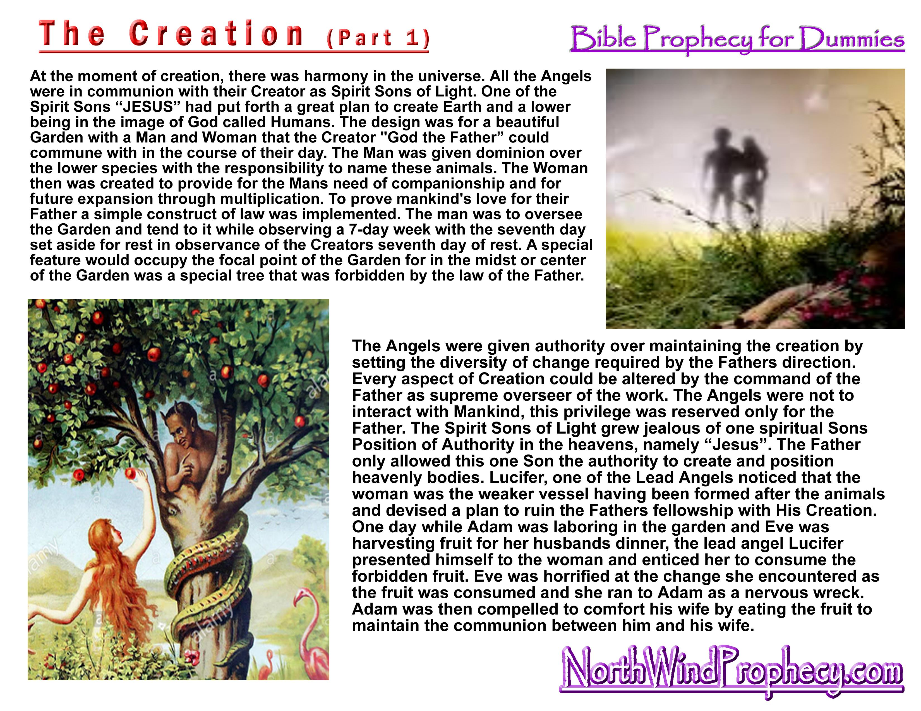

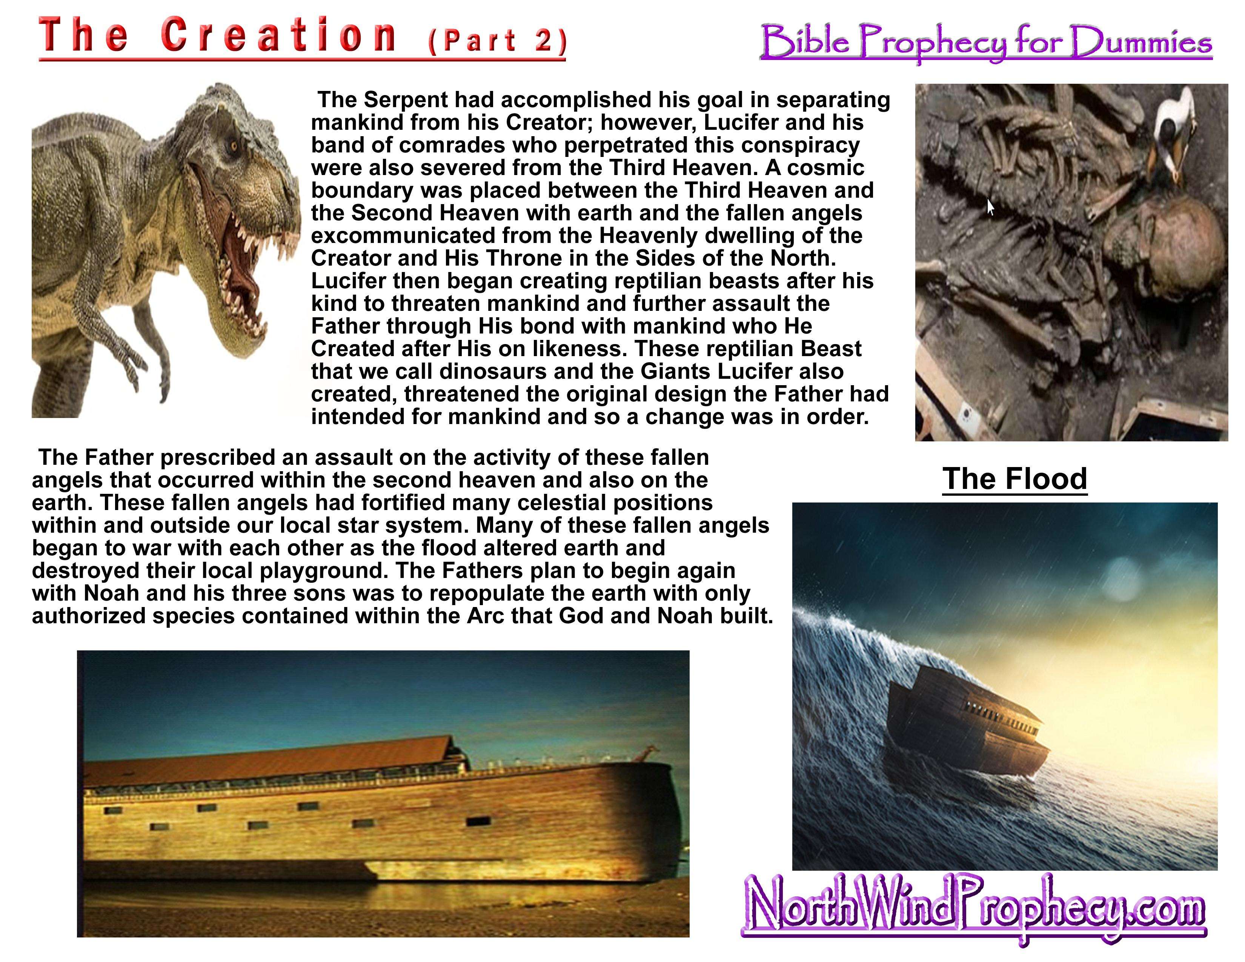
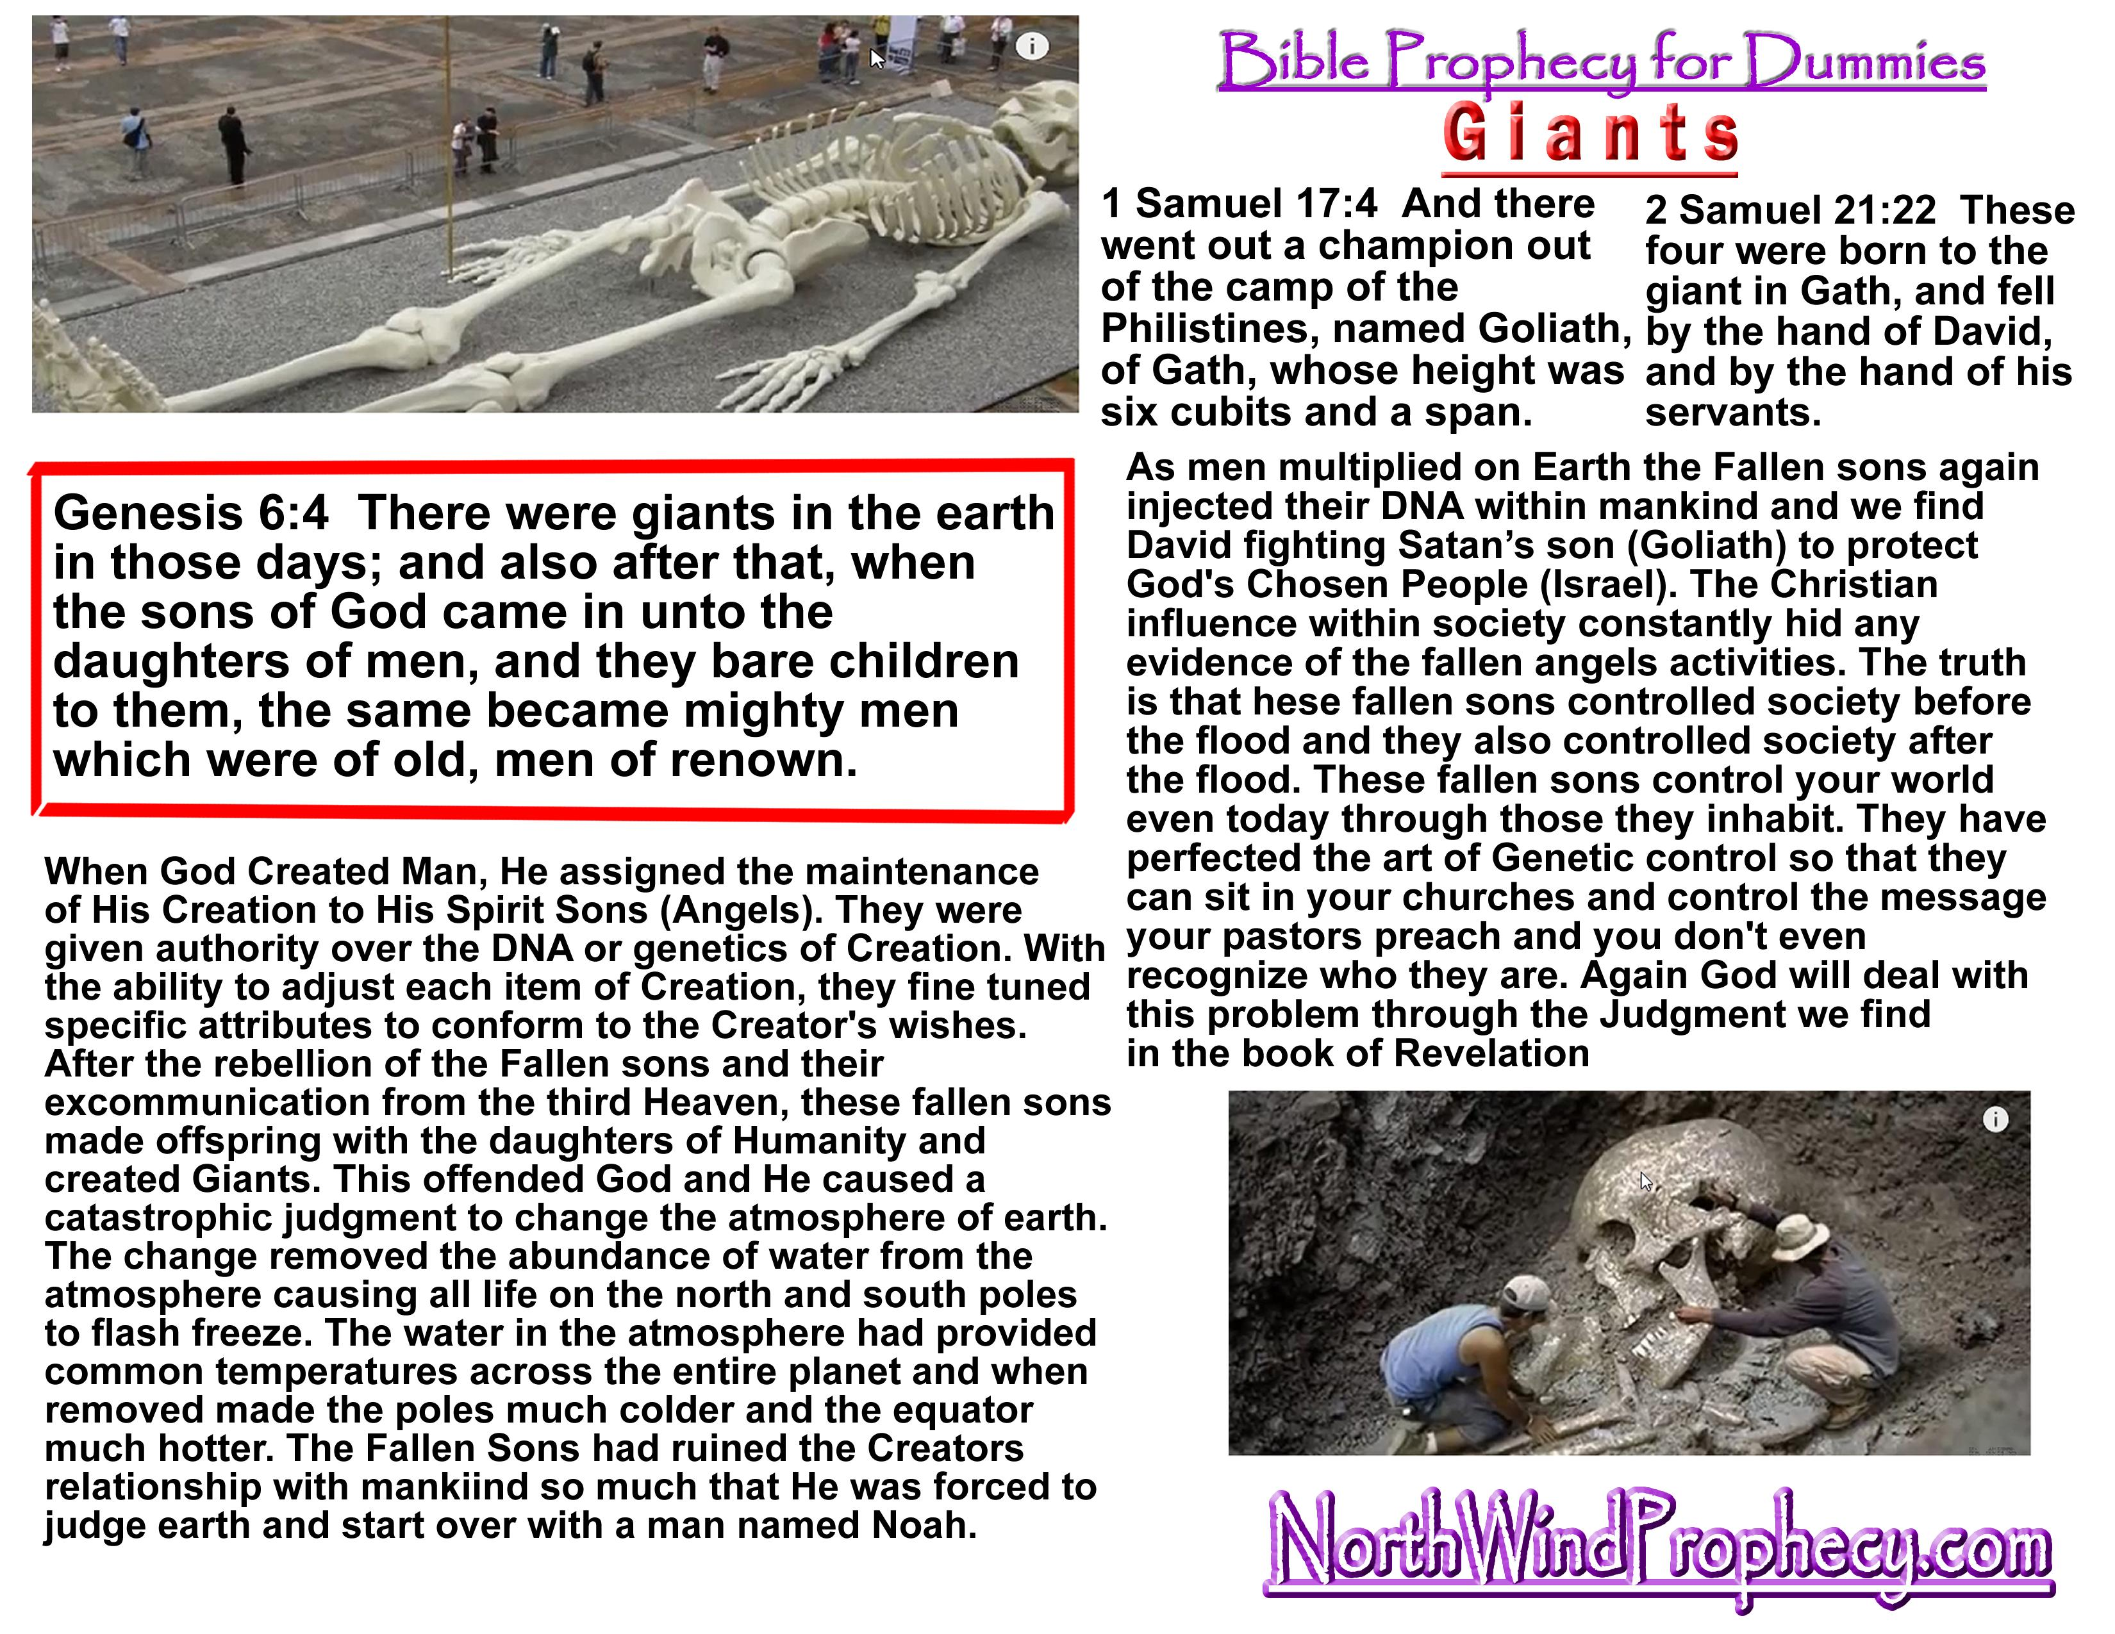
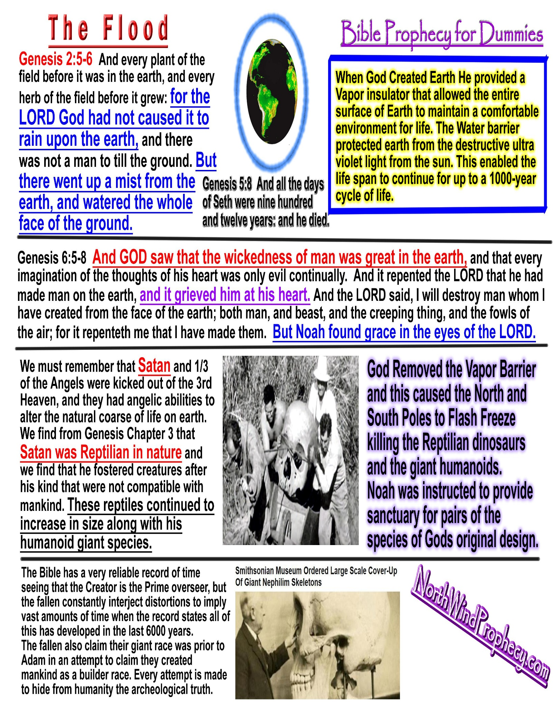
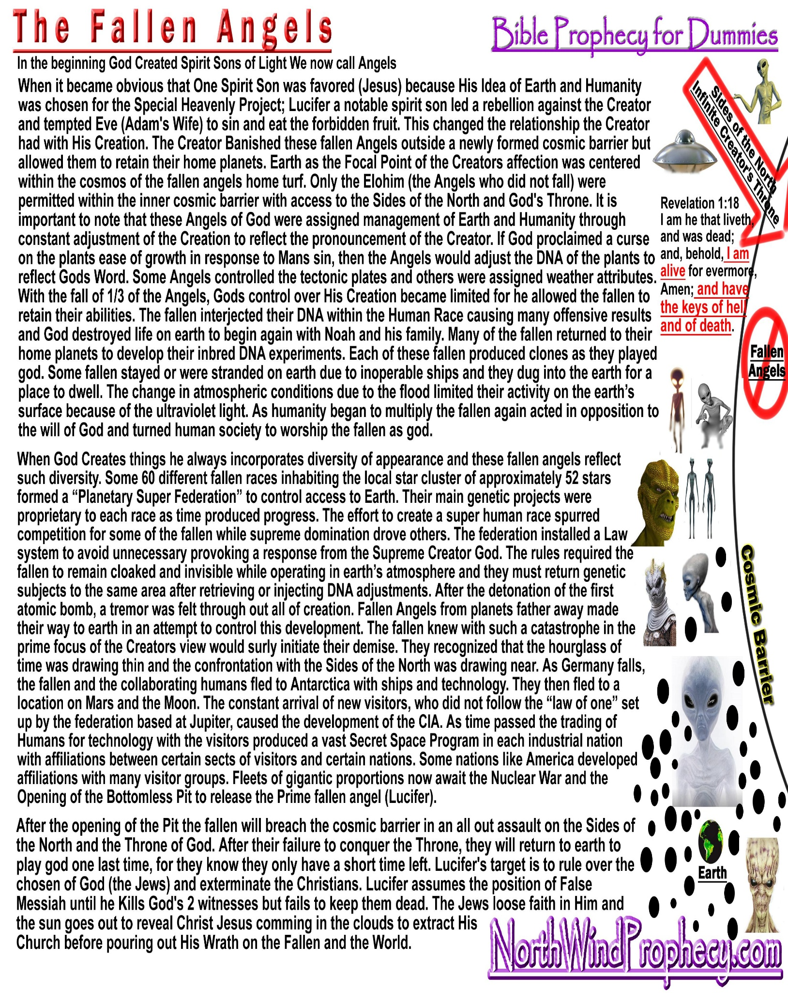

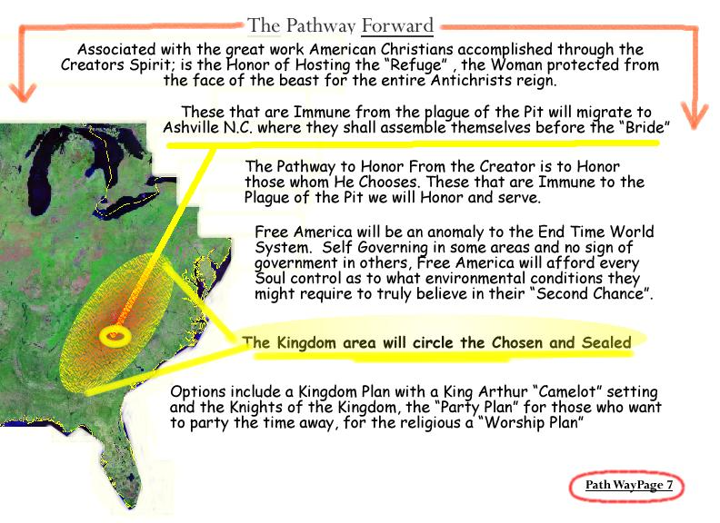
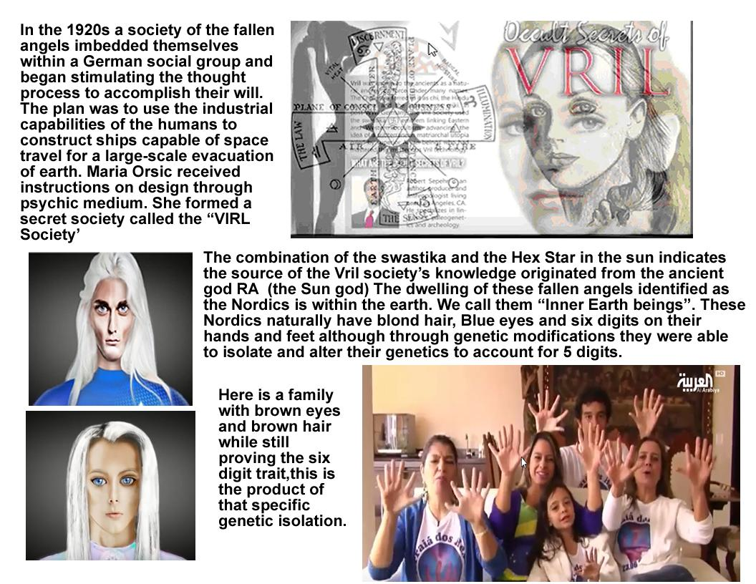
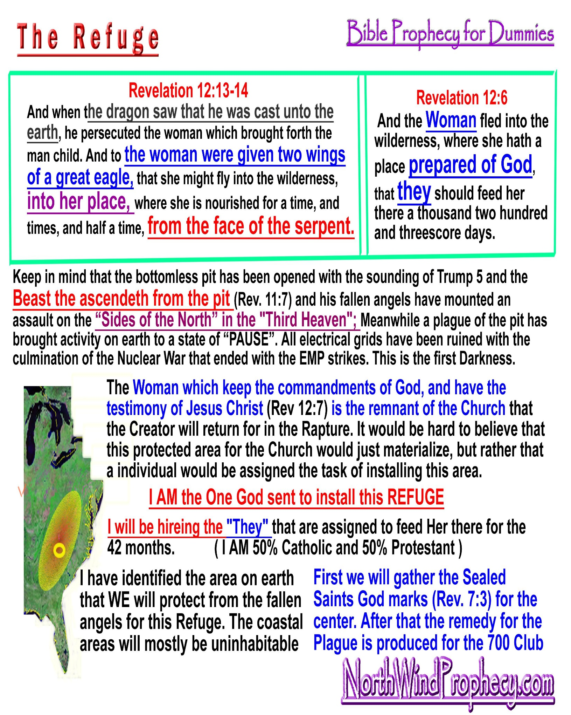
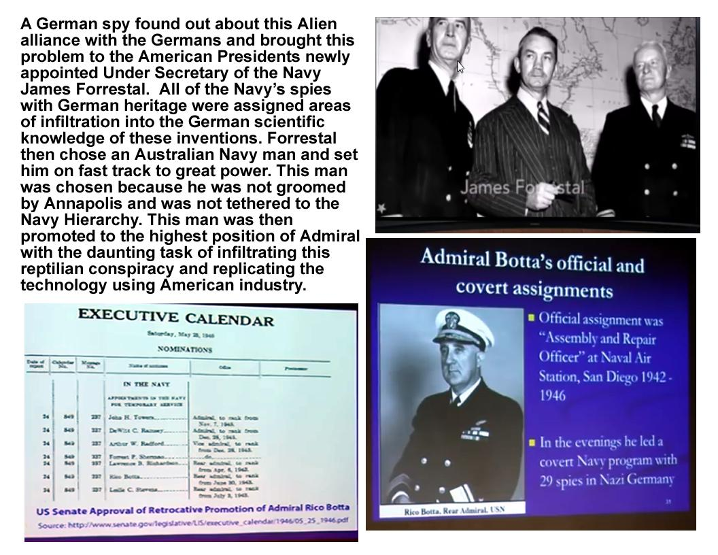
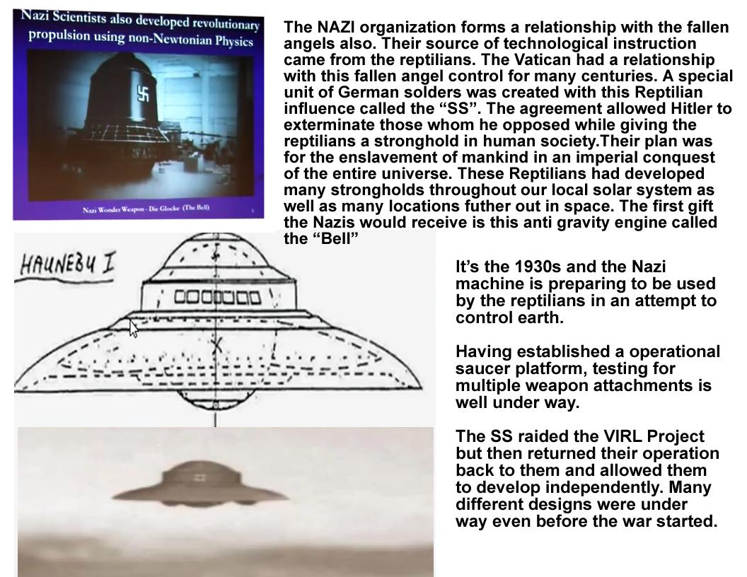
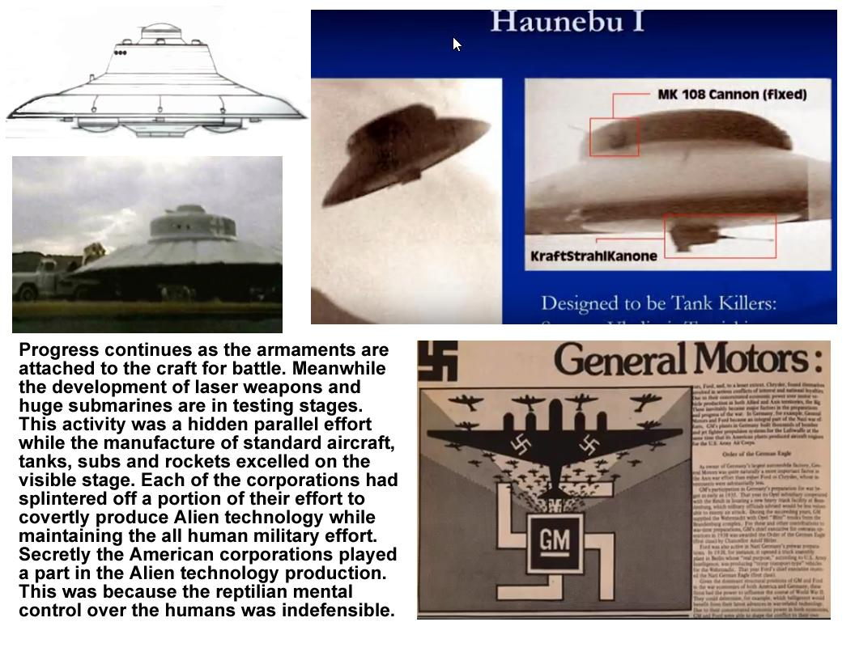

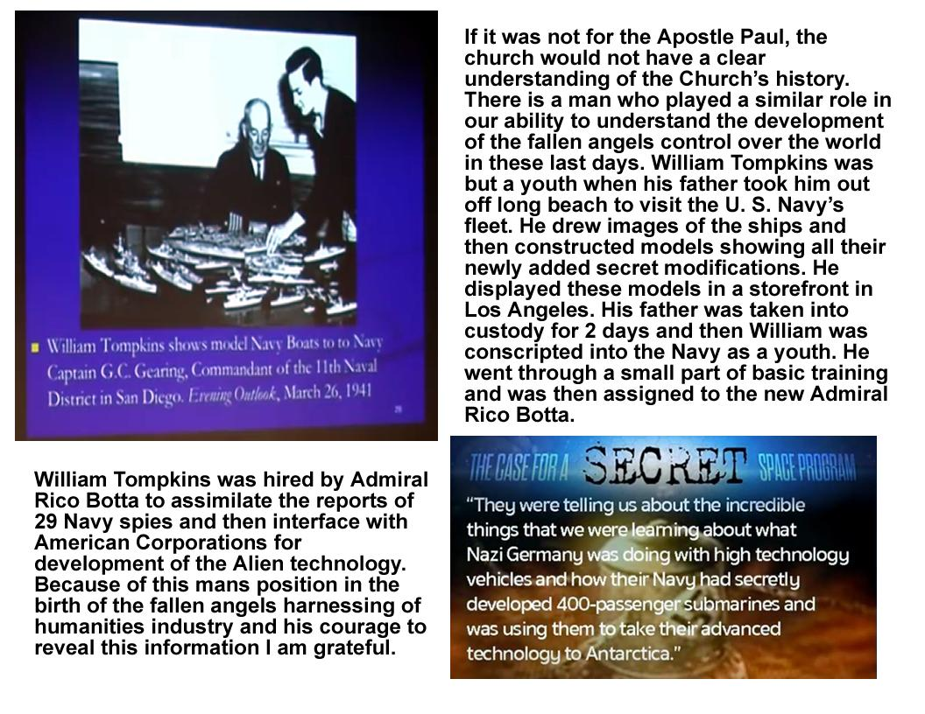

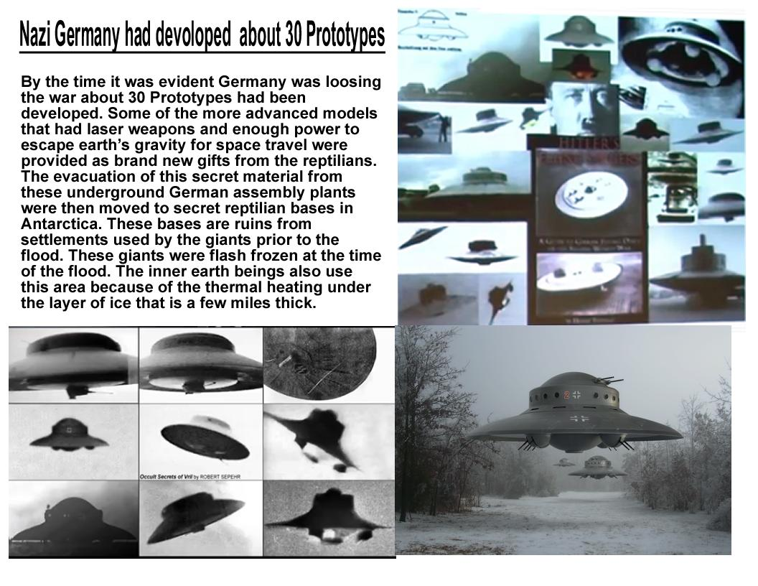

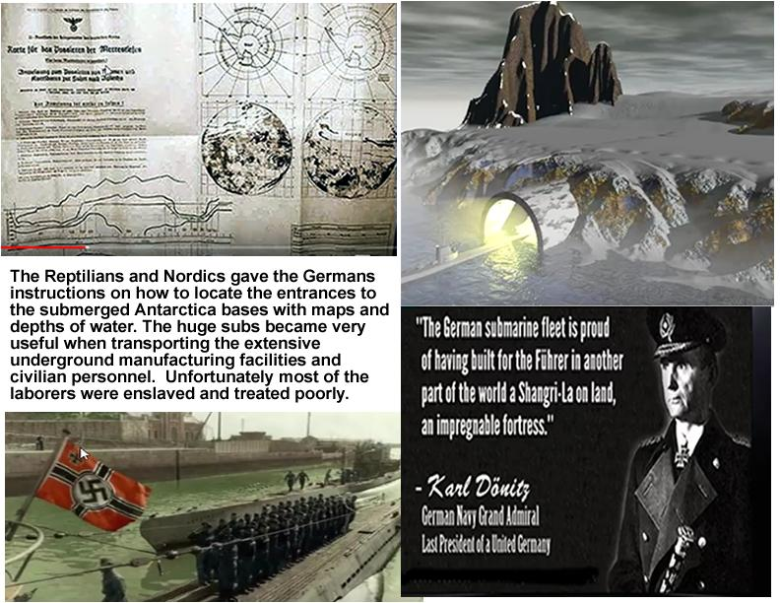

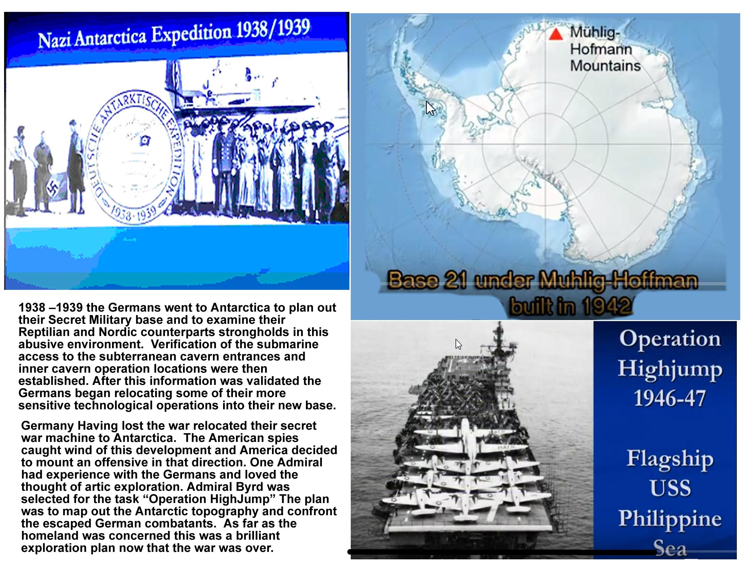
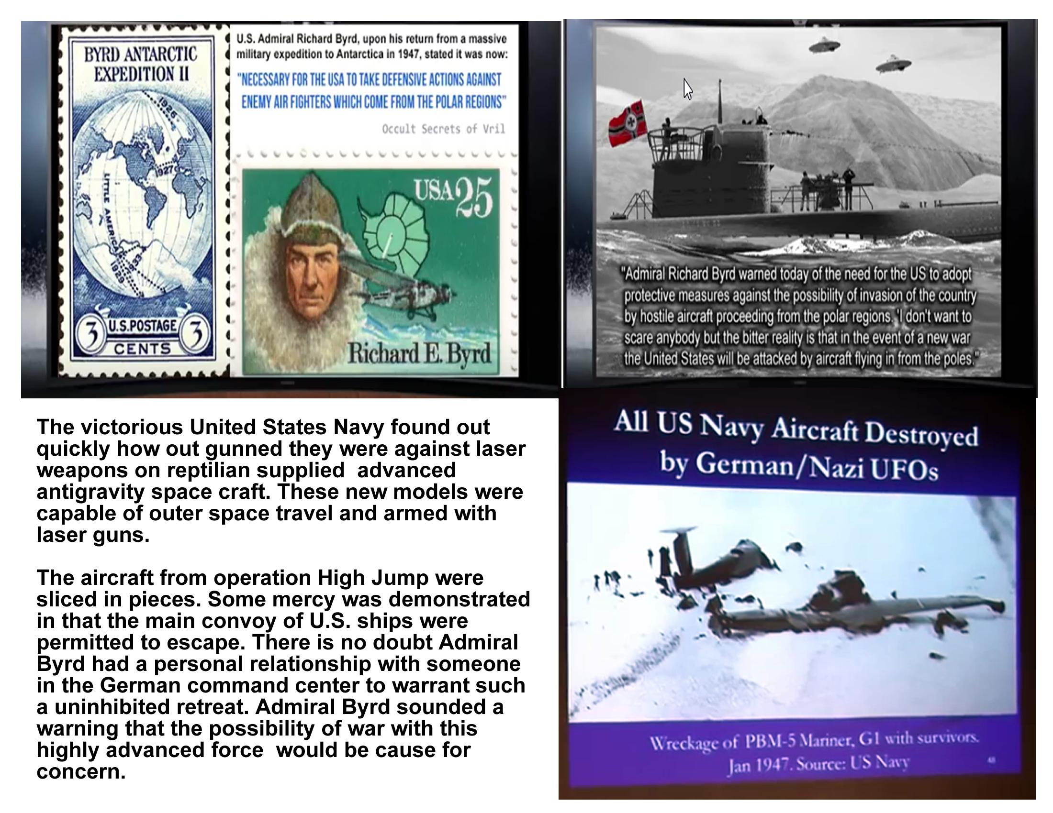

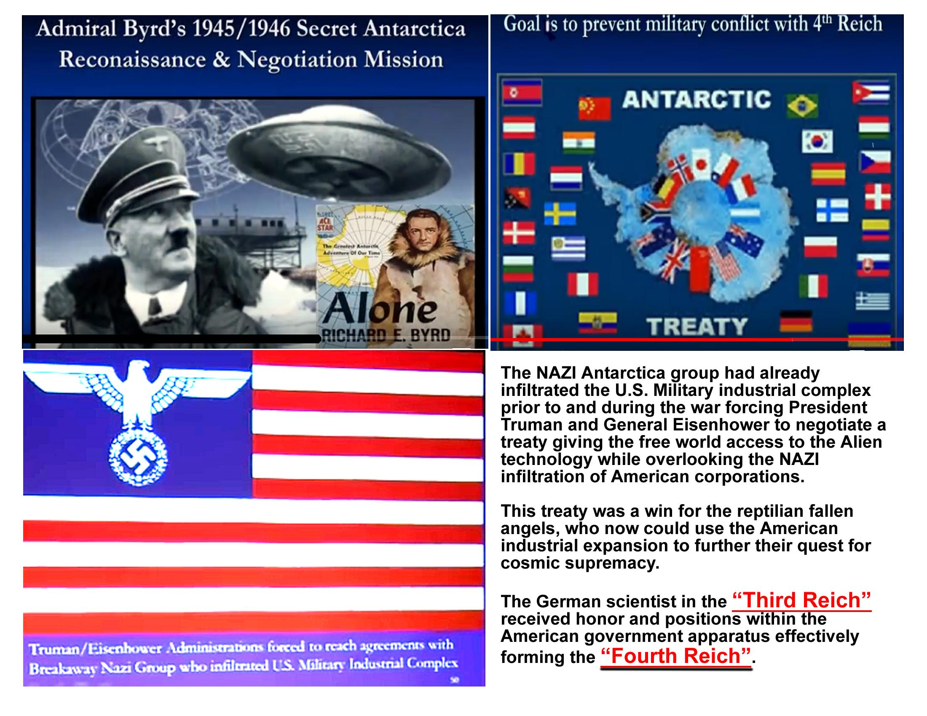

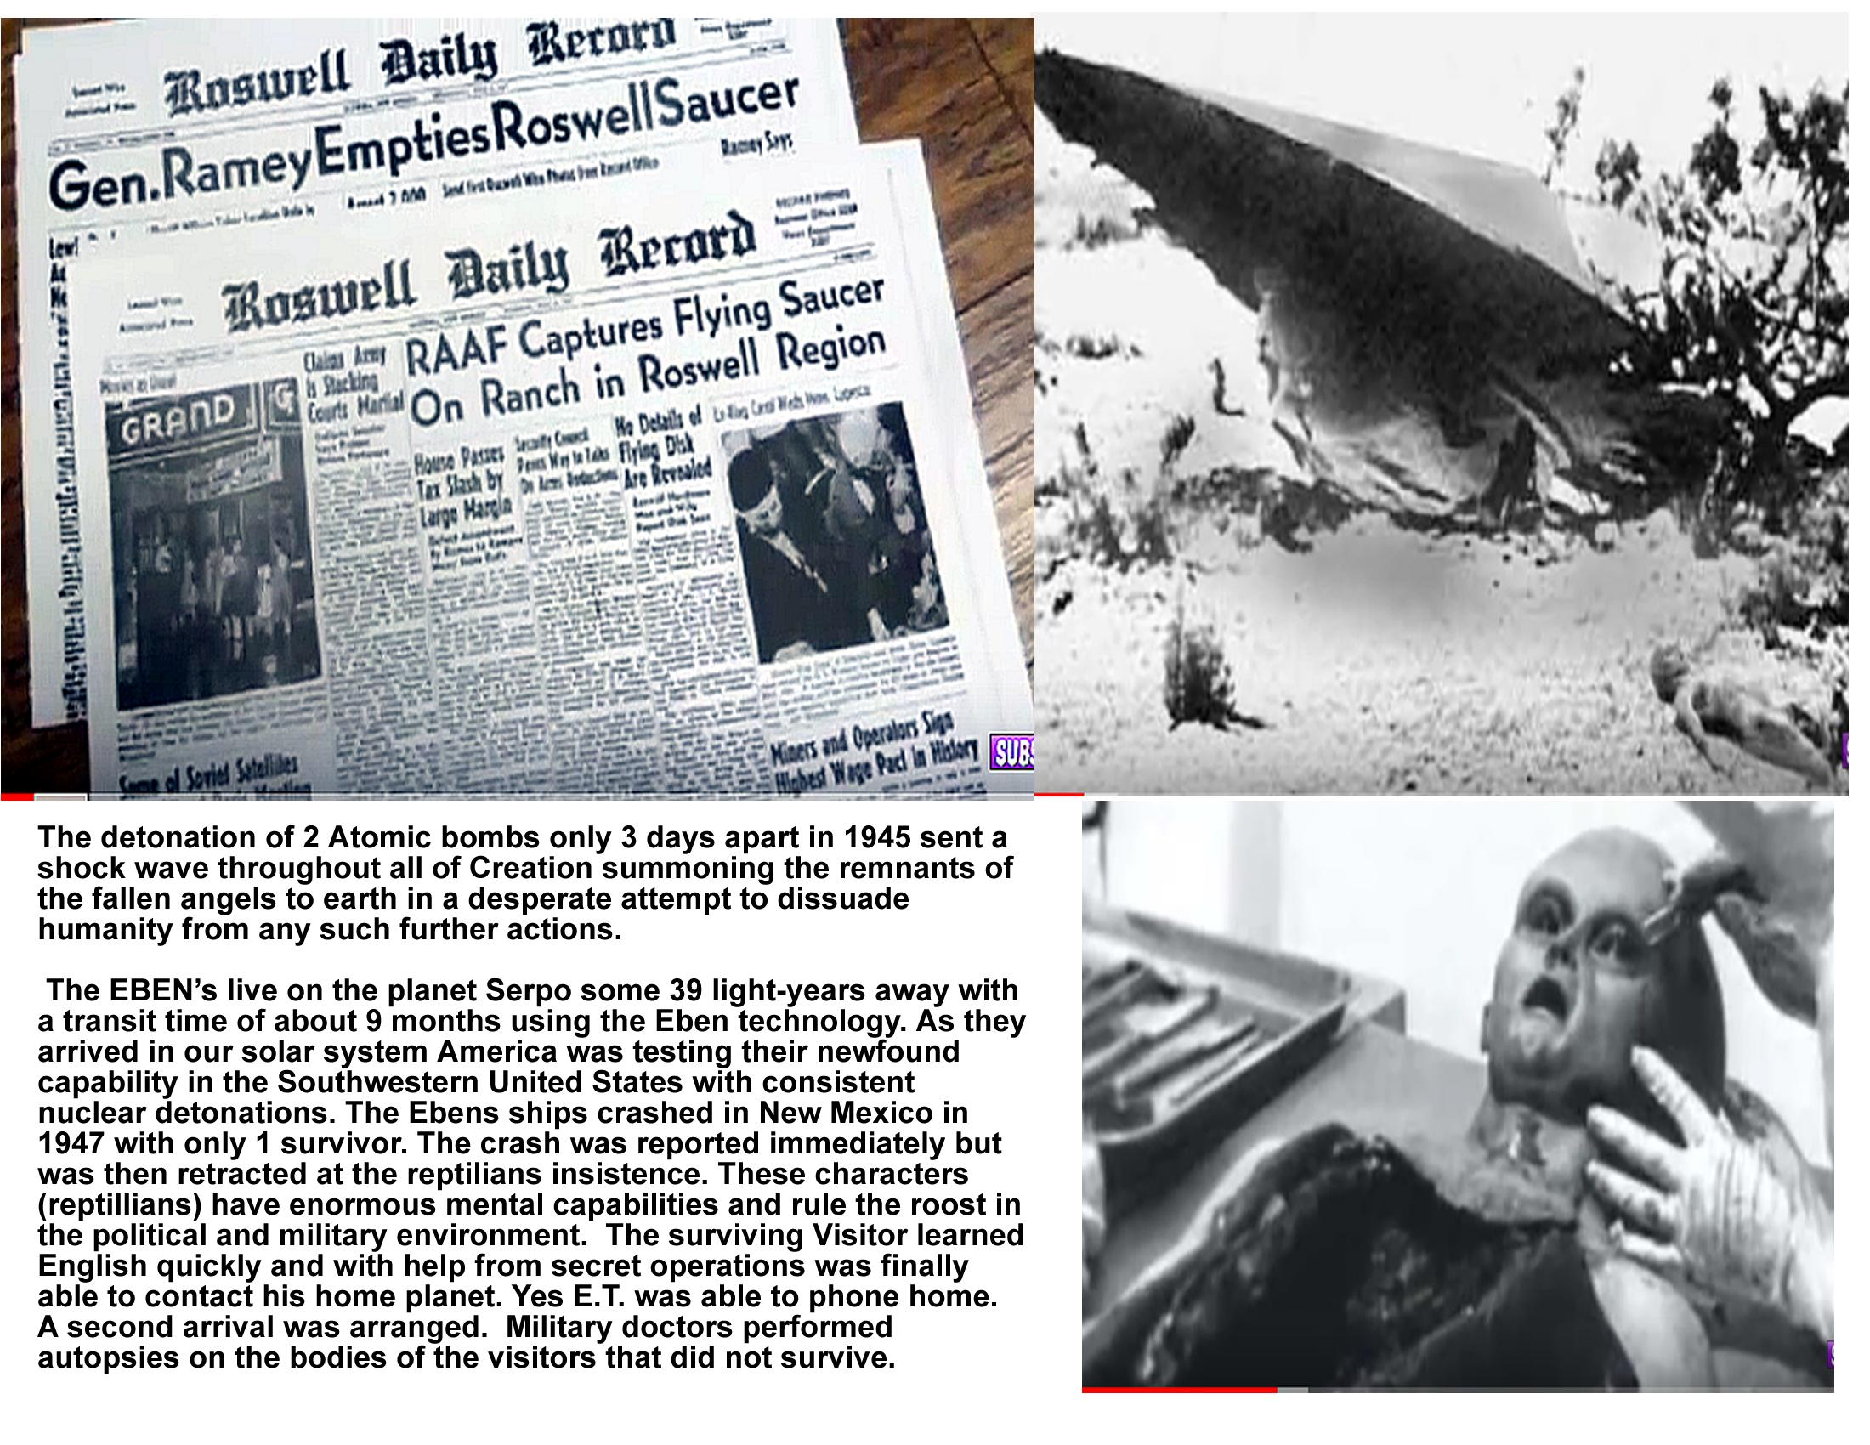

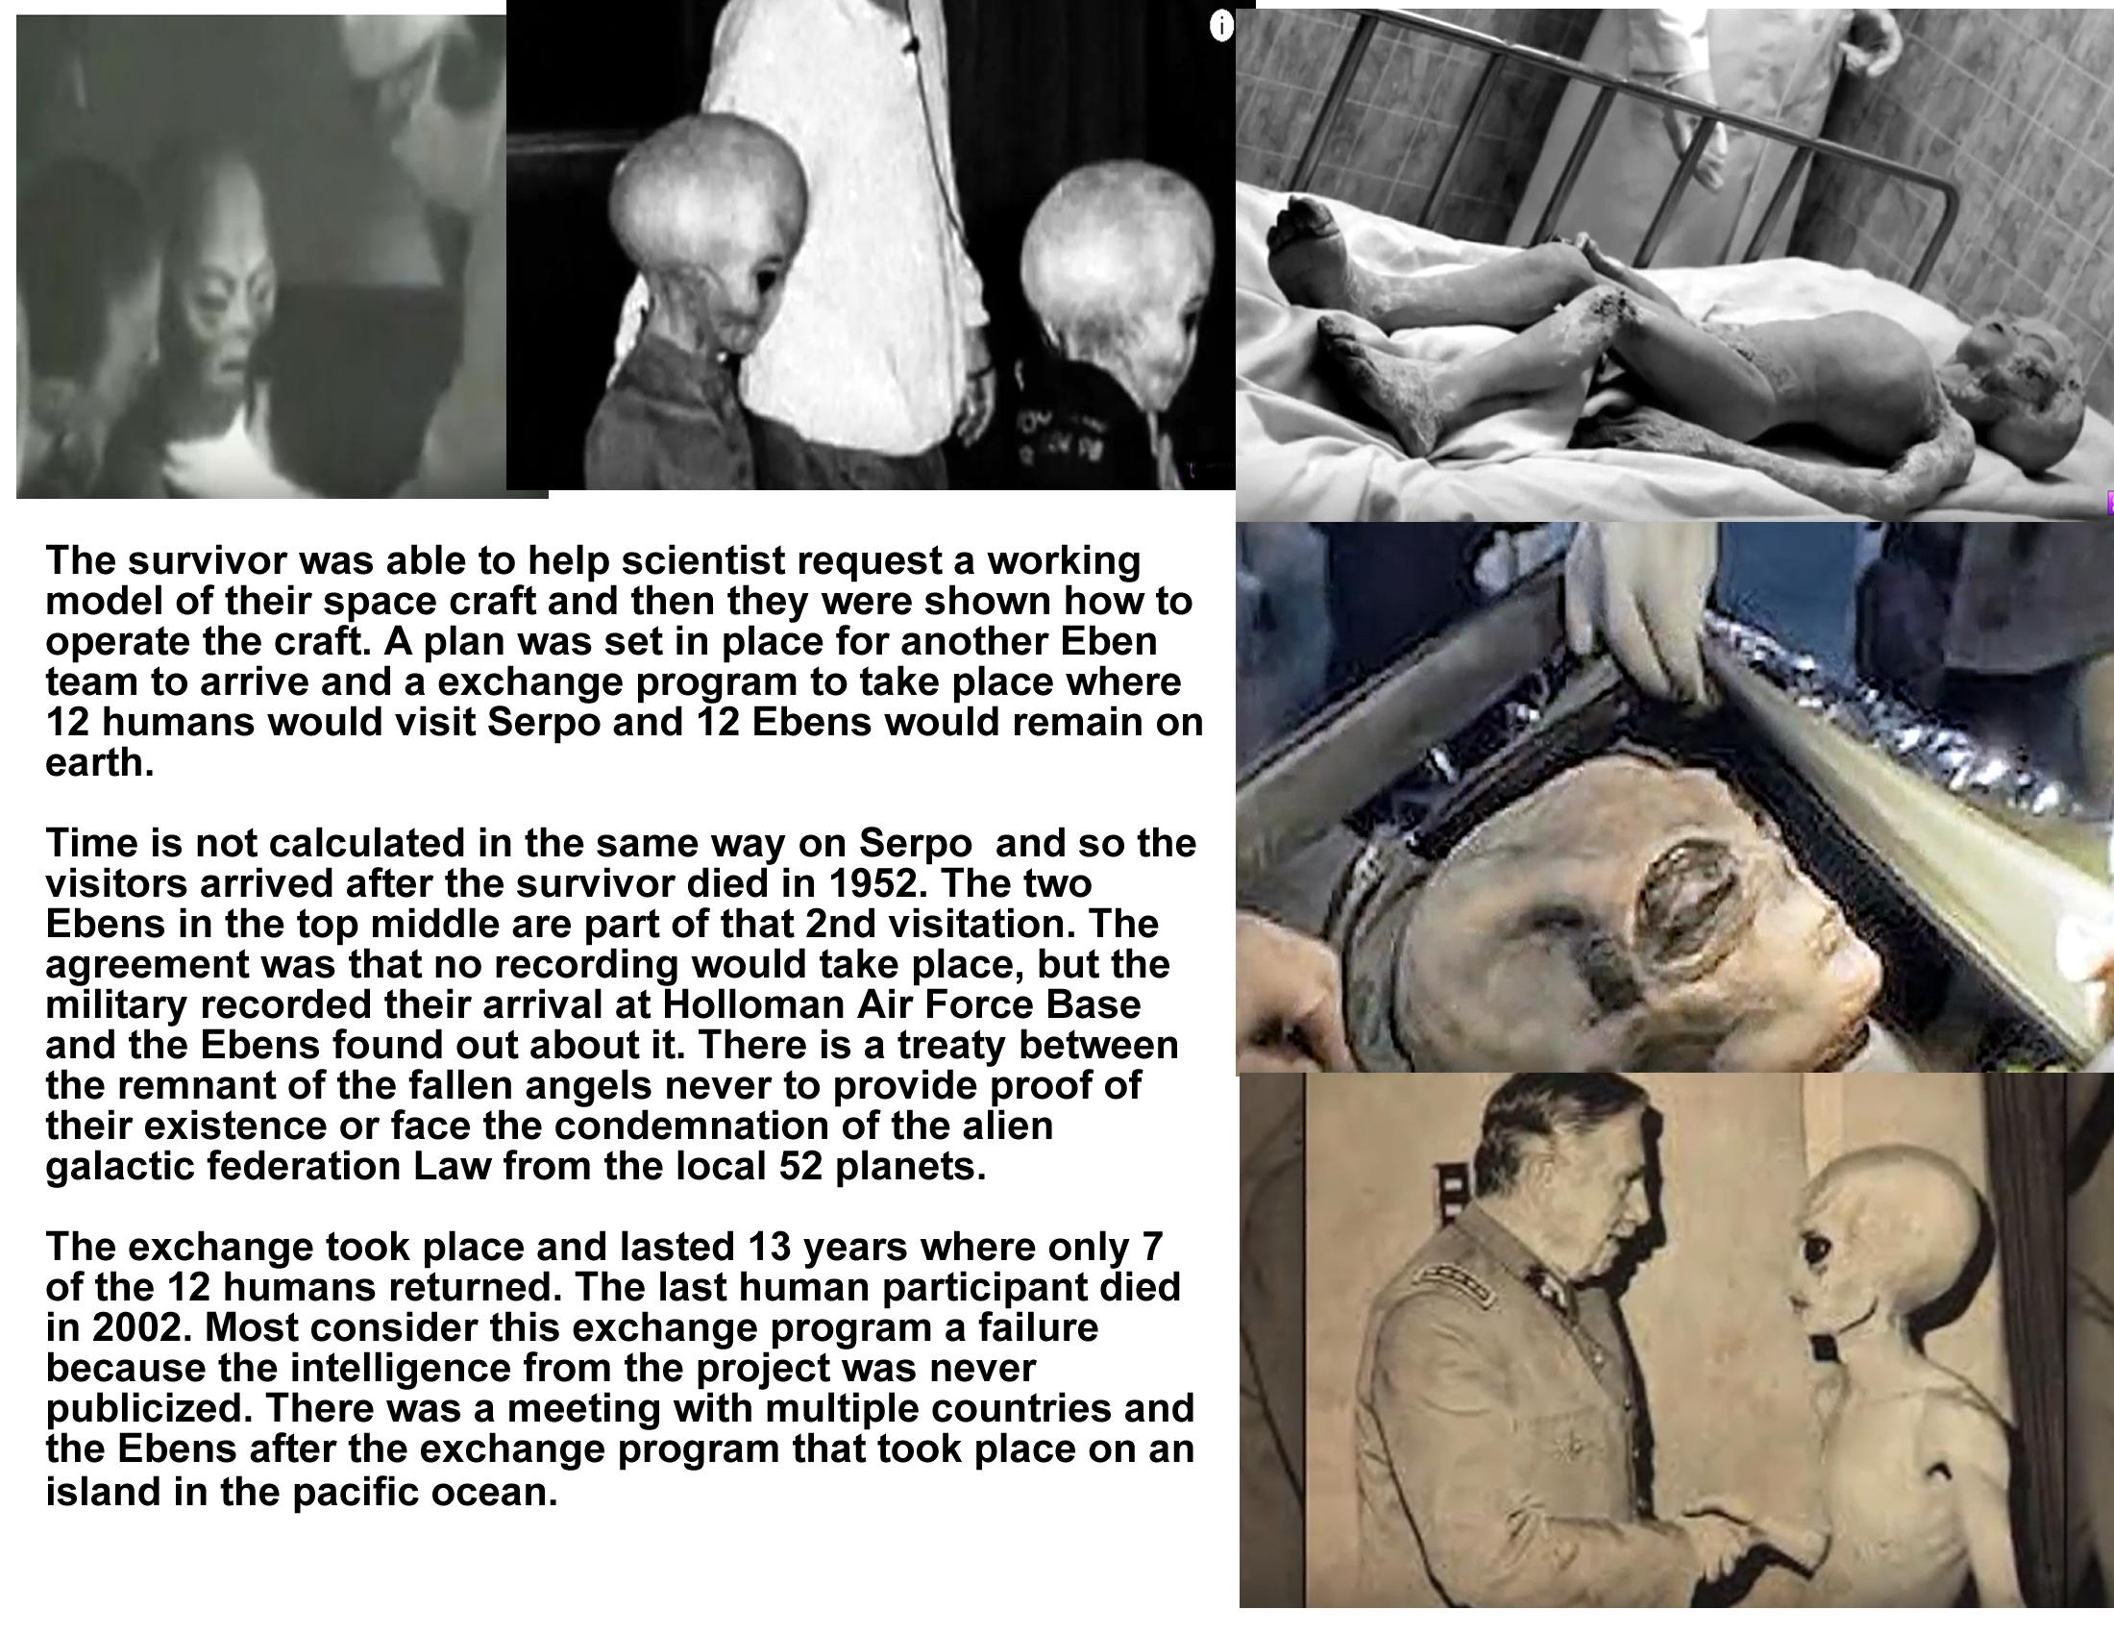

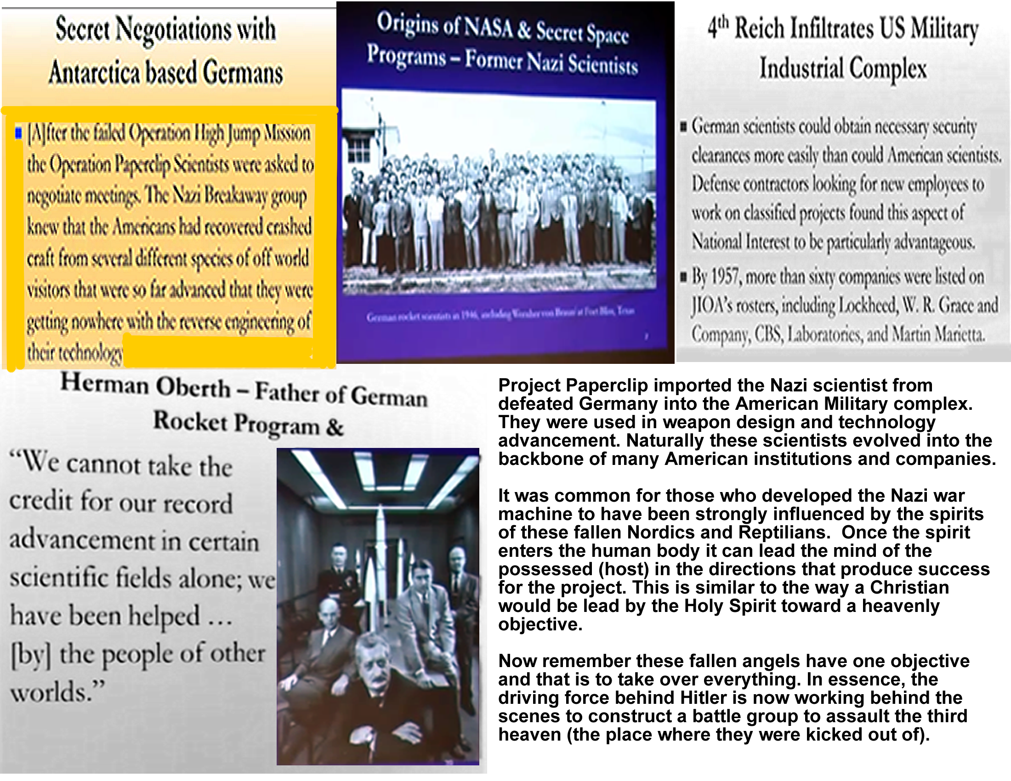

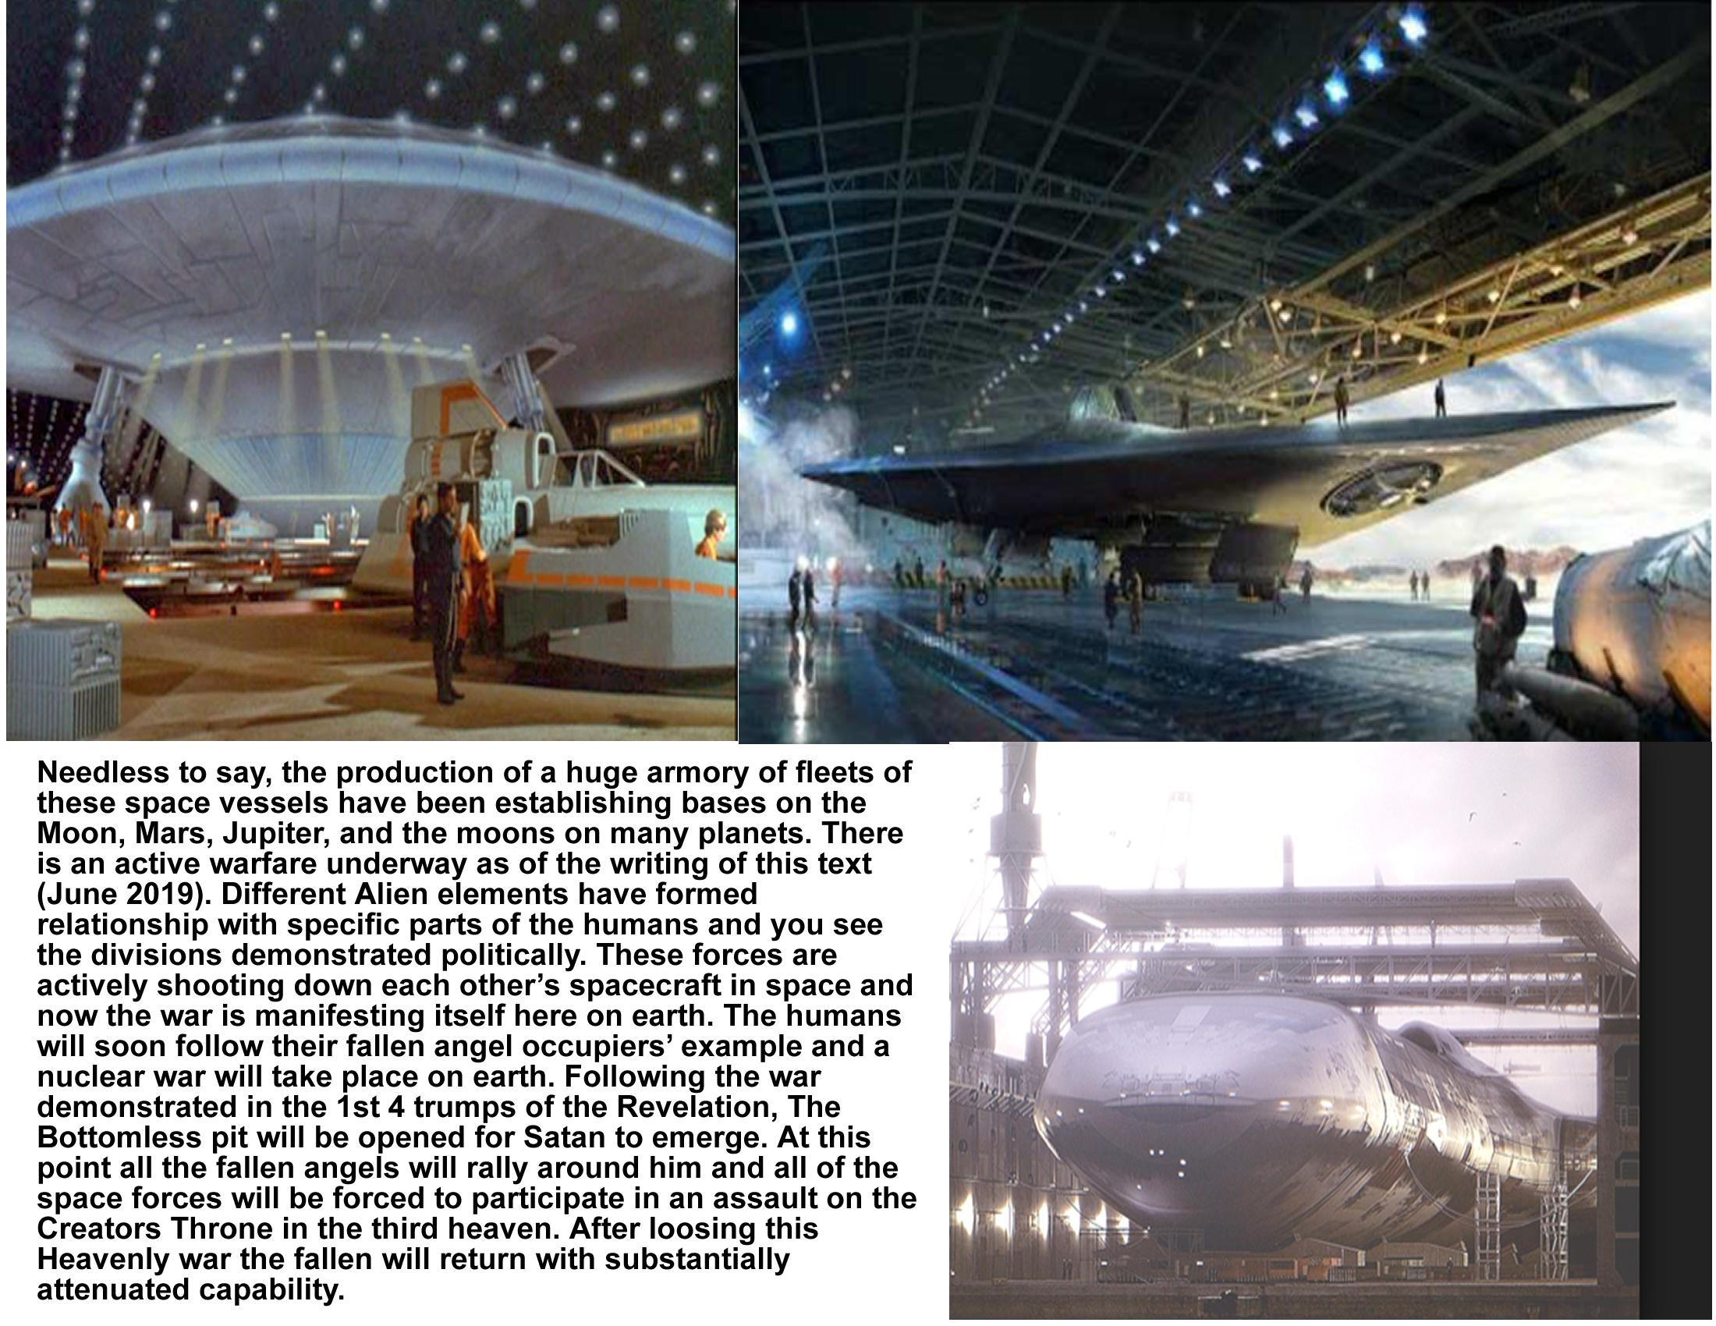

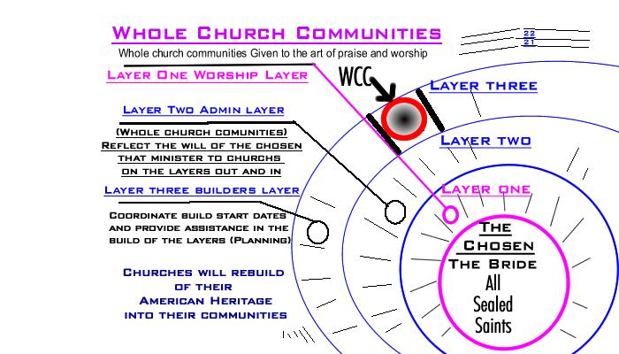

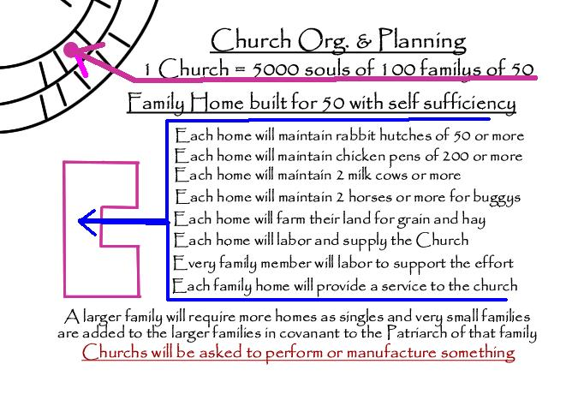

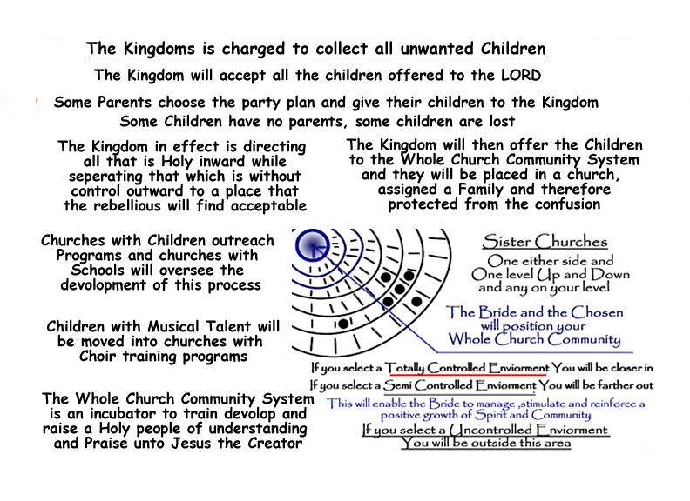

Overview of General Instructions

God our Creator has (will) make selection among us to define His Principle Players that He will Mark with His Mark prior to the Nuclear War. You may have not been identified in this group, you can still win favor with our Creator through how you treat those who He has chosen.

God's economy is not items of this worlds wealth, but what is precious and valuable to Him is these souls He has marked and Identified. We must treat them as Honored Guests and provide for them. In our time those who had great wealth socialized only among themselves and set themselves apart from society as if they were holy; God wants us to set these with His Name apart for they are Holy.

This work for God will be done in a time where there is no electricity and law and order seems to have become the way of the past. Your structure of order through governmental oversight will need to adapt to the New Authority and His Expectations. Your positions were previously underwritten by the god of this world as you became ensnared to him in exchange for things of the psychical realm. The greatest gift the Creator has to offer us is His Forgiveness as He takes us from what we were and converts us into what He needs for us to be.

This “Second Chance” won't upgrade you with His Mark, but it will allow you a position of usefulness and will reposition you on His side of the fence. We will collect those with the Mark of God into a centralized and protected area of your local authoritative district and then transport them to Asheville N.C. as their area of residence is determined.

Only those that are marked will be unaffected by the Plague of the Pit.

Whole Church Communities will then migrate from their home area to find refuge in the country around Asheville (around those God has selected). This will be the settings to protect the church through the tribulation.

I have shown you from Gods' Word, what we can expect to endure before He returns. Now I will tell you what He wants us to do for the duration of our christian experience here on earth. He will be selecting and marking “HIS CHOSEN TREASURE” immediately preceding the Nuclear War. We are tasked with gathering together these who He has chosen into a central point and we will provide for them.

Churches will then begin the migration process by sending those in their community who would volunteer to assist in the organizational process to initiate a Whole Church Community. The first layer that surrounds the Chosen of God, shall be a worship layer that will assist the Chosen in their efforts to Praise and Worship the Creator Jesus.

American Churches will provide of the talent of their church to minister unto the “Treasure of God”. The next layer away from the center layer will be churches responsible for the Administration such a great work. The next layer is the builder layer where the real work happens.

To illustrate the plan, the rule of law is unenforceable in a grid down situation. The world hates the Christian and we live in the World.
“In the World but not of the World”

Each Church that sends Christian volunteers will supply the singers and the carpenters, the teachers and the souls God requires to provide for this work. Many churches will find their own members selected as “Chosen”, and shall send their volunteers with those who received Gods' Mark in their forehead.

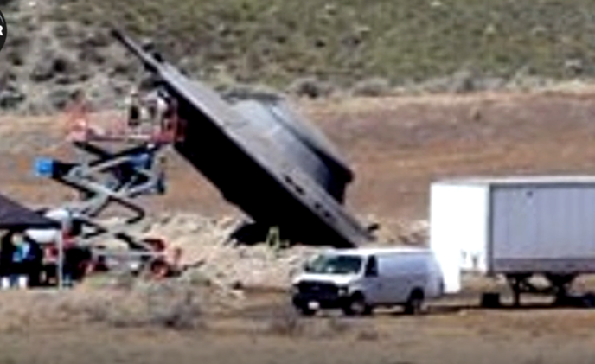










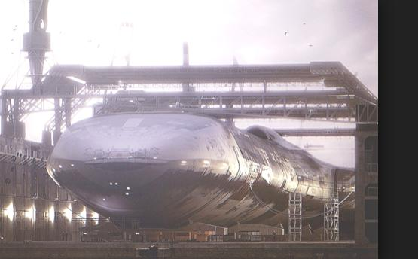
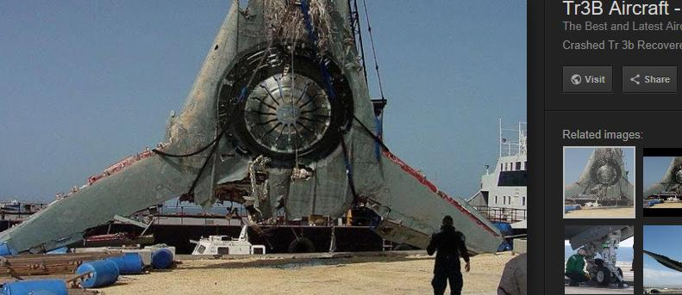
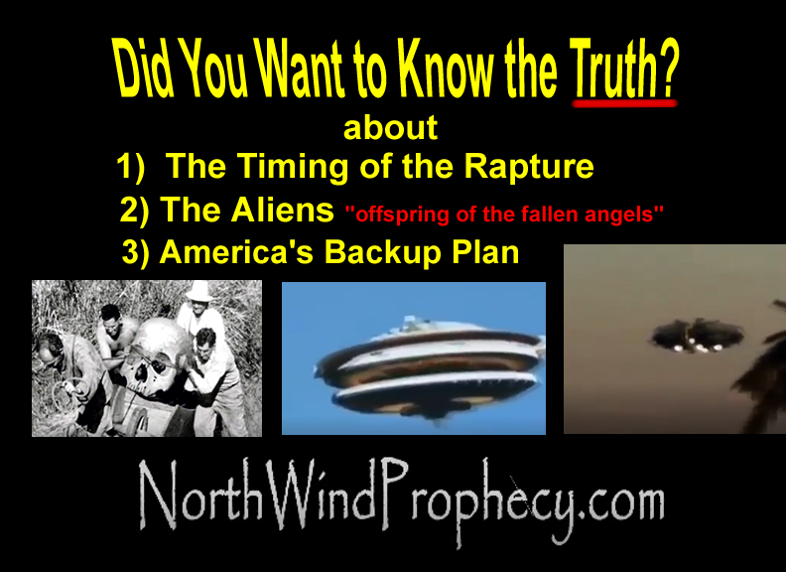

TRIBULATION-CHURCH.COM

